GBA-SPi Zero v1.0 Build Manual

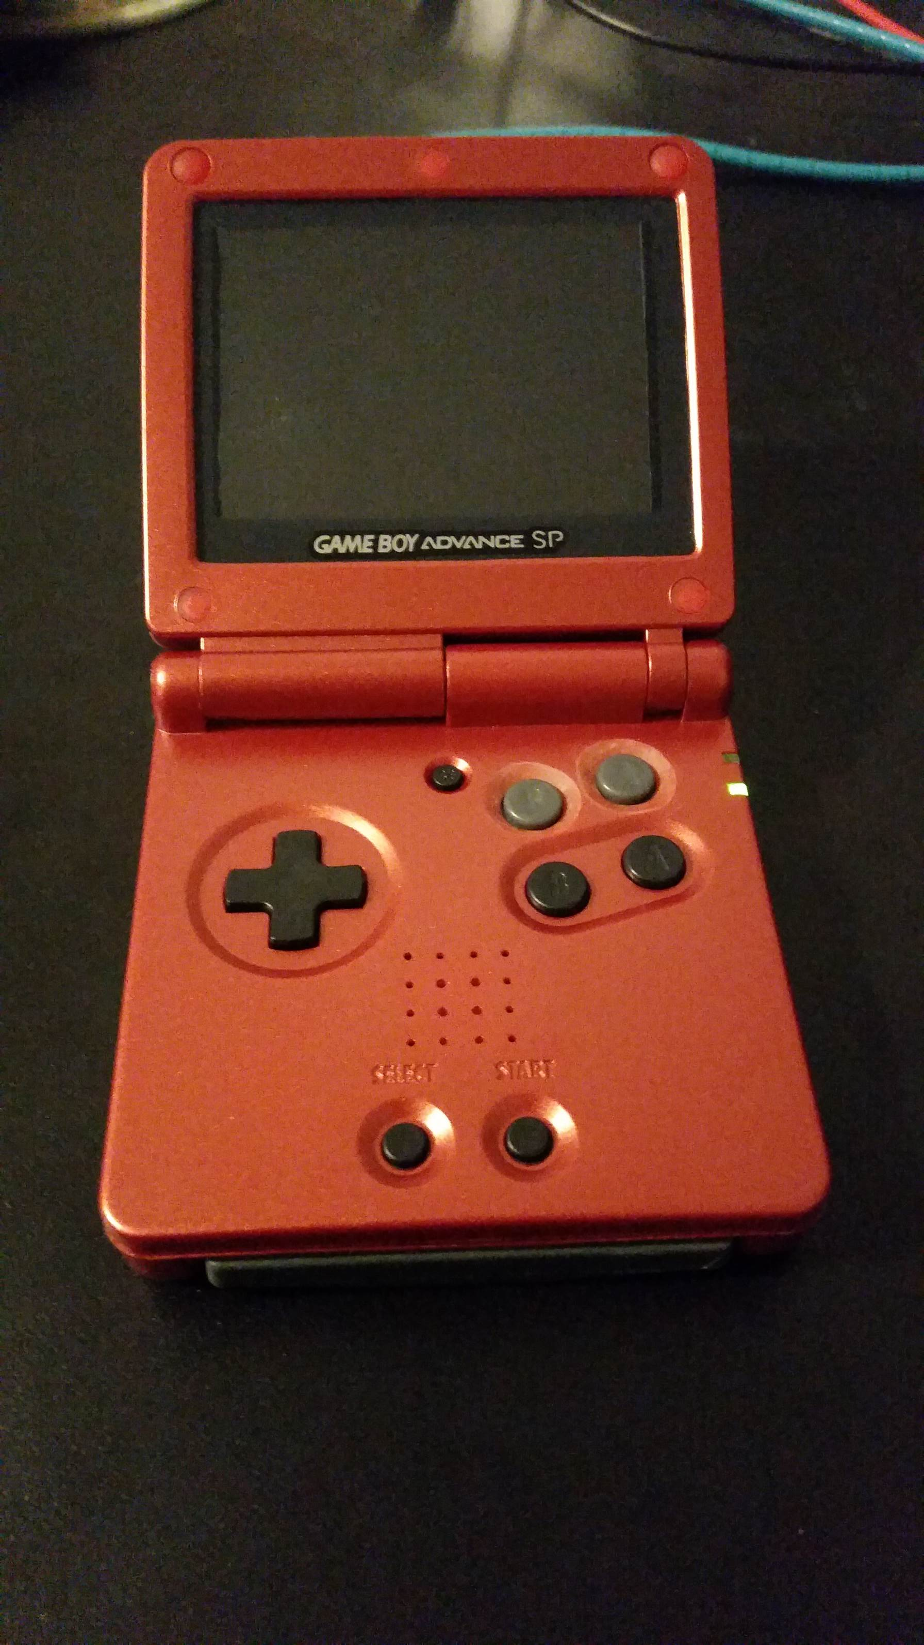

Table of Contents

1. Introduction 7

2. Preparations 8

2.1 Build Options 8

2.1.1 Screen Options 8

2.1.2 Headphones Option 11

2.1.3 Button Option 11

2.2 Items Included in the Kit 12

2.3 Additional Items Needed 13

2.4 Necessary Tools 14

3. Build Steps 15

3.1 Software Installation (SD card prep) 15

3.2 Raspberry Pi Prep 16

3.3 Preparing components 18

3.3.1 Volume Slider 18

3.3.2 USB Port 20

3.4 Case Modifications 21

3.4.1 Front shell 21

3.4.2 X and Y buttons 23

3.4.3 Back shell 25

3.4.4 Screen shell 30

3.5 Preparing the AIO board 31

3.5.1 Separating PCB pieces 31

3.5.2 Trim extra PCB pieces 33

3.6 Desoldering 36

3.7 Micro USB power port 39

3.8 Attaching the Raspberry Pi 44

3.9 Headphone Jack 50

3.10 Volume Slider 51

3.11 Shoulder button switches 52

3.12 USB Riser Board 53

3.13 Screen assembly 56

3.13.1 Soldering and taping the screen 56

3.13.2 Assembling the screen shell 60

3.14 X and Y Buttons 61

3.14.1 Disclaimer 61

3.14.2 Using the included button wells 61

4. Assembly 65

4.1 Screen attach 65

4.2 Assembling the buttons 66

4.3 Attach the AIO board 67

4.4 Hinge installation 69

4.5 Headphone jack 70

4.6 USB port 72

4.7 Volume Slider 74

4.8 Battery 75

4.9 Final Assembly 79

4.10 Fitting the cartridge 80

5. All Done! 82

Figure 1 - 2.8in screen behind protector 9

Figure 2 - 3.2in screen behind protector 9

Figure 3 - 3.2in screen, front of screen shell 10

Figure 4 - 3.2in screen, back of screen shell 10

Figure 5 - Necessary tools 14

Figure 6 - Remove corner of the Pi 16

Figure 7 - Trim Pi USB pad 17

Figure 8 - Pi Kapton tape and solder blobs 17

Figure 9 - Bend volume slider pins 18

Figure 10 - Volume slider plastic before trimming 19

Figure 11 - Volume slider plastic after trimming 19

Figure 12 - Volume slider pieces glued 20

Figure 13 - Trim USB port metal 20

Figure 14 - Front shell, trim interfering plastic 21

Figure 15 - Front shell, open ribbon cable hole 22

Figure 16 - Marking where X and Y button holes go 23

Figure 17 - Make X and Y markings more pronounced 24

Figure 18 - Back shell cutout markings 25

Figure 19 - Back shell, cutting results 26

Figure 20 - Shave plastic for USB port 27

Figure 21 - Check where to trim for USB port 28

Figure 22 - USB port fit into shell opening 29

Figure 23 - Trim cart slot plastic 29

Figure 24 - Screen shell modification 30

Figure 25 - Separate the board pieces 31

Figure 26 - Separated main board 32

Figure 27 - Cut PCB nubs 33

Figure 28 - PCB pieces to remove 34

Figure 29 - Smooth PCB after pieces removed 35

Figure 30 - Desoldering the volume slider 36

Figure 31 - Desoldering the headphone jack 37

Figure 32 - Solder removed from volume slider and headphone jack 38

Figure 33 - Solder removed from speaker pads 38

Figure 34 - Cut off a single pin 39

Figure 35 - Solder to hold the micro USB pin in place 40

Figure 36 - Sewing needle to stop boards from rotating 41

Figure 37 - Soldering iron into holes for USB power 41

Figure 38 - Solder coming through the holes in the board 42

Figure 39 - Remove the plastic piece of the pin 42

Figure 40 - These are connected together 43

Figure 41 - Finished power port soldering 43

Figure 42 - Solder balls for Pi attach 44

Figure 43 - Pi alignment pins 44

Figure 44 - Solder blobs on back side of Pi alignment pins 45

Figure 45 - More flux on Pi pins 45

Figure 46 - First pass soldering of a few Pi pins 47

Figure 47 - Starting to solder the rest of the pins 47

Figure 48 - Clip and solder the alignment pins 48

Figure 49 - Finished soldering Pi pins 48

Figure 50 - Solder the USB pins 49

Figure 51 - Headphone jack soldered on 50

Figure 52 - Connect these two points if headphone jack is not installed 50

Figure 53 - Assembled volume slider 51

Figure 54 - Volume slider - only solder two right connections for now 51

Figure 55 - Shoulder buttons installed and soldered 52

Figure 56 - Add USB riser board, align with pin 53

Figure 57 - Solder blob USB riser board pin 53

Figure 58 - USB connections soldered 54

Figure 59 - Cut and solder the USB board pin 54

Figure 60 - Add USB port, solder only one pin 55

Figure 61 - Slight trimming for USB port fit 55

Figure 62 - Align and tape down screen ribbon and adapter 56

Figure 63 - Solder end screen pins, and confirm alignment 56

Figure 64 - Finished screen soldering 57

Figure 65 - Kapton tape on back of the screen 57

Figure 66 - Test the screen and AIO board 58

Figure 67 - Tape down ribbon cable, align behind the screen protector and tape screen down 59

Figure 68 - Screen aligned behind protector, with electrical tape on edges 59

Figure 69 - Spiral the cable through the hinge 60

Figure 70 - X and Y button hole locations 61

Figure 71 - Countersunk X and Y holes 62

Figure 72 - Scratch button well pieces 62

Figure 73 - Glue first button well layer 63

Figure 74 - Scratch up both button well layers 63

Figure 75 - Button wells assembled 64

Figure 76 - Screen shell mounting to board shell 65

Figure 77 - Cable cover holding screw 65

Figure 78 - Buttons installed 66

Figure 79 - Add button gaskets and speaker 66

Figure 80 - Install ribbon cable and kapton tape 67

Figure 81 - Seat AIO board into shell, screw in place 68

Figure 82 - Install the hinges 69

Figure 83 - Mark headphone jack location 70

Figure 84 - Check headphone jack fit 70

Figure 85 - Finish headphone cutout 71

Figure 86 - Realign the USB port 72

Figure 87 - USB port pins soldered 72

Figure 88 - Super glue under USB port 73

Figure 89 - Two pins on volume slider 74

Figure 90 - Wrap battery in kapton tape 75

Figure 91 - Battery location on AIO board 75

Figure 92 - DO NOT CUT BATTERY WIRES TOGETHER 76

Figure 93 - Cut battery wires one at a time 77

Figure 94 - Solder the battery wires, and add some kapton tape 78

Figure 95 - Adding the final assembly pieces. 79

Figure 96 - Battery through cart slot first 79

Figure 97 - Glue cartridge shell together 80

Figure 98 - How far to cut the game cartridge 80

Figure 99 - Fully cut game cartridge 81

Figure 100 - FInished product 82

# Introduction

# Preparations

## Build Options

This build is loaded with options. The builder needs to decide on their path **before** starting this build. There are actions taken based off some these decisions that cannot be undone. I will do my best to spell out these options so the builder can decide how they would like to proceed.

### Screen Options

|  |  |  |
| --- | --- | --- |
| **Option** | **Pros** | **Cons** |
| 2.8 inch SPI screen – 18pin solder type | No cutting of GBA shell necessary, relatively easy to solder | Screen does not completely fill opening in the glass. Pictures below (See picture below) |
| 2.8 inch SPI screen – mounted to carrier board | Easiest to solder to | Have to trim the carrier board to fit. Screen does not completely fill opening in the glass |
| 3.2 inch SPI screen – 18pin solder type | Easily fills opening in the glass | Need to cut the shell for it to fit properly. Either need to lose a lot of pixels with overscan settings, or modify the opening in the glass to see the entire screen (See picture below) |
| 3.5 inch composite screen | Completely fills opening in the shell (with no glass), so lots of viewing area. No refresh rate issues like with SPI screens | Heavy driver board modifications necessary to get it to fit in the shell |

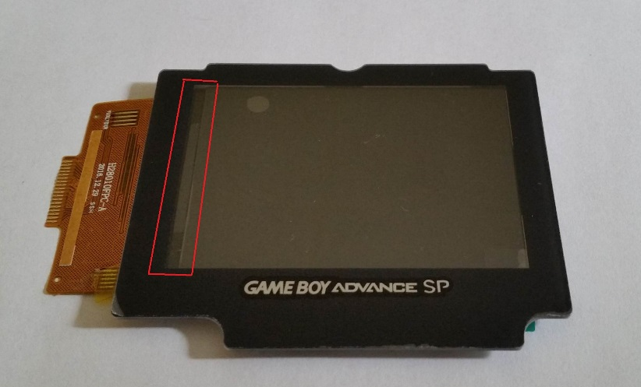

Figure 1 - 2.8in screen behind protector

The area highlighted in red is non-active screen area on the 2.8in screen. The screen does not completely fill the opening in the protector, so there will always be a gap. This looks better when it is centered within the opening, and is not difficult to put a few small black strips of electrical tape to cover the exposed area.

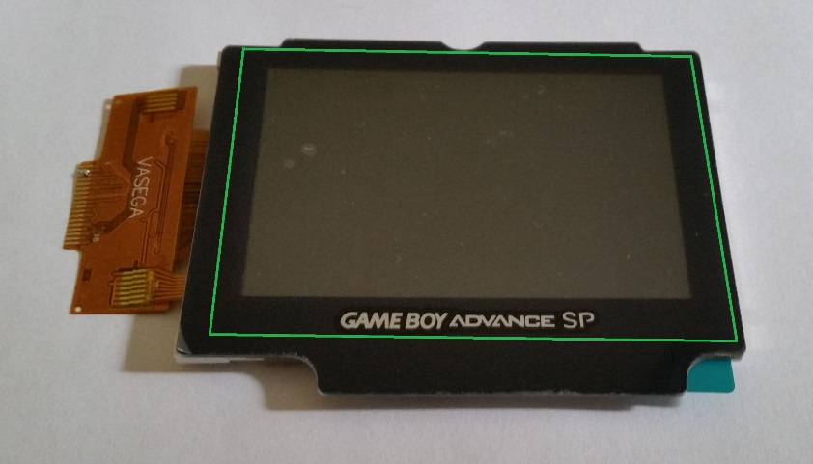

Figure 2 - 3.2in screen behind protector

The 3.2in screen nicely fills the entire opening in the protector. The green outline shows where the actual edges of the screen fall. It is nice to have the entire opening filled, but you will lose pixels around the edge of the screen when you set the proper overscan settings. On a 320x240 resolution screen, all pixels are valuable!

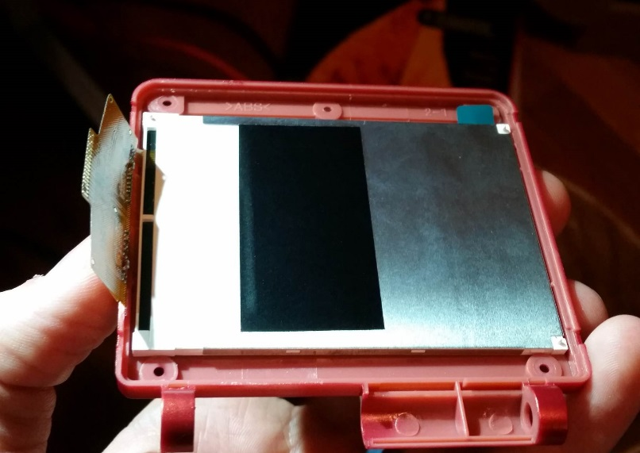

Figure 3 - 3.2in screen, front of screen shell

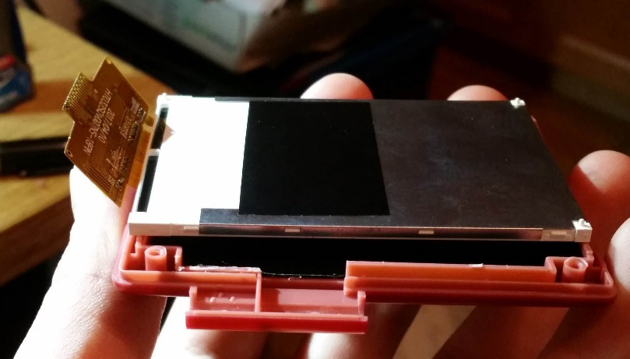

Figure 4 - 3.2in screen, back of screen shell

The 3.2 inch screen fits perfectly in the front part of the screen shell, but will require some trimming of the back of the shell to get it to fit properly.

So again, more tradeoffs, but nothing too difficult to overcome.

### Headphones Option

|  |  |  |
| --- | --- | --- |
| **Option** | **Pros** | **Cons** |
| Install headphone jack? | You have a headphone jack | Extra hole needs to be cut in the side of the case. This can ruin the “stock look” of the case |

### Button Option

|  |  |  |
| --- | --- | --- |
| **Option** | **Pros** | **Cons** |
| Add X and Y buttons? | Have full buttons for SNES emulation | Need to cut holes in the case for these buttons. Can be difficult to make it look nice, so ruins the stock look of the case |
| What type of buttons to use? | If you choose to do X and Y buttons, you do not need to use the GBA-SP A and B buttons as I do. You can find and use any buttons you wish, as long as they can properly press the tact switches on the AIO board | I have no idea what buttons to tell you to use. I have only used the SP A and B buttons, but I have no doubt someone can find better buttons and do a better job than me! |

**Basic build configuration:**

2.8 in SPI screen, 1500mAh battery, no X and Y buttons, with headphone jack

This is the build configuration I will be detailing in this guide.

**Most difficult build configuration:**

3.5 in composite screen, 2000mAh battery, X and Y buttons, no headphone jack

If you want a challenge, this is it! Everything will fit, and it is awesome when it is done, but there is a lot of soldering skill involved. I will not be describing this build here. If you really want a challenge then you can contact me for more details on how to do this build.

## Items Included in the Kit

The kit includes:

* The AIO board
  + AIO board includes button wells
* Ribbon cable to go to the screen
* All header pins necessary for assembly
* USB port
* Volume Slider
  + And the plastic piece that attaches to it
* GBA SP speaker
* Blank game cartridge

## Additional Items Needed

The AIO kit contains almost all the necessary electronics for the build. But there are some necessary items that are not included and are up to the builder to acquire.

Here’s what else you need to complete this build:

1. GBA SP shell, buttons, etc
   1. The shells all come as a kit, with all the hardware included. On Amazon you can also find the Philips and tri-wing screwdrivers included with the shell
2. Hinge mechanisms for the GBA SP
   1. These are not usually included in any shell kit
3. Raspberry Pi Zero W and SD card
   1. The W version is important for connectivity to set everything up
4. Battery
   1. A known fitting battery is the 1500mAh 803450 size battery. This is where I purchased mine from: <https://www.ebay.com/itm/3-7V-1500mAh-Lipo-polymer-li-ion-Battery-For-mobile-phone-MP5-camera-PAD-803450/182100726138?ssPageName=STRK%3AMEBIDX%3AIT&_trksid=p2057872.m2749.l2649>
   2. Bigger batteries will fit, but there are compromises. 2000mAh can be fit, but this doesn’t allow the headphone jack, and connectors need to be desoldered from the Pi
5. Screen
   1. There are many options for a screen to purchase. There is a SPI screen option, or composite screen. I highly recommend using the SPI screen. The screen must be:
      1. Either 2.8 in or 3.2 in
      2. Use the 4-wire SPI setup for the ILI9341 driver IC
      3. Either the 18-pin solder version, or be mounted to a driver board with all the SPI connections available to solder on wires
6. Heatsink
   1. Not necessary but recommended. These ones fit well: https://www.amazon.com/Raspberry-Copper-Cooling-Heat-Sinks/dp/B00RKJG2HY/ref=sr_1_18?ie=UTF8&qid=1529775873&sr=8-18&keywords=raspberry+pi+heatsink

These pieces are the bare minimum necessary for this build. This does not include the extra pieces necessary for the X and Y button addition. If you are adding X and Y buttons, you will also need:

1. A second button set (GBA SP A and B buttons if using the provided button wells)
2. The rubber button piece for the A and B buttons (or anything else necessary for your button choices)

## Necessary Tools

Figure 5 - Necessary tools

|  |  |
| --- | --- |
| **Tool** | **Comments** |
| Kapton Tape | Good for everything! Make sure you have plenty of this available |
| Super Glue | Used for holding together the game cart and volume slider |
| Solder | Be sure to get good solder. Review this forum thread by Helder:  http://www.sudomod.com/forum/viewtopic.php?f=34&t=4106 |
| Desoldering braid | Needed to remove solder from AIO board pads |
| No-Clean Flux pen | Keeps all the solder joints clean |
| Sewing needle | For marking X and Y button locations, and aligning riser boards |
| Thumb tack | For making X and Y button mark larger/deeper |
| Small drill bit (1/16 in) | Starting X and Y button holes |
| Step drill bit (with 11/32in or 9mm step) | For cutting X and Y button holes |
| X-acto knife | The case needs a lot of trimming, x-acto knife cuts the soft plastic nicely |
| X-acto refill blades | You’ll go through quite a few! |
| Philips screw driver | For the Philips screws |
| Tri-wing screw driver | The external screws that come with the shells are the Nintendo tri-wing screws |
| Flush cutters | For cutting wires and separating the AIO board |
| Needle nose pliers | For bending leads on the volume slider |

# Build Steps

## Software Installation (SD card prep)

Before soldering the Pi to the AIO board, it’s important to first get the SD card setup, and confirm that everything is functioning properly.

Everything should work well on the latest version of Retropie, which as of right now is version 4.4. So to get everything installed and setup, follow these steps. You will need a micro SD card adapter, a way to connect the Pi to an HDMI screen, a keyboard with the proper USB OTG adapter, and a power supply to power the Pi.

1. Download the latest version of Retropie: <https://retropie.org.uk/download/>
2. Write the Retropie image to your SD card (use win32diskimager or something similar, there are lots of tutorials available on how to get Retropie onto your SD card)
3. Insert the SD card into the Pi, plug in the keyboard, HDMI, and then power
4. Let everything expand and reboot. Once Retropie fully boots, you should be presented with the controller setup dialog.
   1. Map the controller keys to these keyboard keys (basically identical letters on the keyboard)
      1. Up = Up
      2. Down = Down
      3. Left = Left
      4. Right = Right
      5. Start = Enter
      6. Select = Right Shift
      7. A = A
      8. B = B
      9. X = X
      10. Y=Y
      11. Left Shoulder = L
      12. Right Shoulder = R
      13. Skip the rest of the inputs (hold down the Enter key is easiest)
      14. Hot Key = Right Shift (the select button)
5. Connect to WiFi
   1. Go into Configuration (use the A key) and select WiFi setup
   2. A prompt should come up saying it needs your WiFi country
      1. Select Yes, scroll down to Localisation Options, select Change Wi-Fi Country, and select your country. Then select finish to return to the WiFi setup
   3. Select Connect to WiFi network, choose your home network, and type in your password
   4. Once that’s done, select Finish to return to the Retropie menu
6. In the Retropie configuration menu, select Raspi-Config
   1. Select Interfacing Options
      1. Select Serial, and say No to having the login shell accessible over serial
      2. Select Yes to enable the serial port hardware
      3. Select SSH, and enable the SSH server (this is needed for easy ROM transfers over WiFi)
   2. Go to Finish to exit Raspi-Config
      1. Select Yes to reboot
7. Once it has rebooted and you’re back at the main menu, press F4 to go to the command line. It’s time to install the necessary custom code pieces. Type the following commands:
   1. git clone <https://github.com/codeman0624/GBA-SPi>
   2. cd GBA-SPi/Setup
   3. sudo chmod 777 Installer.sh
   4. sudo ./Installer.sh
   5. When it’s all done, choose yes to reboot

## Raspberry Pi Prep

First let’s get the Pi prepared. The upper left corner of the board needs to be cut out. Just remove the area of the mounting hole, and you’re safe. Like the picture below:

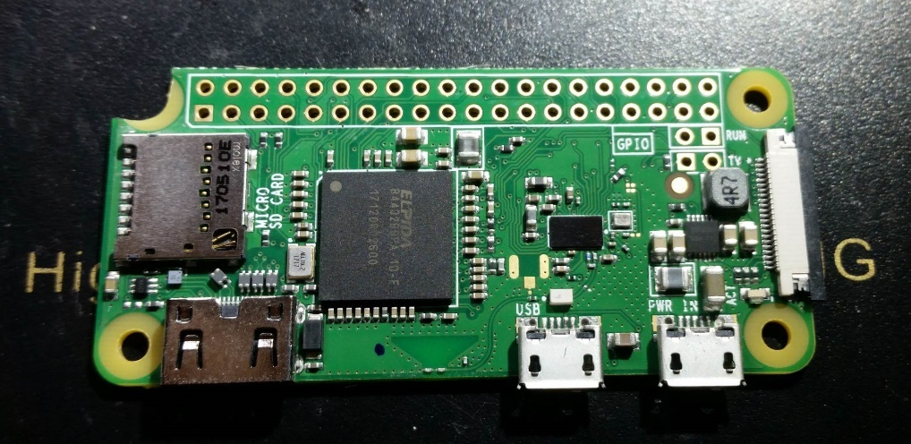

Figure 6 - Remove corner of the Pi

Next take a sharp x-acto knife and trim a small amount of the USB pad shown in the picture below. Only need to remove ~0.5mm, just enough to keep the pad away from the ground connection next to it.

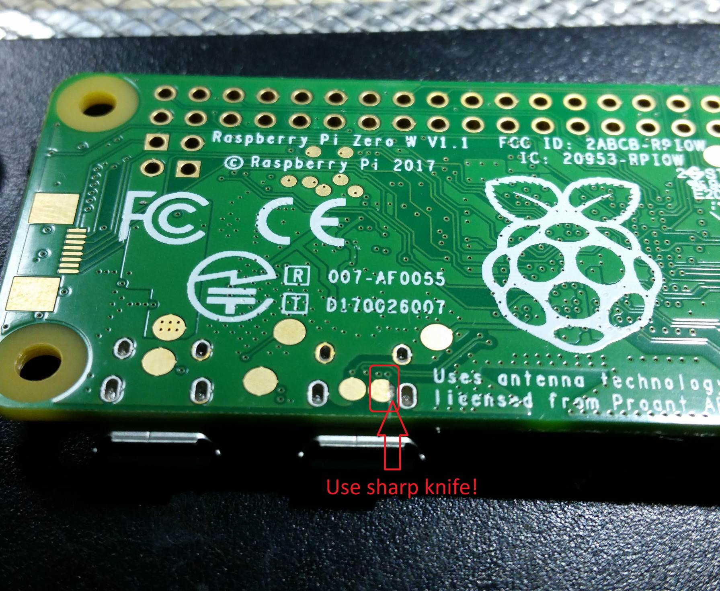

Figure 7 - Trim Pi USB pad

Next put a piece of Kapton tape over the back of the Pi. Using a sharp knife, open up the areas around the USB pads.

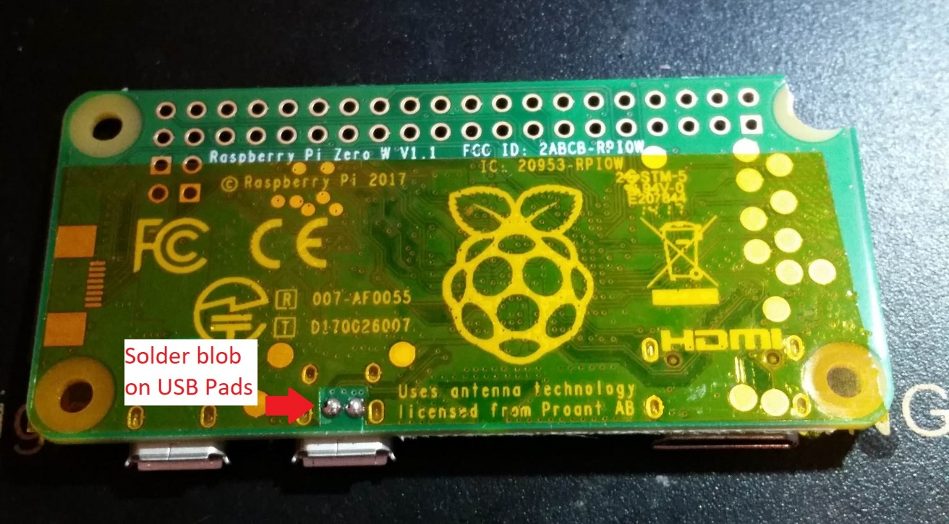

Figure 8 - Pi Kapton tape and solder blobs

## Preparing components

A few of the electronics components need to be prepared, so we might as well get that out of the way first.

### Volume Slider

First take the volume slider, and using the needle-nose pliers, gently bend the pins in the back so they are flat. Leave the middle pin vertical. This is shown in the picture below

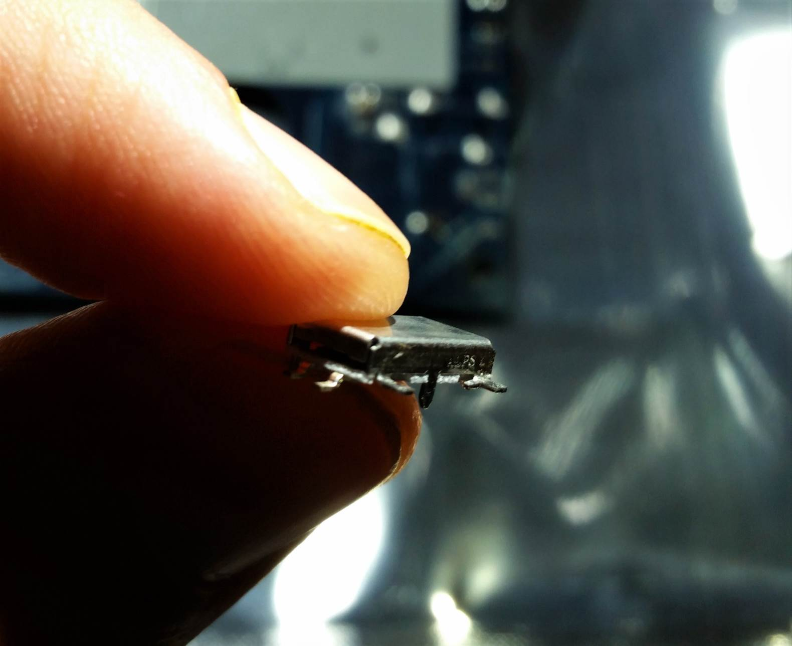

Figure 9 - Bend volume slider pins

Next use your knife to trim the plastic protruding off the back of the volume slider plastic piece, as shown below.

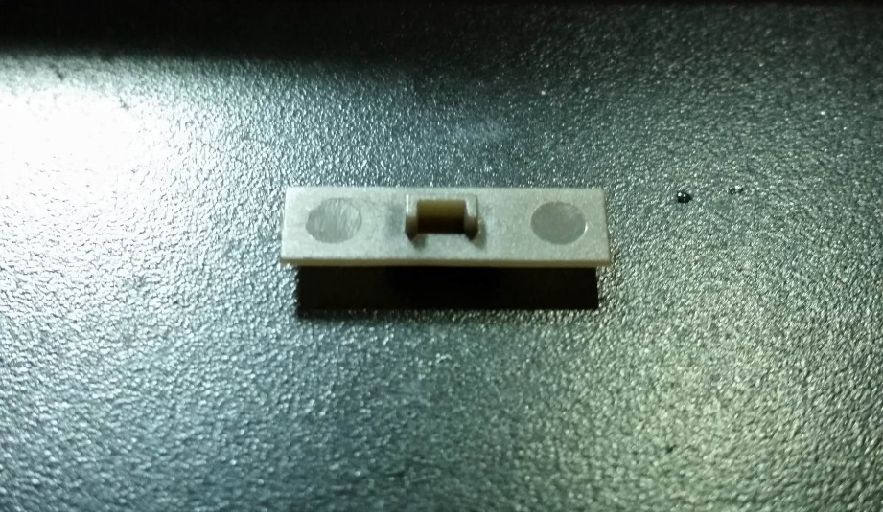

Figure 10 - Volume slider plastic before trimming

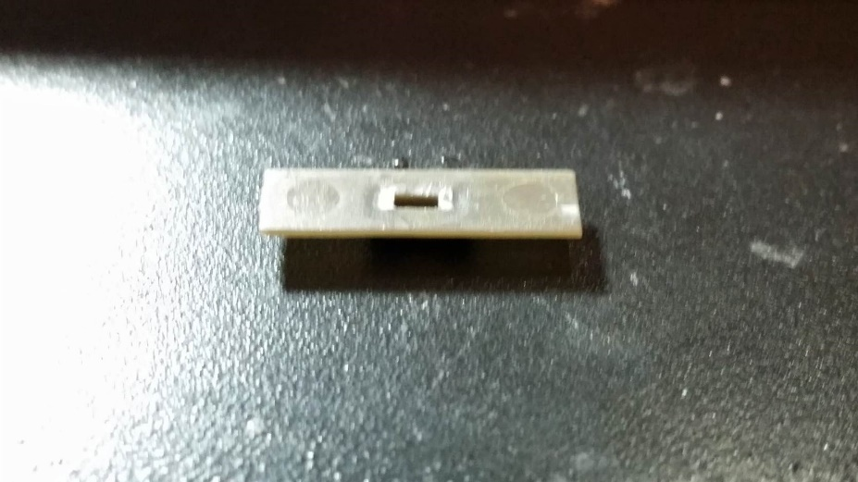

Figure 11 - Volume slider plastic after trimming

Then put a small bit of super glue in and around the hole of the plastic piece. Be careful not to use too much, if the glue oozes out and accidentally glues the slider so that it can’t move, you’ll be in trouble.

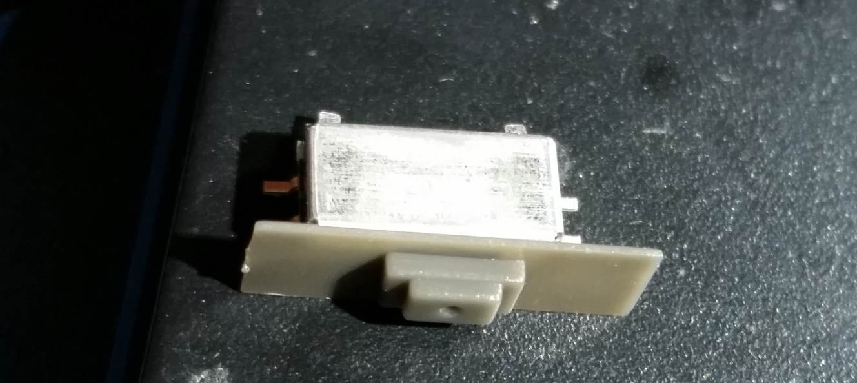

Figure 12 - Volume slider pieces glued

### USB Port

The USB port is easy to modify. Just trim the small metal bits protruding from the bottom. These normally would go through holes in the PCB, but we don’t have space to put those holes, so they need to be trimmed.

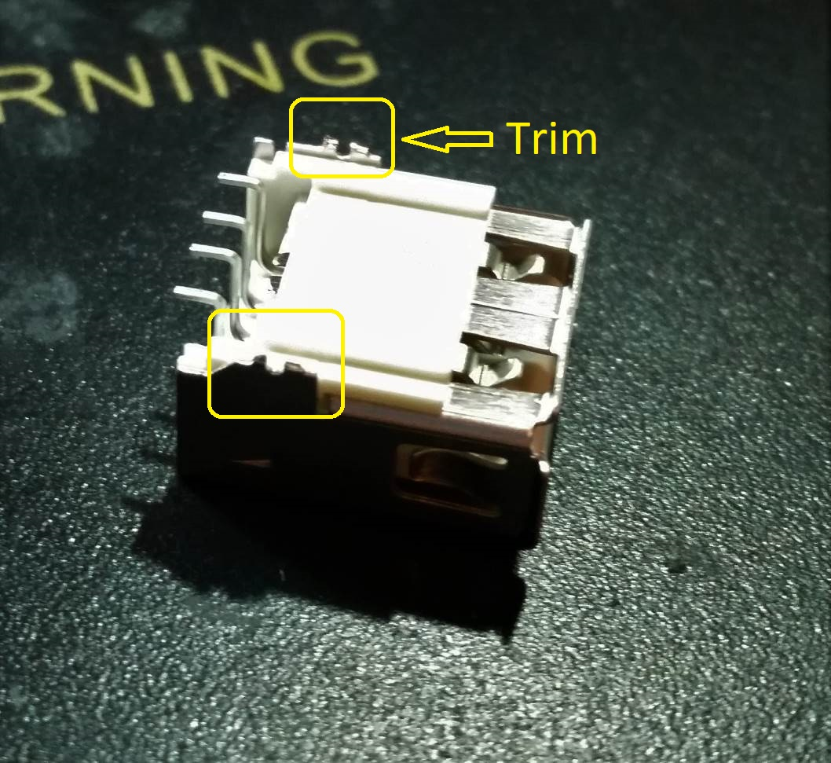

Figure 13 - Trim USB port metal

## Case Modifications

The case modifications require a Dremel, a **sharp** x-acto knife, and some patience. This section will not cover what is required for the X and Y button modifications, just what is required to get everything to fit properly.

### Front shell

The front part of the shell does not need much for modifications. First off trim this tiny piece of plastic circled in the picture below. It interferes with one of the components on the AIO board

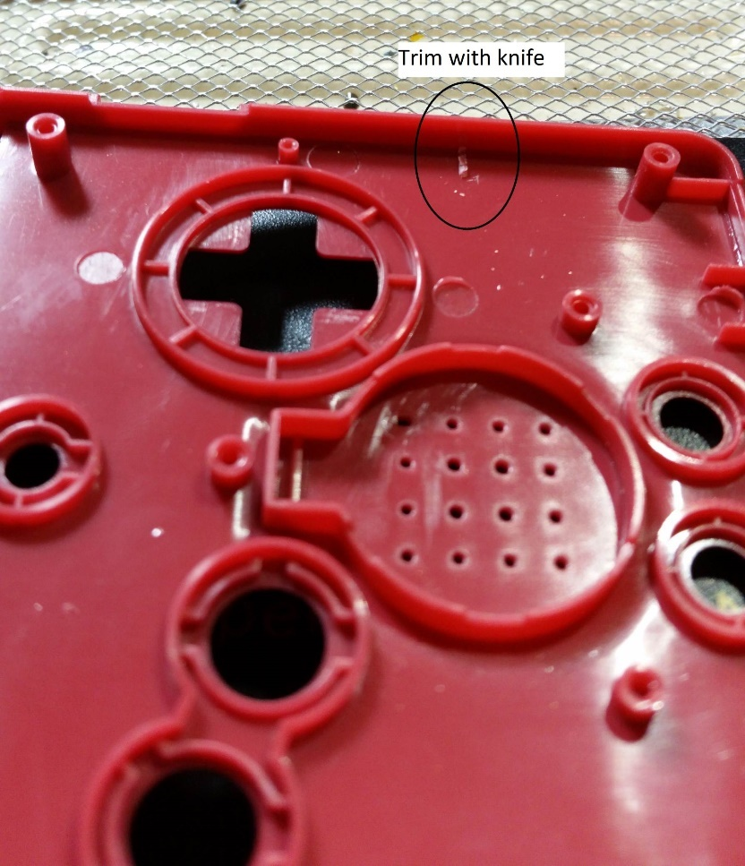

Figure 14 - Front shell, trim interfering plastic

Next use the knife to open up a wider hole for the ribbon cable. Be sure not to cut too far! I made that mistake in the picture below, and this messed up an important piece on the inside of the shell that I needed to repair.

Don’t go beyond the left-right boundaries of the existing hole. Just open it up top-bottom.

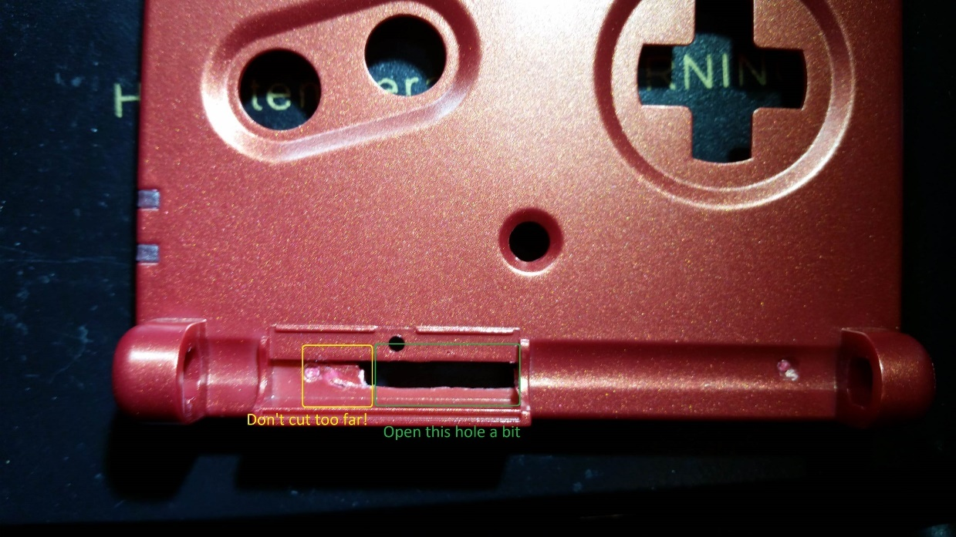

Figure 15 - Front shell, open ribbon cable hole

That’s it for modifying the front half of the shell, not much to it. But don’t hide this part away just yet, we’ll need to come back to this soon for X and Y button markings.

### X and Y buttons

If you are planning to install X and Y buttons, now is the time to mark where the holes need to be cut. For version 1.0, a full extra blank board is included, to use as a drill template. In version 1.1 a separate drill template is included.

Put the drill template into the front shell. Put a sewing needle through each of the holes to make a small mark on the plastic.

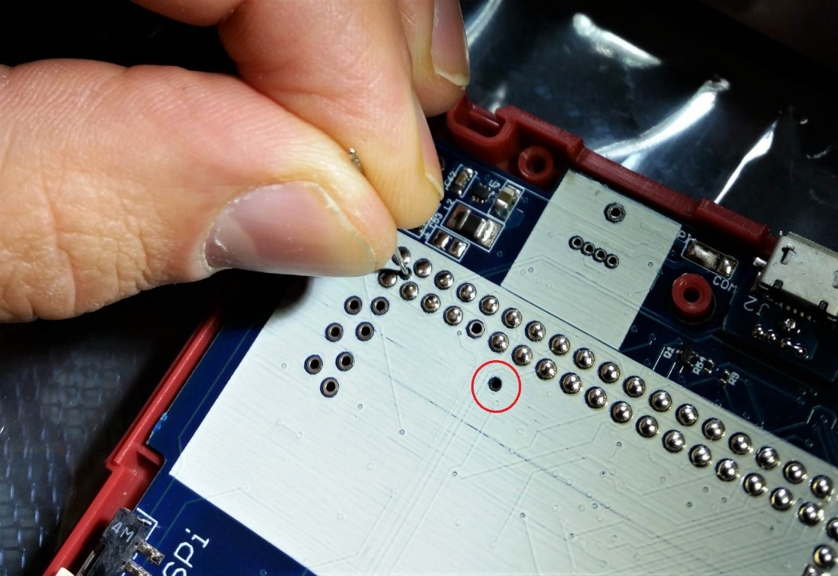

Figure 16 - Marking where X and Y button holes go

Use a thumb tack to make the markings more pronounced.

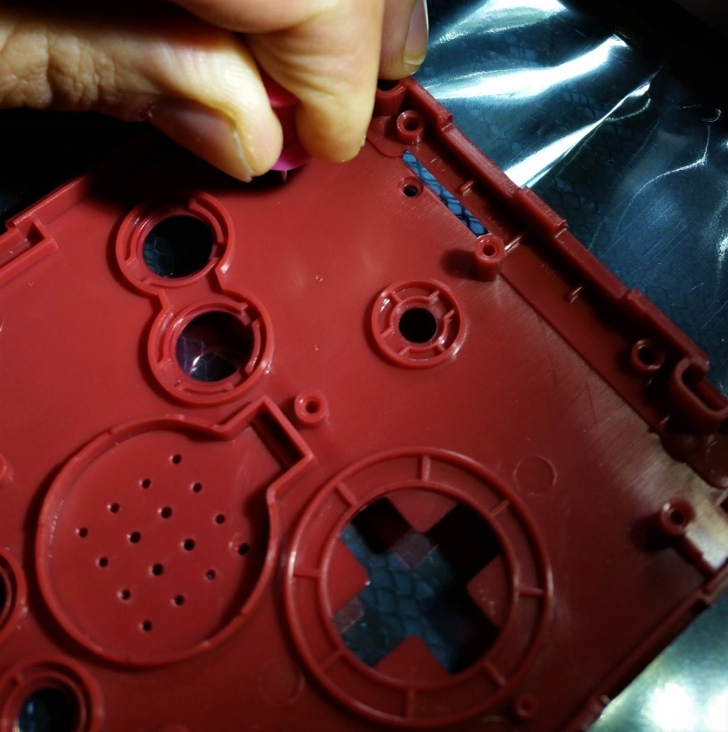

Figure 17 - Make X and Y markings more pronounced

For now, since the markings are in place, we can move on with the build and come back to finishing the X and Y buttons later.

### Back shell

The back shell needs more careful modifications. The markings in the picture below show the area to make the rough Dremel cutout.

Be careful of the points circled! These are the holders for the L and R button springs, so be very careful around these, they can’t be replaced or repaired.

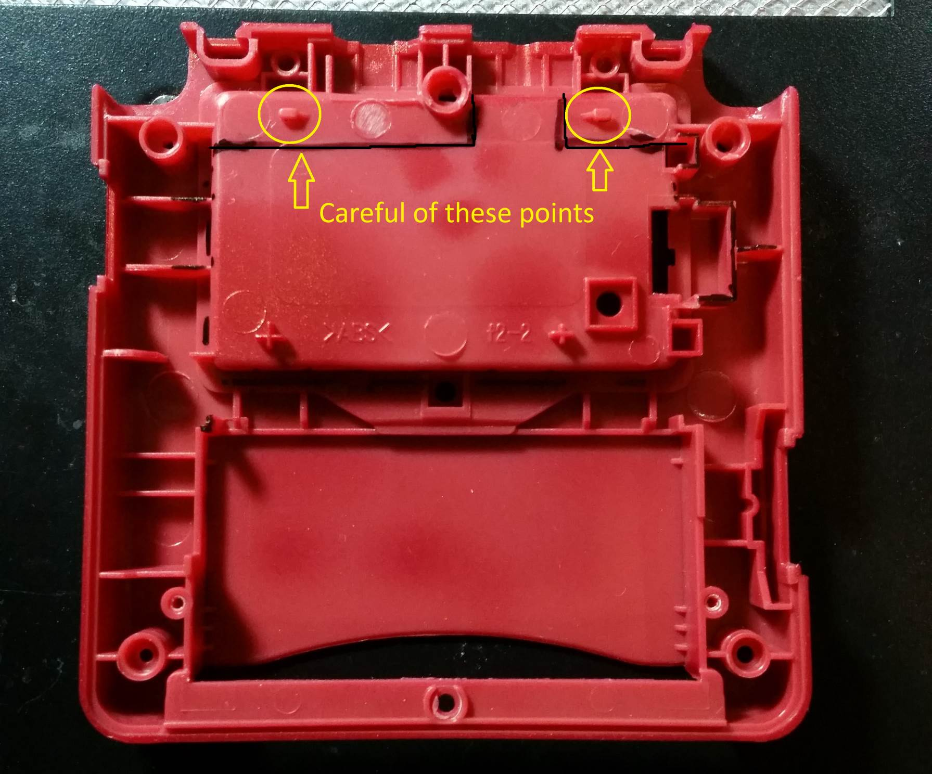

Figure 18 - Back shell cutout markings

The finished result should look like the picture below.

The red arrow shows the point I used when determining how thin to leave the plastic. You do not want to go any thinner than this point, so you can still use the screw for mounting the back cover.

The yellow sections show where it’s best to trim with a knife. Be patient with the screw mount in the upper right. It can be difficult to cut through. But just shave it small layers at a time, and eventually you’ll get it flush. **Do not cut past this point**, otherwise the case screw will not have anything to hold.

The black section is where the USB port will go, this will require more careful shaving.

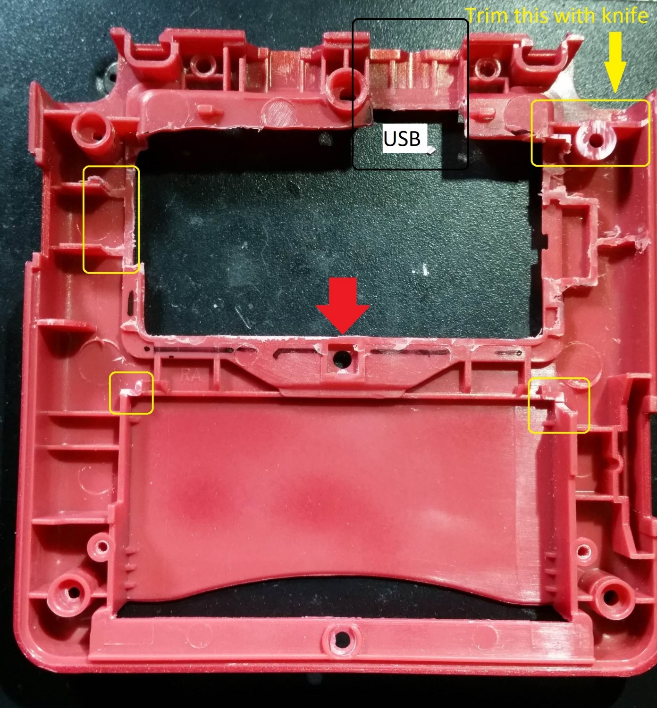

Figure 19 - Back shell, cutting results

Next we need to prepare for the USB port to fit. Start by shaving down the plastic shown in the picture below. Use a sharp knife, and just remove small layers at a time. Be careful not to cut all the way through. The goal is to just make this area thinner, so the USB port will fit better.

In the picture below you can see where it has been shaved slightly. But the amount shown is not enough.

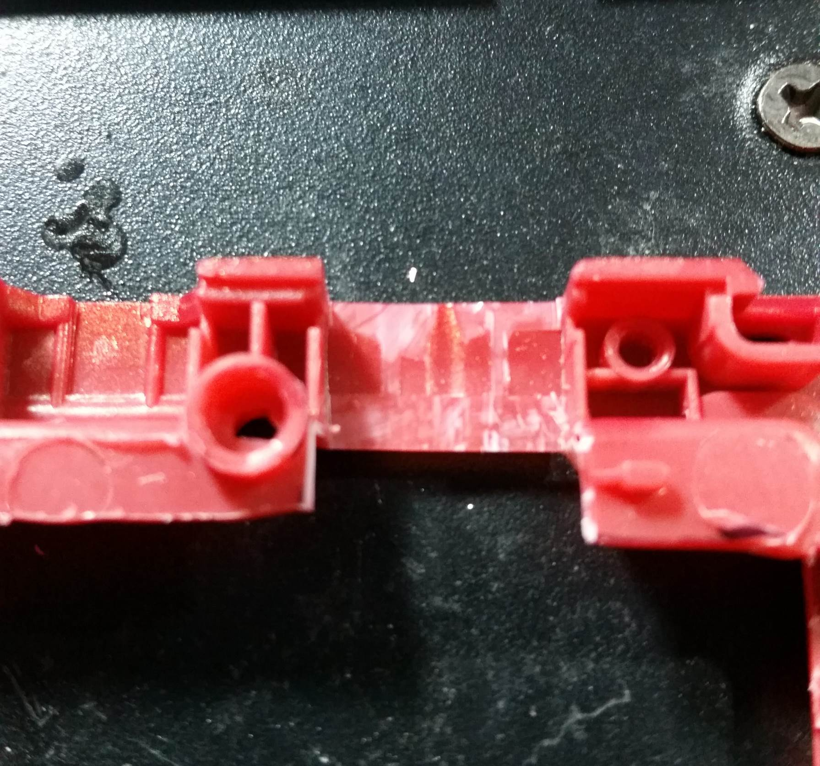

Figure 20 - Shave plastic for USB port

The USB port is just barely too wide, maybe by 1mm max. Put the USB port up to the opening, and check where the rest of the plastic needs to be trimmed.

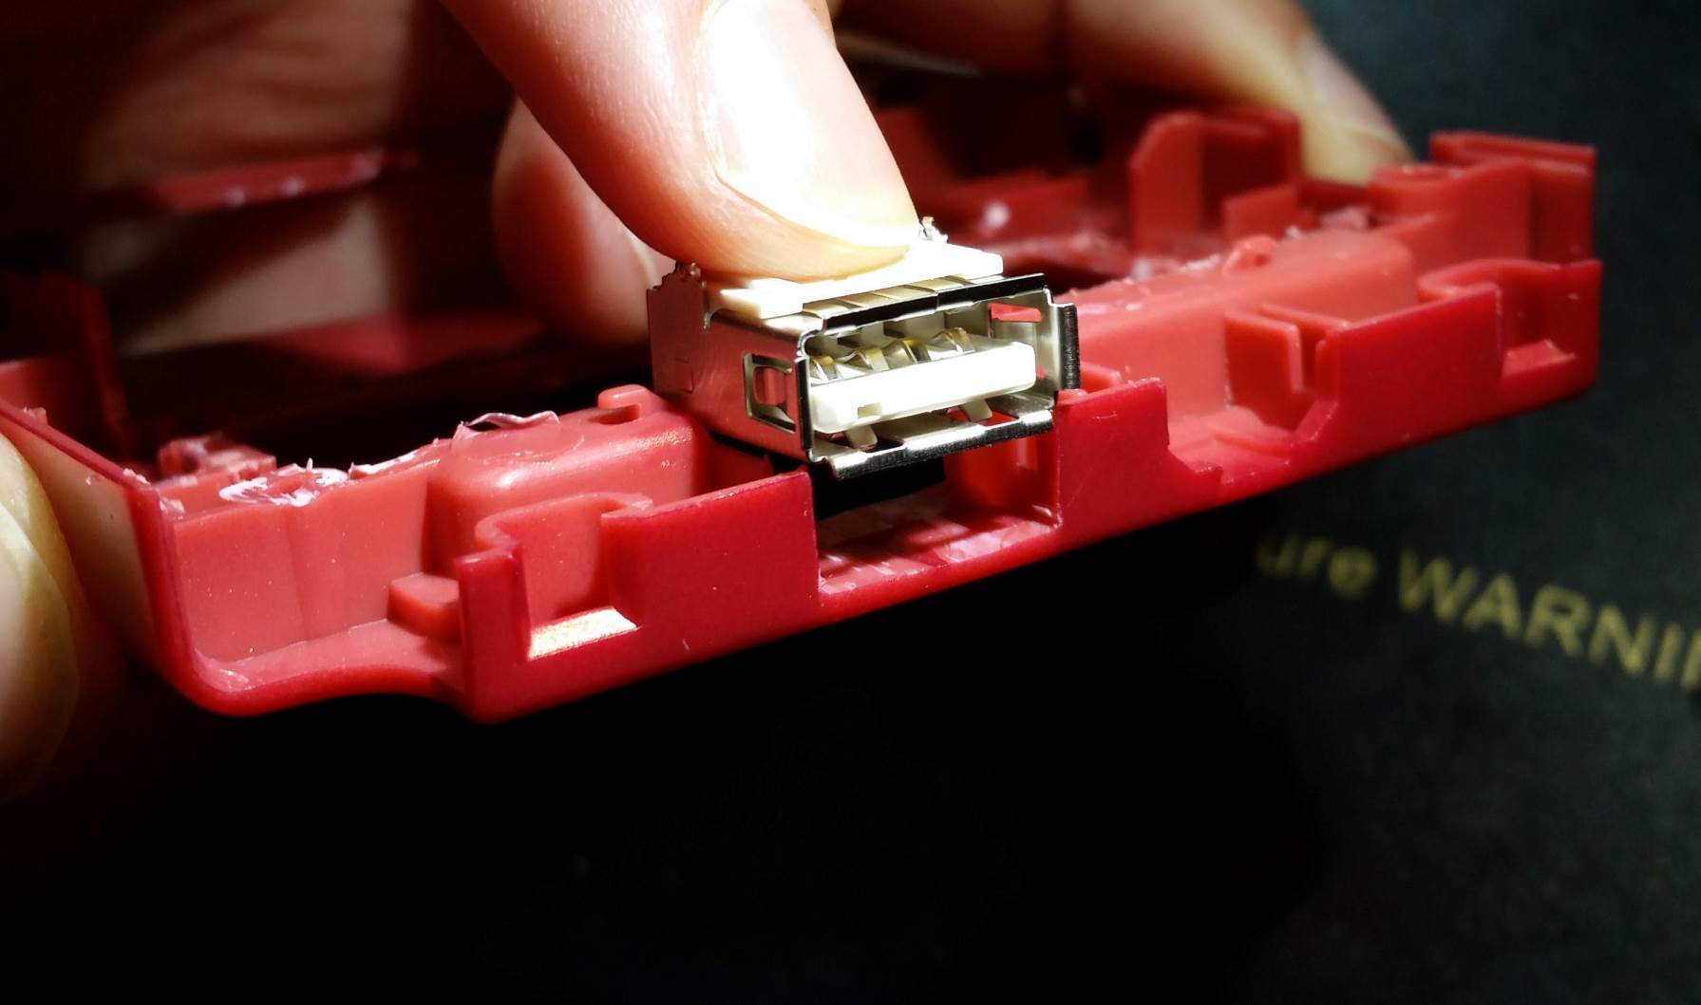

Figure 21 - Check where to trim for USB port

SLOWLY and CAREFULLY trim the necessary plastic to open up the USB port. I mentioned patience is necessary, this is when to put that into practice. Cutting too far will ruin your day. So slowly trim the plastic until the USB port fits like in the picture below.

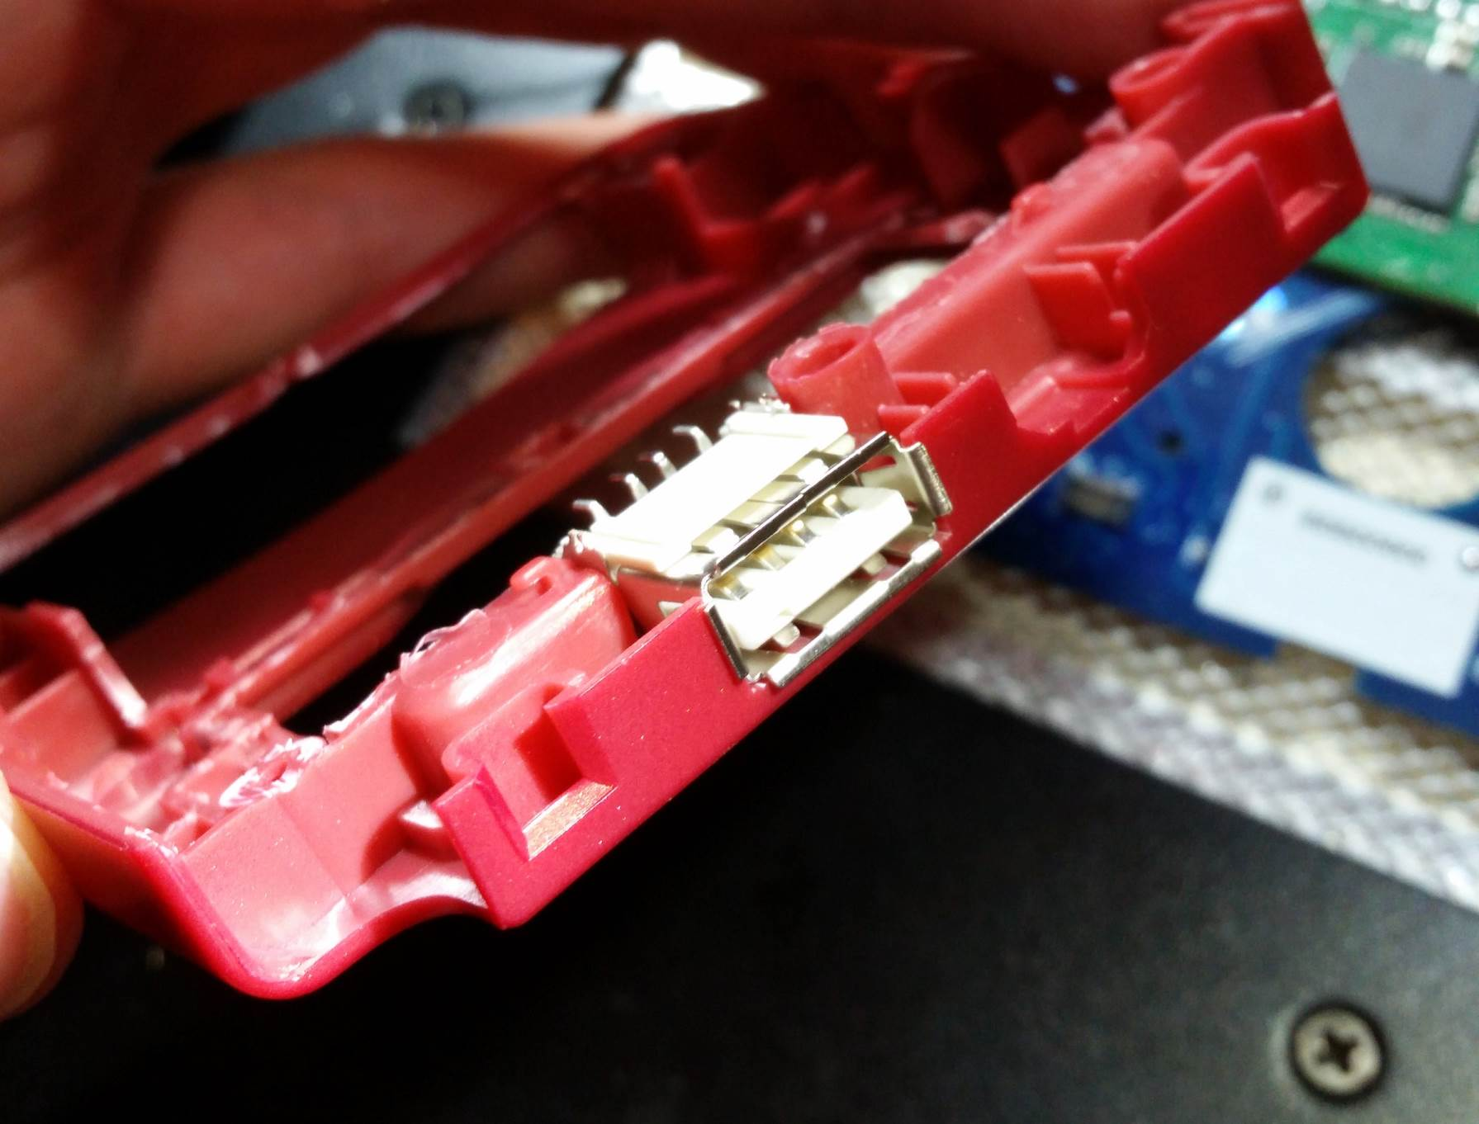

Figure 22 - USB port fit into shell opening

Also, using your X-acto knife, trim a little bit of the plastic bit shown in the picture below. This will allow the battery to sit more flush to the PCB, so the case will close better. It may not look like much, but when getting everything to fit into this case ever millimeter counts.

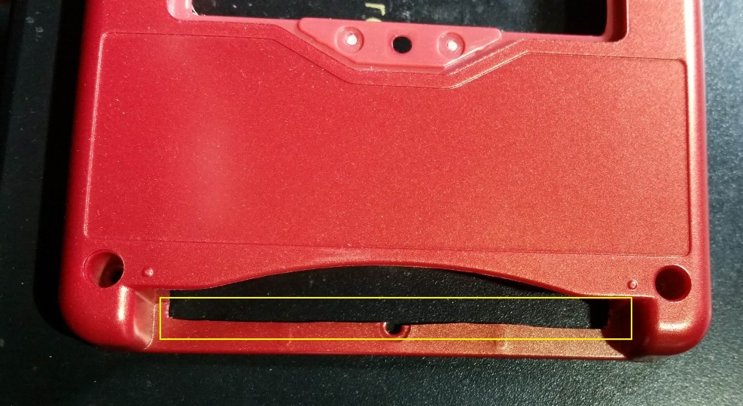

Figure 23 - Trim cart slot plastic

### Screen shell

The shell for the screen is easy to modify. Just shave the small section shown in the picture below. This is simply so the ribbon cable coming through here does not get pinched.

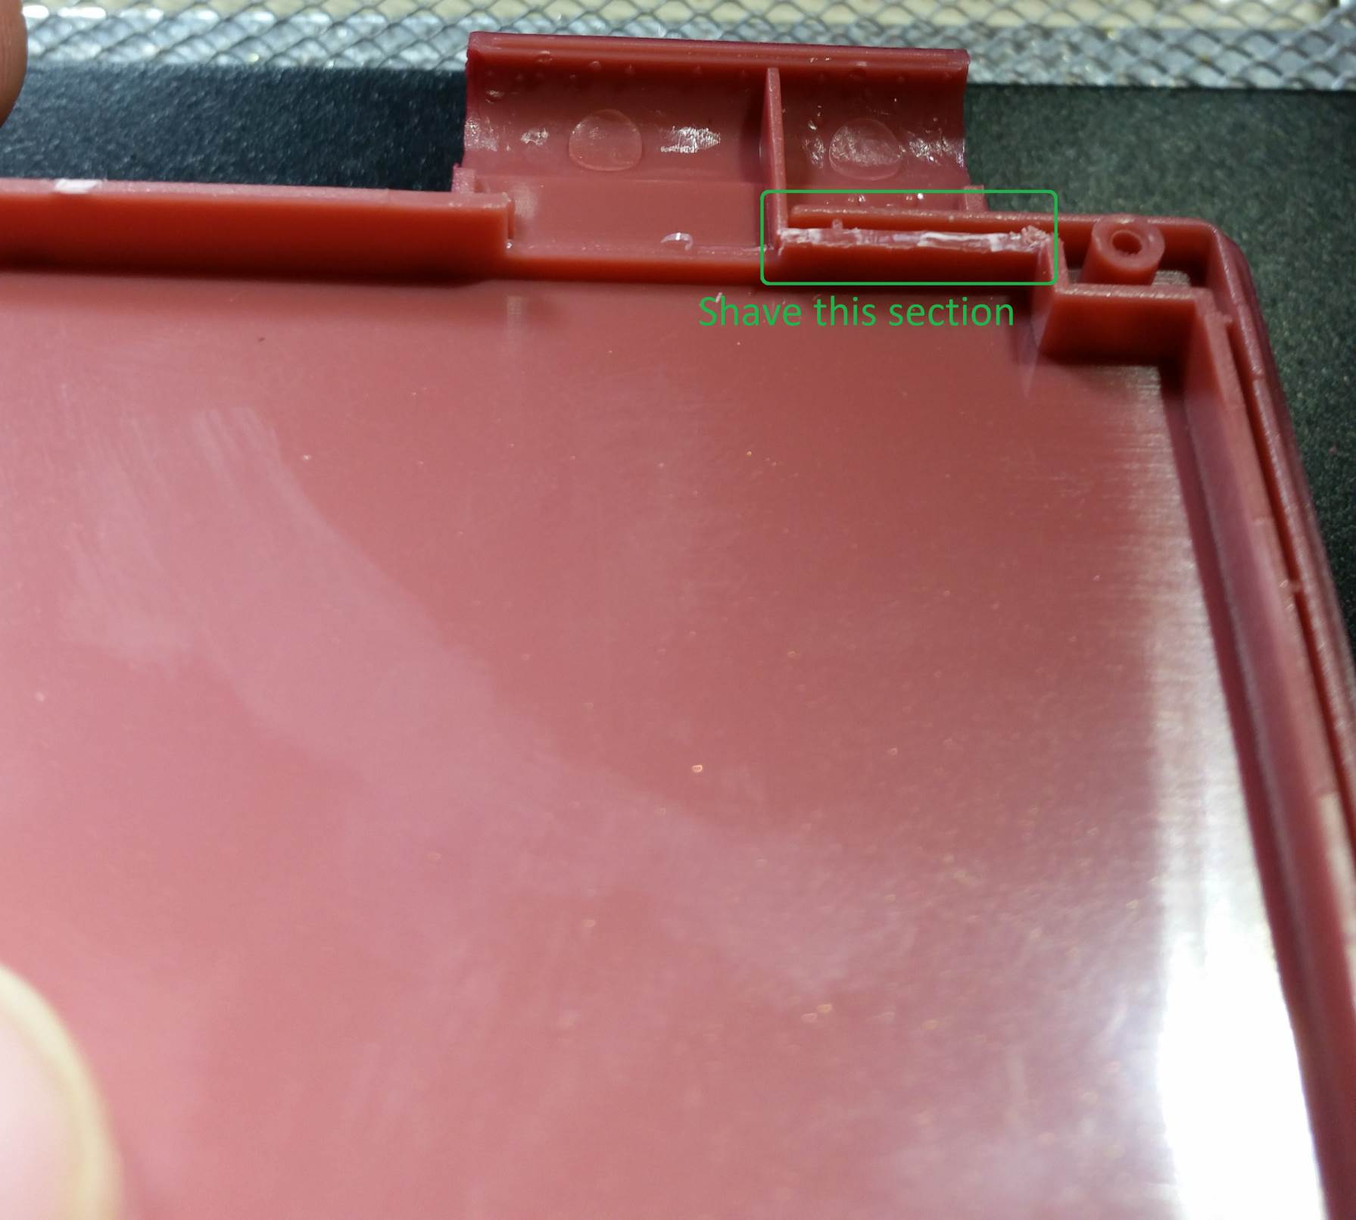

Figure 24 - Screen shell modification

## Preparing the AIO board

It’s finally time to move on to the AIO board itself. First step is to use the flush cutters to separate all the pieces.

### Separating PCB pieces

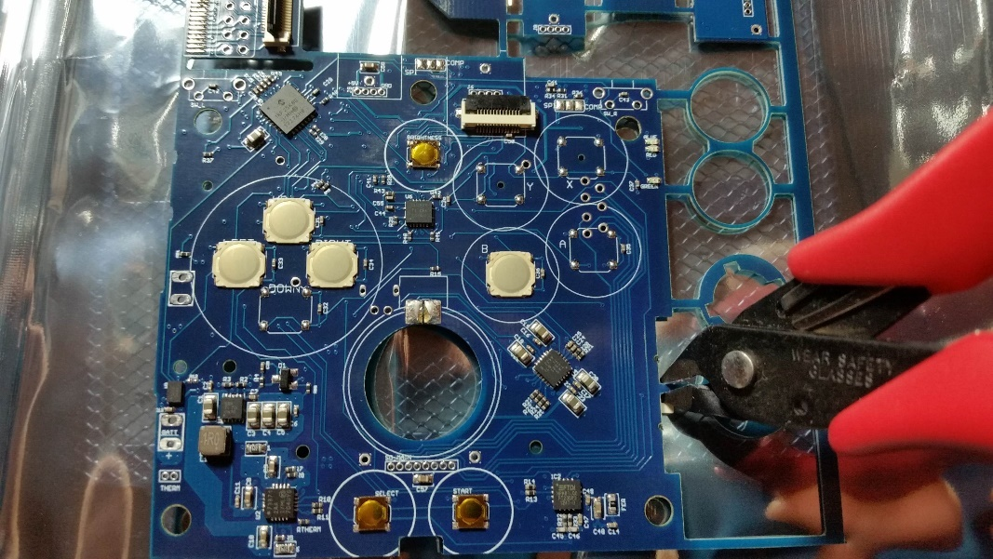

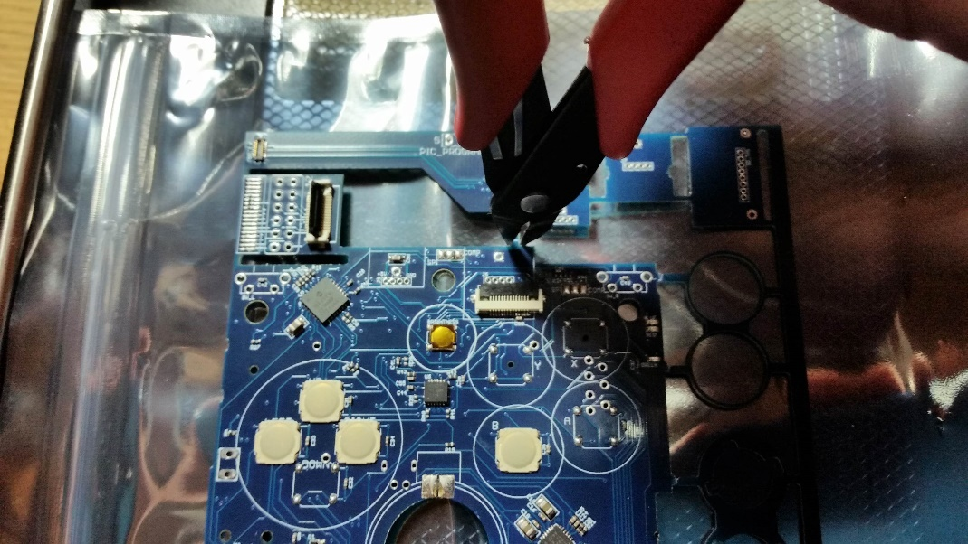

Figure 25 - Separate the board pieces

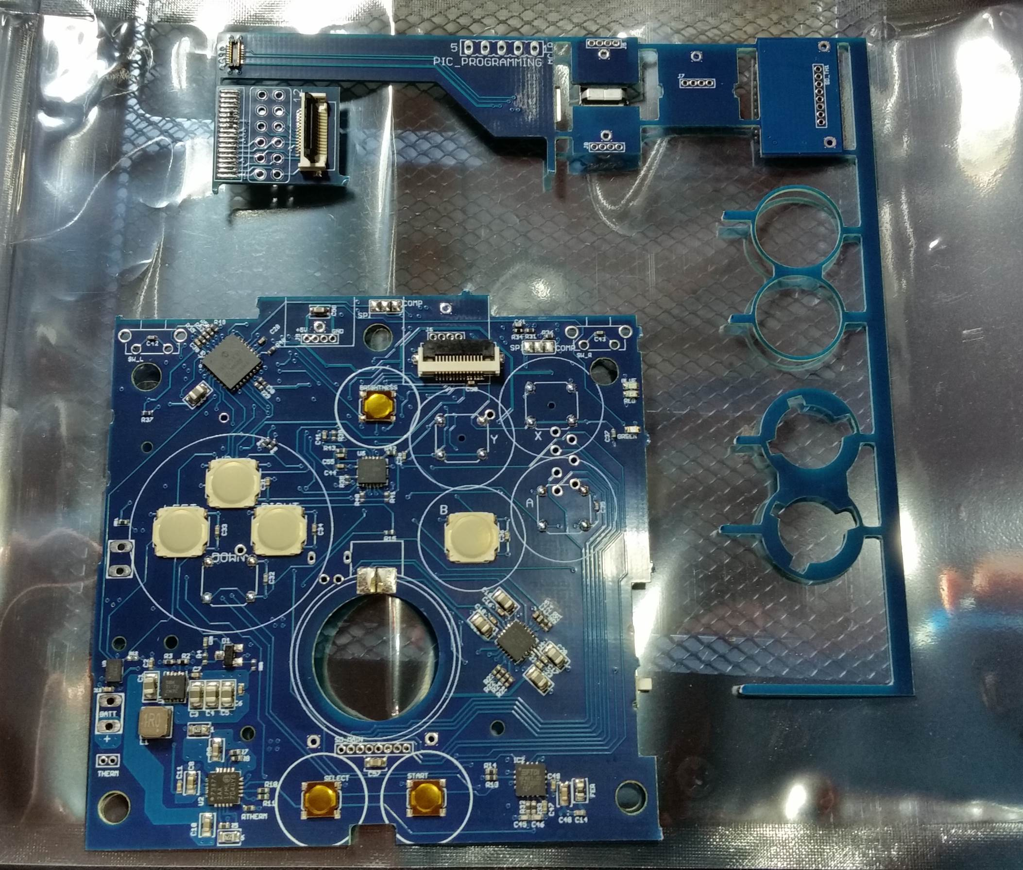

Figure 26 - Separated main board

Once the main board has been separated, carefully clip the pieces holding the rest of the board parts together. **Be careful around the thin circle pieces!** They are fragile and will break easily.

### Trim extra PCB pieces

Once the pieces are separated, use the flush cutters to remove the small nubs of PCB that is left over (avoid the circle pieces for now). Don’t be afraid to cut close to the board, as shown below

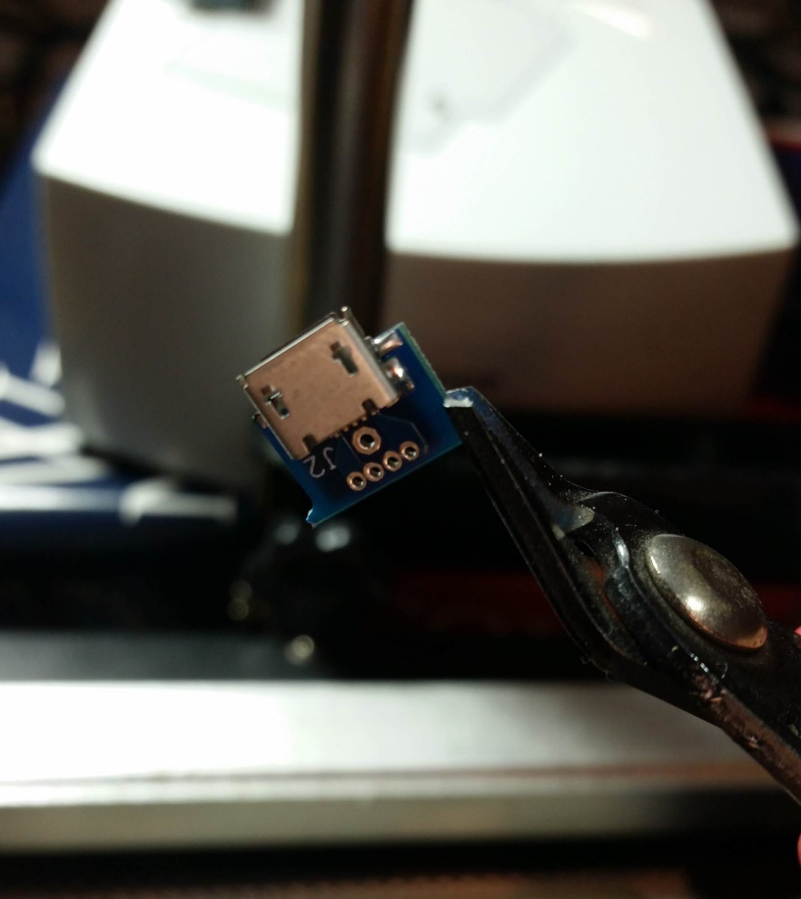

Figure 27 - Cut PCB nubs

Be sure to remove these extra PCB pieces from the main board as well, try to get them as smooth as possible, as shown in the pictures below.

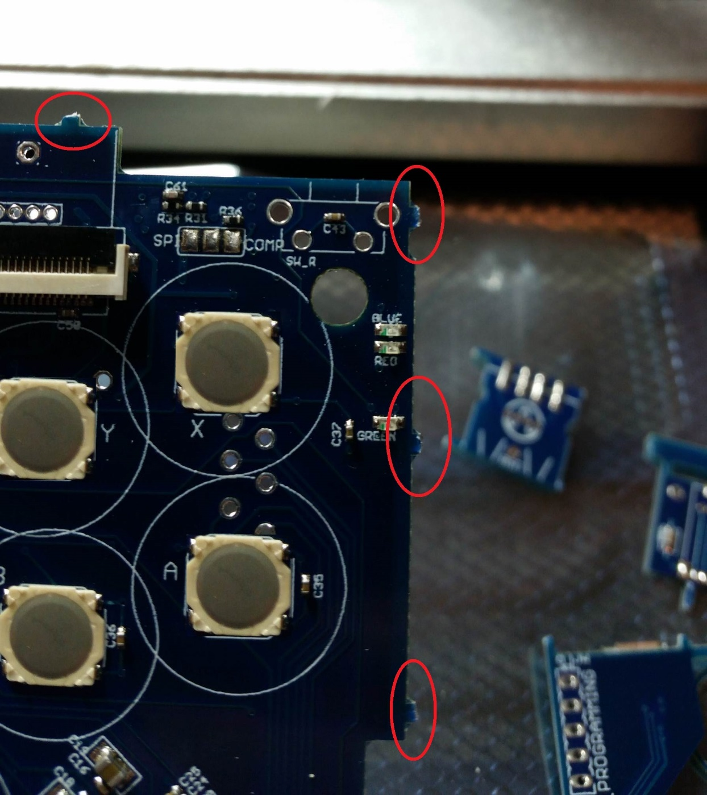

Figure 28 - PCB pieces to remove

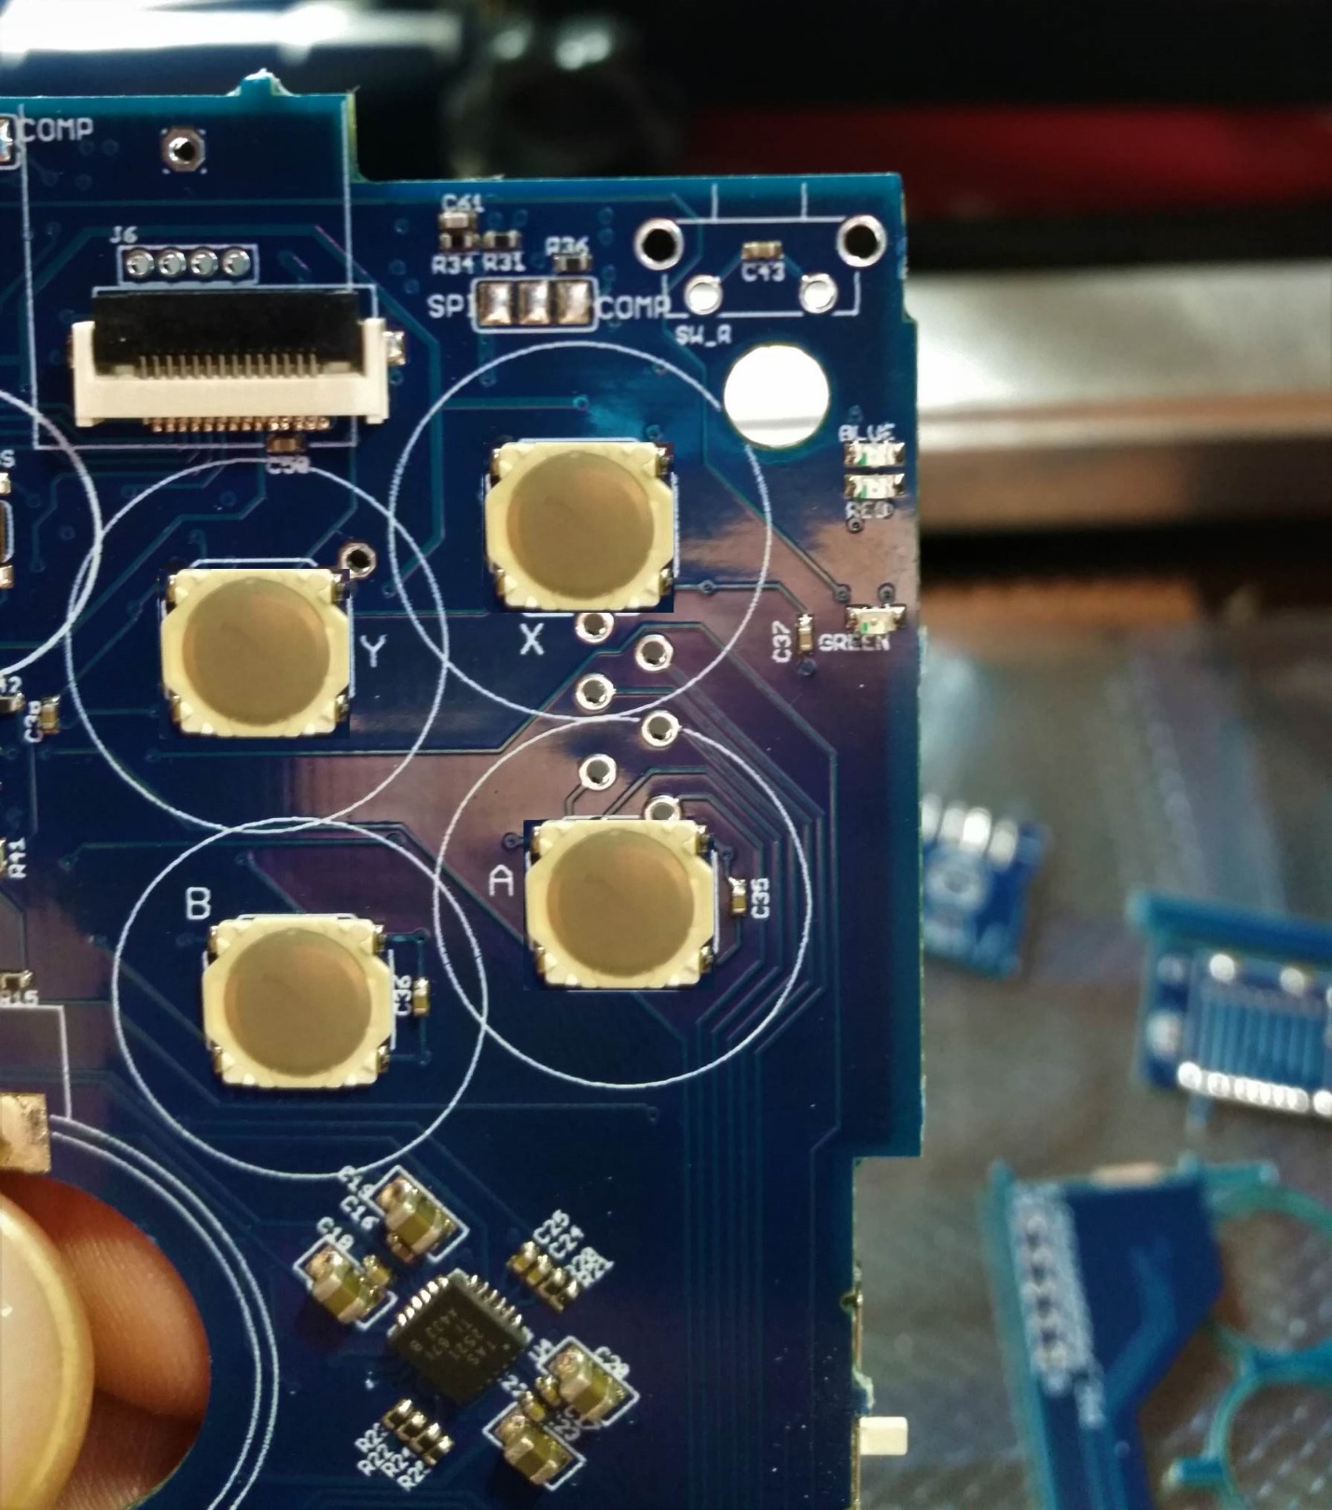

Figure 29 - Smooth PCB after pieces removed

## Desoldering

Some components are not already assembled on the board, but during the assembly process they get some solder blobs on their pads. We need to remove this excess solder so we can properly assemble the components.

To do this, you need some good quality desoldering braid. Then use the braid to desolder all the pads for the volume slide, headphone jack, and the speaker pads. Before and after is shown in the pictures below.

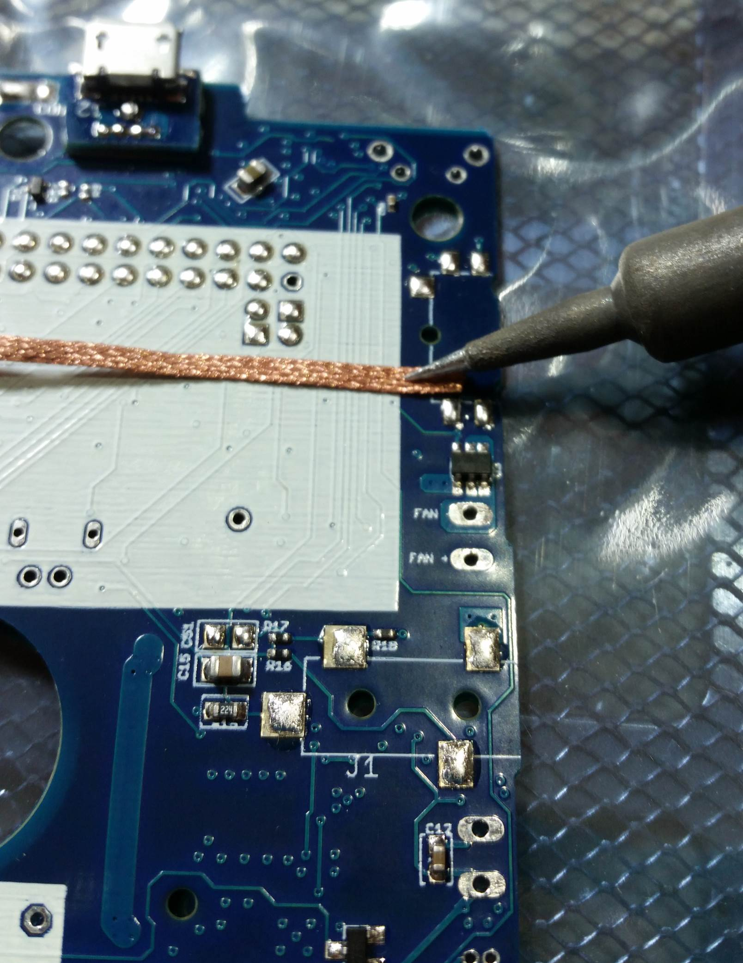

Figure 30 - Desoldering the volume slider

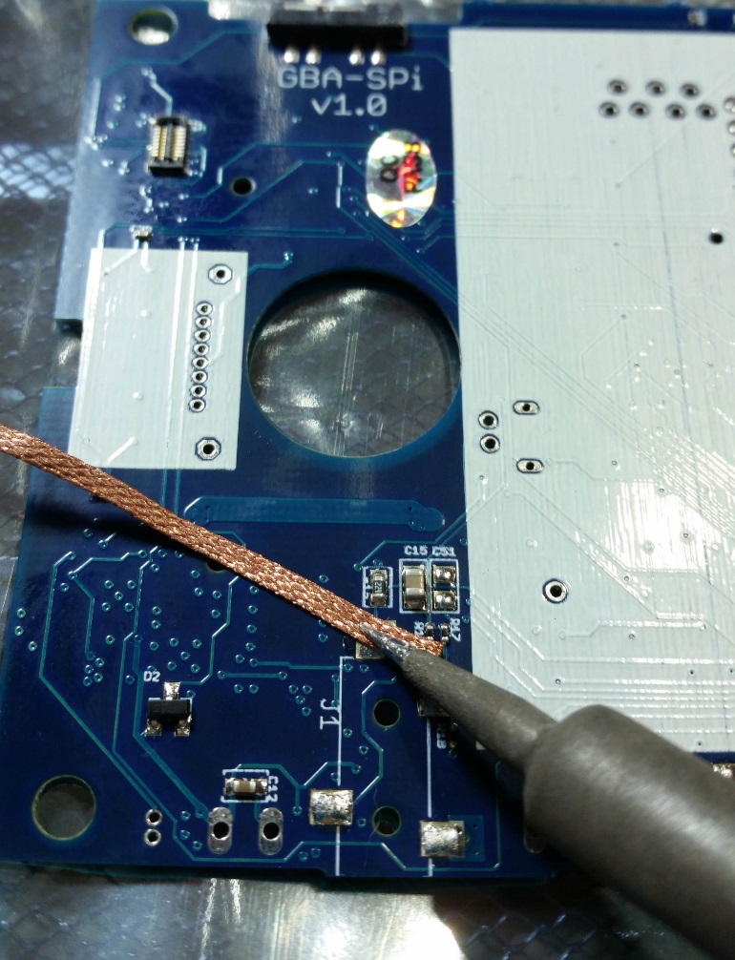

Figure 31 - Desoldering the headphone jack

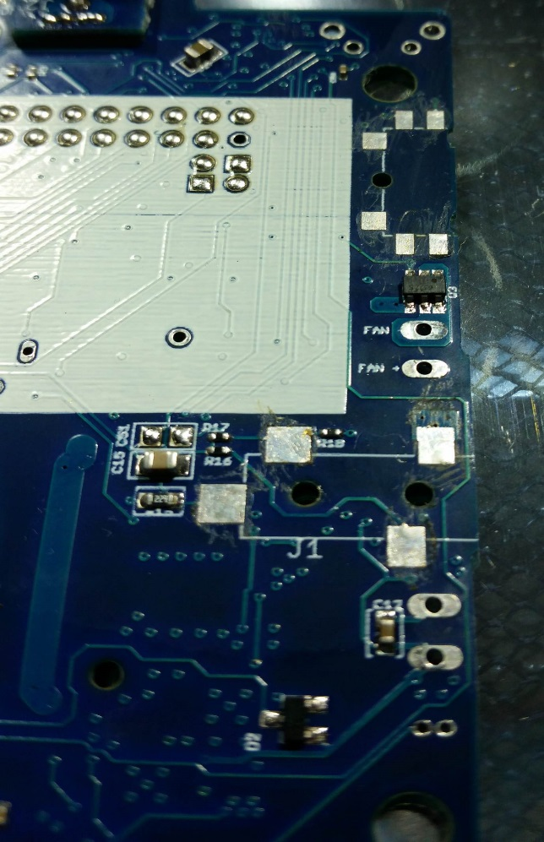

Figure 32 - Solder removed from volume slider and headphone jack

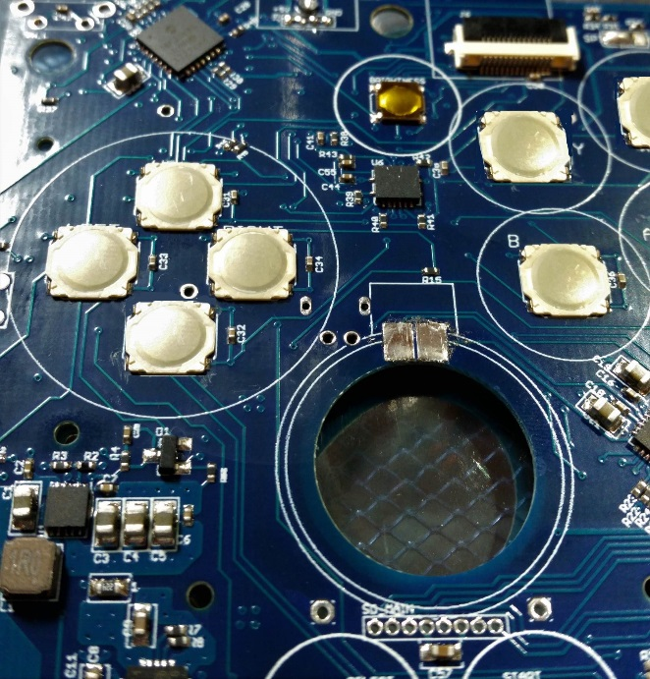

Figure 33 - Solder removed from speaker pads

## Micro USB power port

First thing to assemble on the board is the power port. Power is needed in order to test everything on the board, so this is a good first step.

First cut off a single pin from the provided pin header, as shown in the picture below.

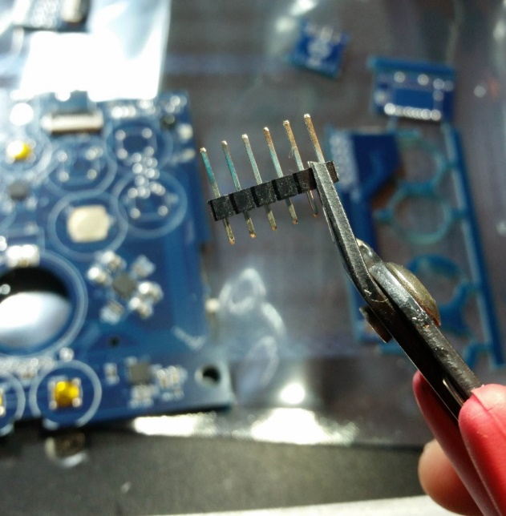

Figure 34 - Cut off a single pin

This pin will be used for holding the power port boards in place when soldering. It will also help with strain relief on the power port boards when inserting and removing the micro USB cable.

The power port is made up of two small boards. There’s the board with the actual micro USB port, and a small riser board of the same shape. These are shown in the AIO board pictures at the beginning of this manual.

Put the pin through the two boards, and through the main board. Pinch the pieces together and hold them in place. Put a blob of solder on the iron, and apply that solder to connect the pin to the board, as shown below. This solder joint can be ugly, we just want it to hold the pin in place, so it holds the boards in place.

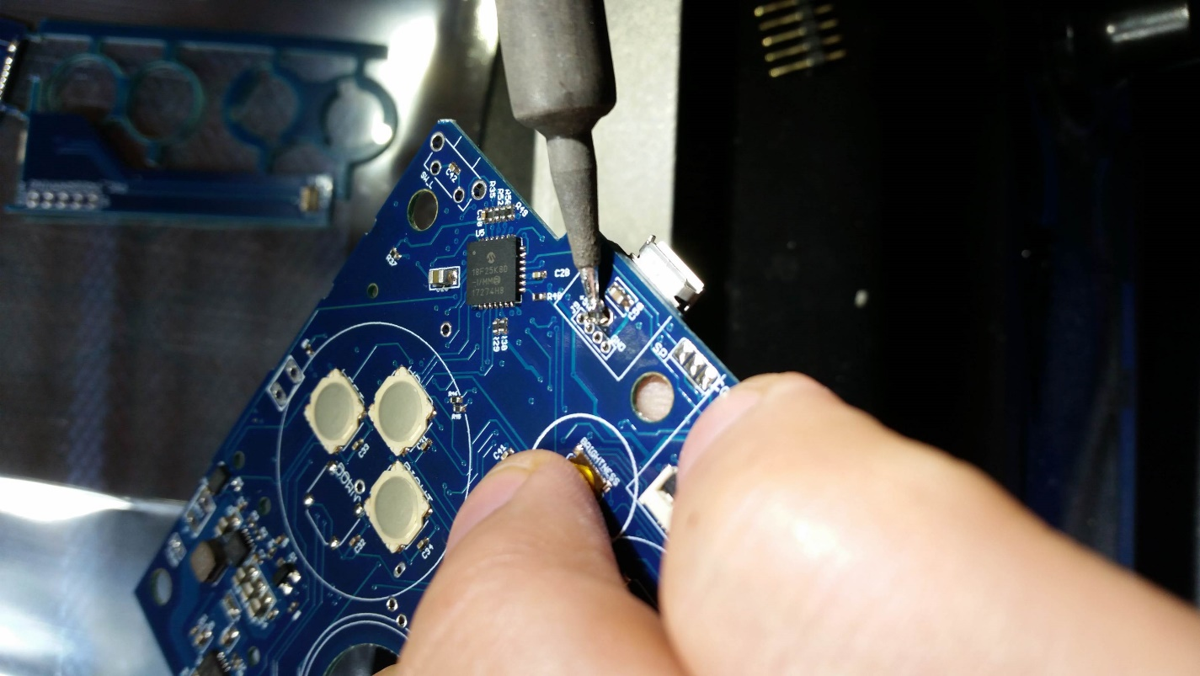

Figure 35 - Solder to hold the micro USB pin in place

The solder on one side, and the plastic piece of the pin on the other side should hold the boards in place. But they are still able to rotate, so that’s where we use the sewing needle. Put the needle through one of the holes to keep the boards from rotating.

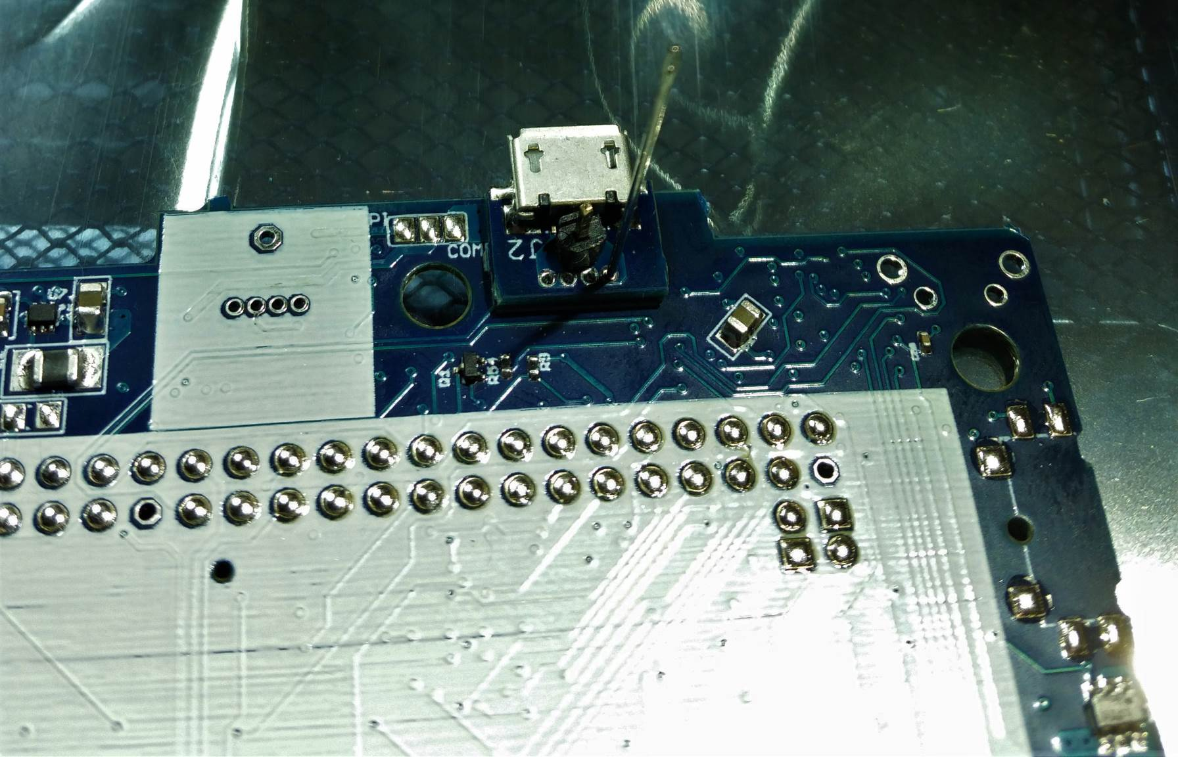

Figure 36 - Sewing needle to stop boards from rotating

**Now apply flux from the pen to the holes**. This will make the soldering easier. Get the iron into the hole to heat everything up, and slowly add solder so it fills all the way through.

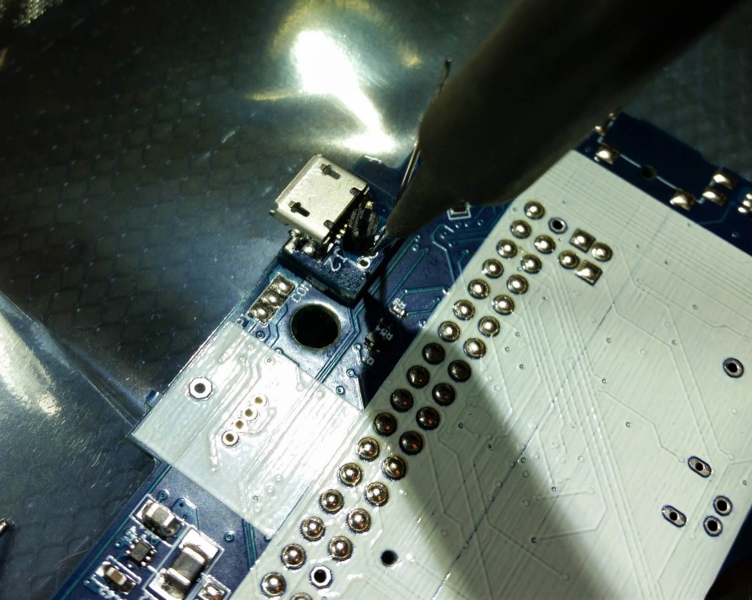

Figure 37 - Soldering iron into holes for USB power

Check the back side of the board to see solder beginning to come through. Then put the iron through the back side of the board to flow the solder from this side.

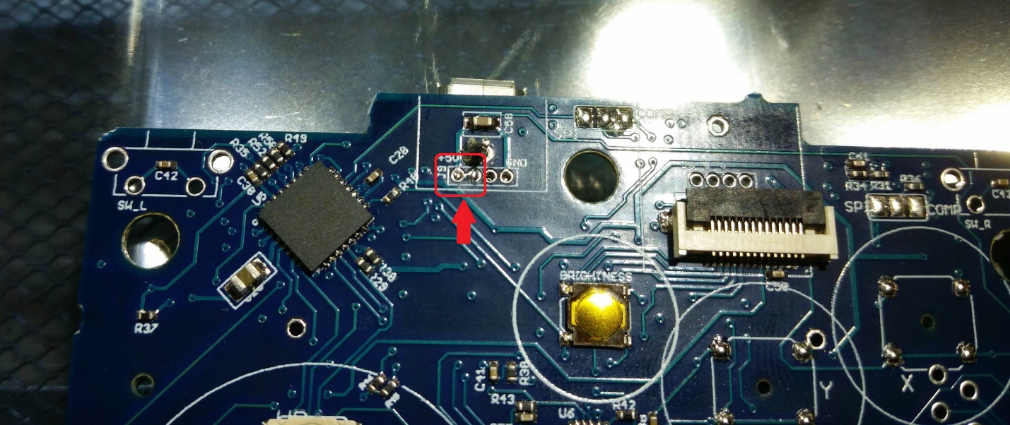

Figure 38 - Solder coming through the holes in the board

Finish soldering the rest of the holes, then securely solder the back side of the pin. Then use the needle nose pliers to slowly pull off the plastic on the pin.

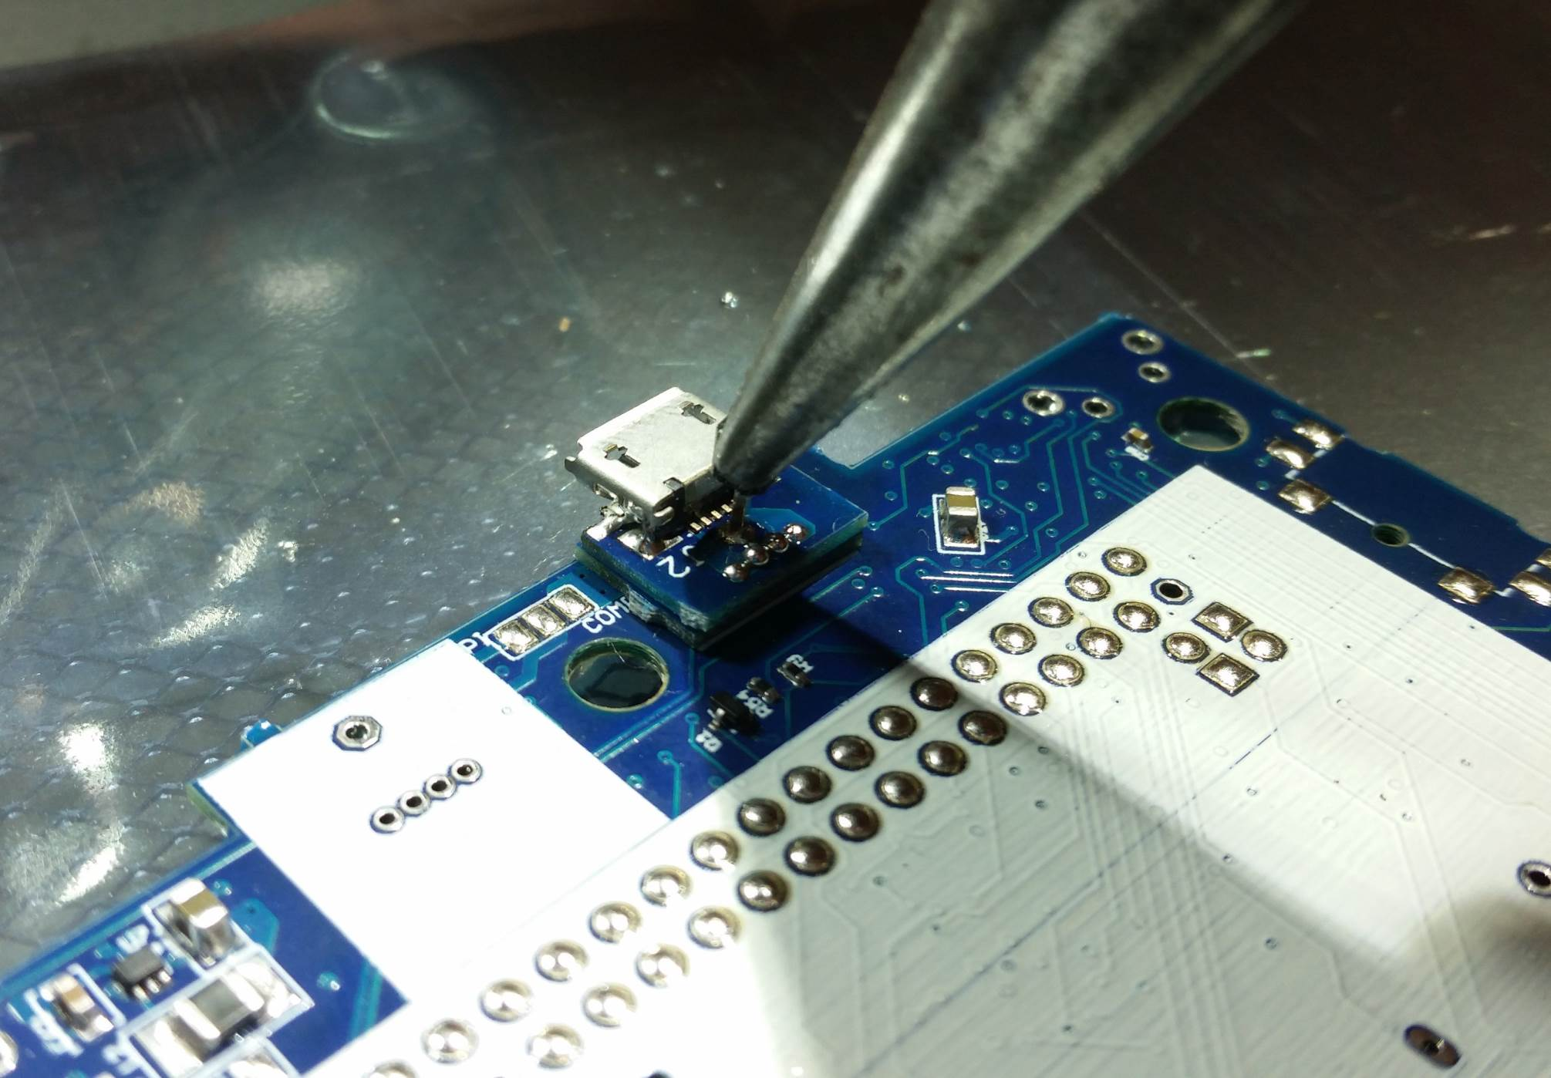

Figure 39 - Remove the plastic piece of the pin

The pieces in the red and yellow boxes are connected together, so it is alright if the solder bridges, as it is in the picture below.

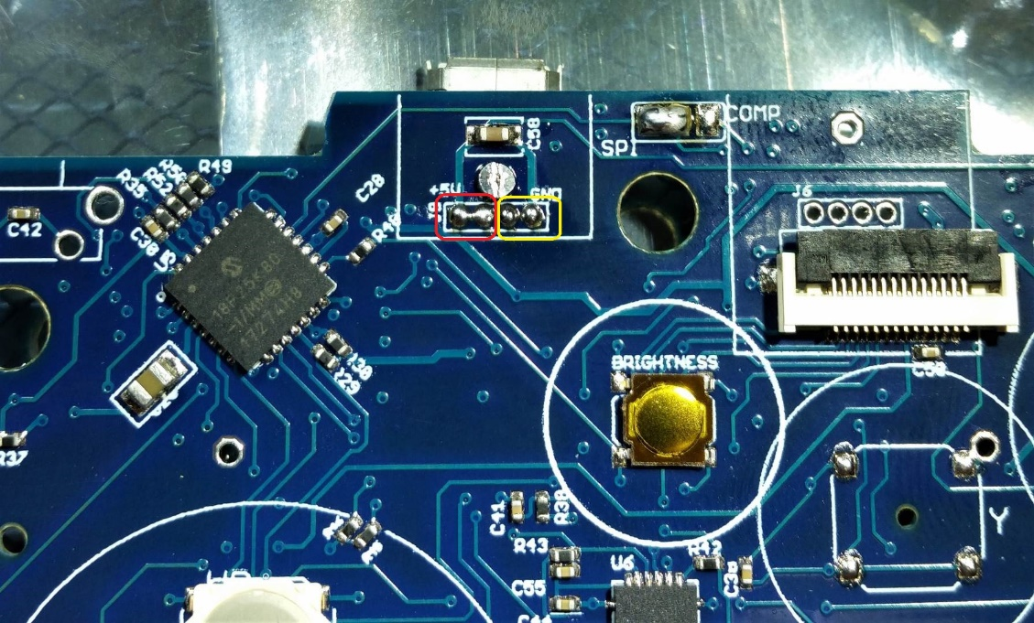

Figure 40 - These are connected together

Finish soldering the pin and clip the pin close to the board on both sides.

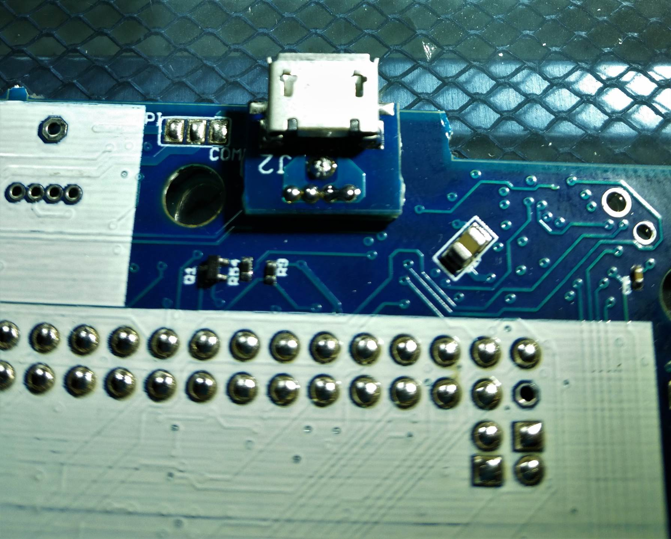

Figure 41 - Finished power port soldering

## Attaching the Raspberry Pi

Now we can finally attach the Raspberry Pi Zero board. This is a bit tedious, but important to do right.

Please refer to some of Kite’s soldering descriptions, they are way better than mine:

https://github.com/kiteretro/Super-AIO/wiki/Pi-Zero-SAIO-v0.6c

First put a little more solder on all the pads, to make little solder balls, like in the picture below. Try to keep their height as even as possible.

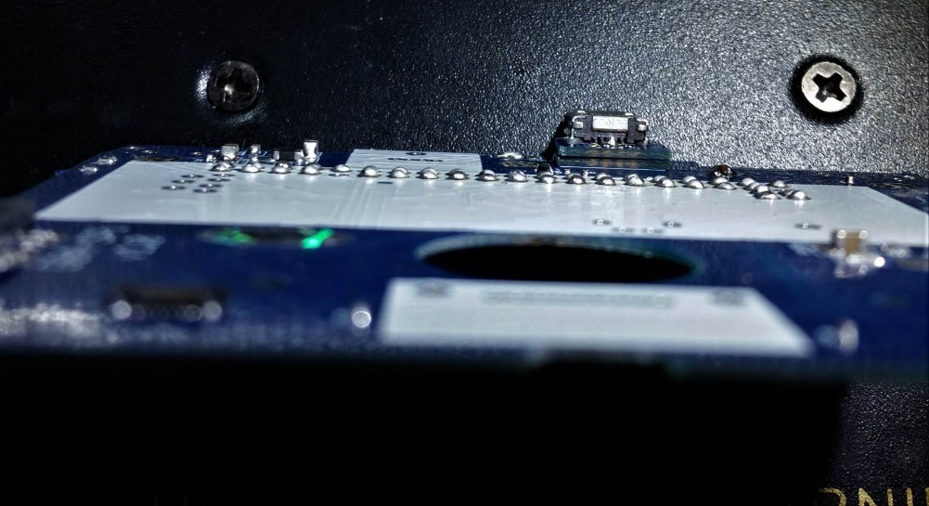

Figure 42 - Solder balls for Pi attach

**Next, brush all the solder balls with the flux pen!** I’m a big fan of flux, it makes soldering much easier. Then there are two through hole positions in the board, where you can insert solder pins. This helps keep the Pi aligned to the rest of the balls and holds it down while soldering the first few pieces.

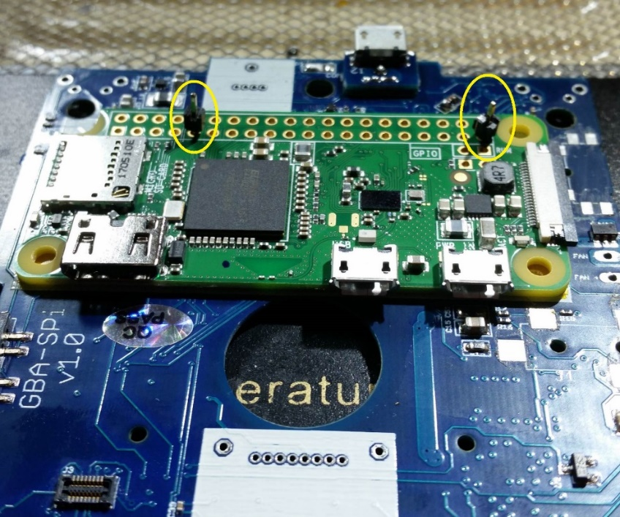

Figure 43 - Pi alignment pins

The pins come through the other side of the board. While holding the Pi and the pin (just hold it by the plastic piece) tight to the board, put a quick solder blob on the other side of the board, to secure the pin in place.

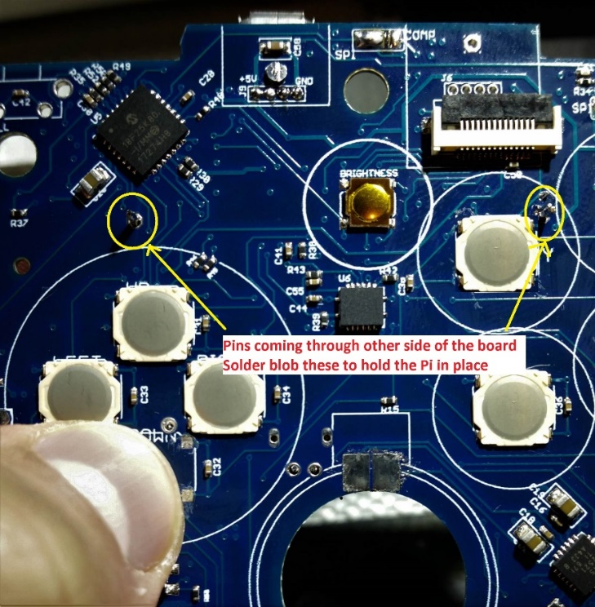

Figure 44 - Solder blobs on back side of Pi alignment pins

**Now add more flux!** Use the flux pen to get flux down into the holes on the Pi.

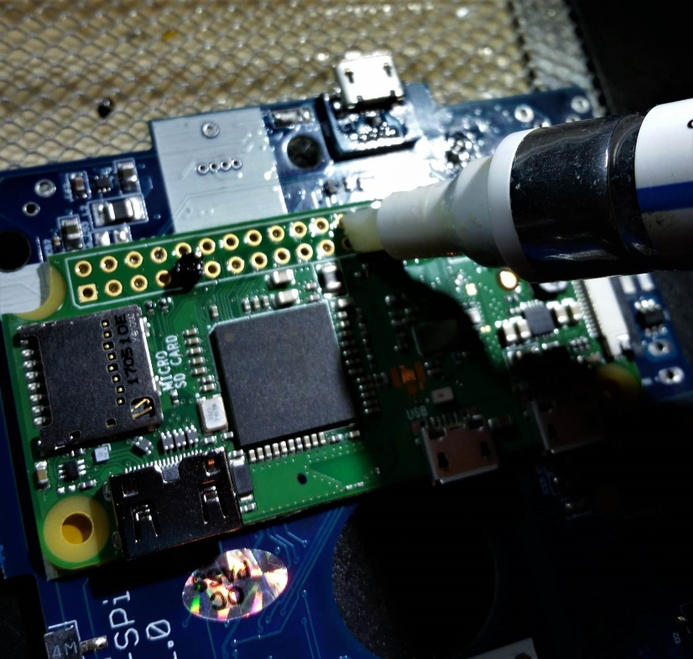

Figure 45 - More flux on Pi pins

Insert the soldering iron into a few holes and just melt the solder ball, drawing the solder up into the hole. Do this just on a few of the pins, just to get the Pi reasonably secured to the board.

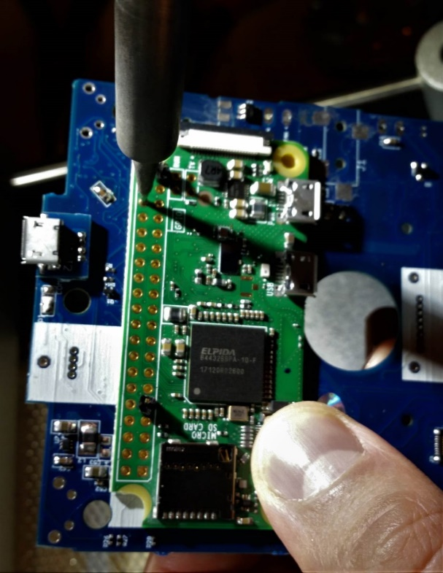

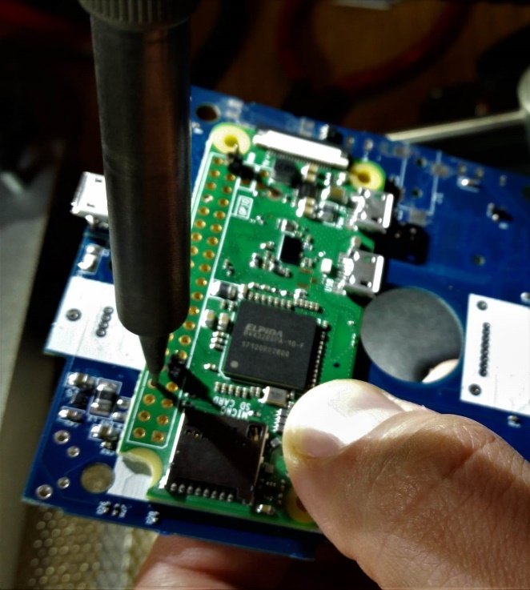

A few of the pins should look like the picture below. This should hold the Pi in place well enough to solder the rest of the pins.

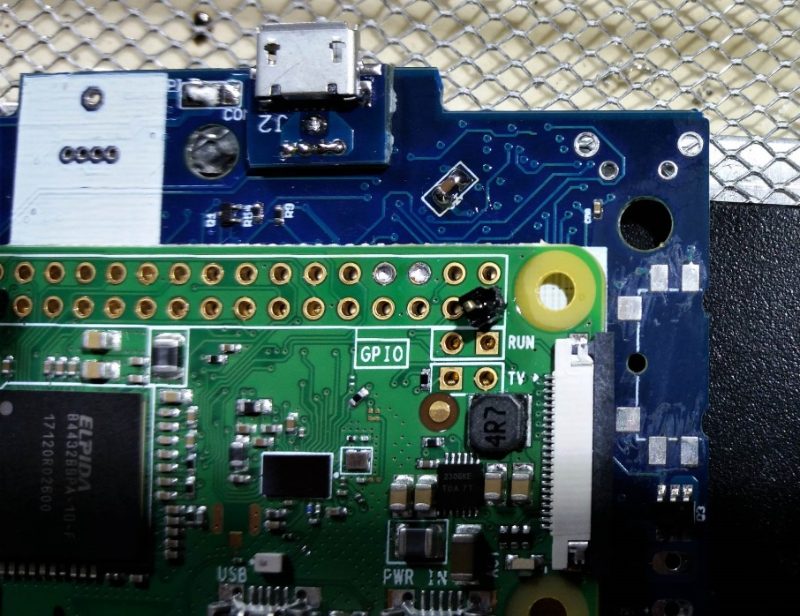

Figure 46 - First pass soldering of a few Pi pins

After the Pi is held in place by the initial soldering, you can start soldering the rest of the pins. The pin should have a small shiny dome of solder when it is properly done.

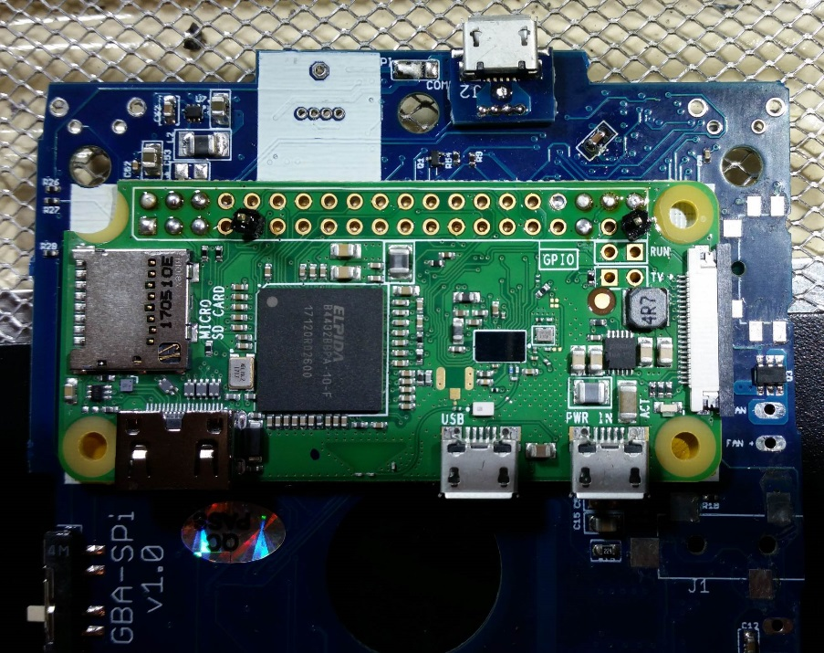

Figure 47 - Starting to solder the rest of the pins

Once more pins have been soldered, you can clip the alignment pins on both sides of the board, and properly solder them into place.

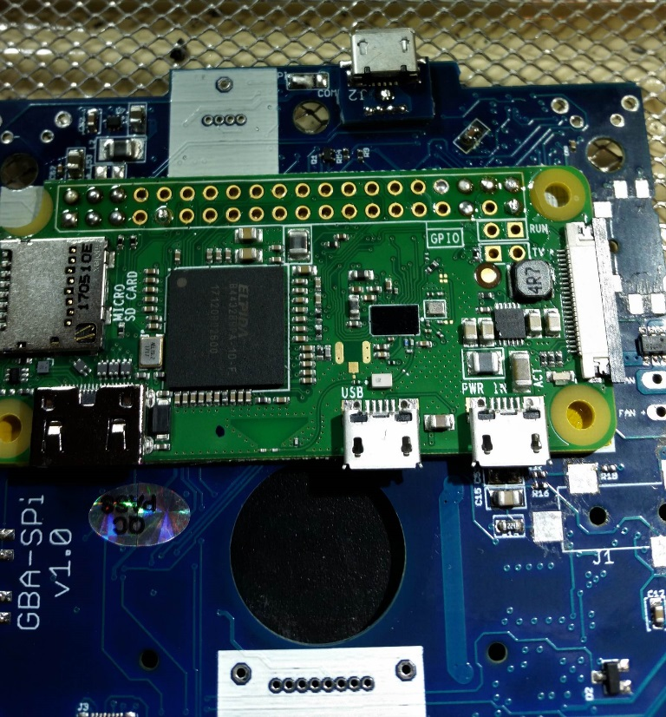

Figure 48 - Clip and solder the alignment pins

Finish soldering the rest of the pins. Nearly every connection is used, so they all need to be properly soldered. Again, the final result should be a rounded, shiny ball on every pin. But also be careful not to add too much solder, since it could short pins underneath the board, and this is very hard to fix!

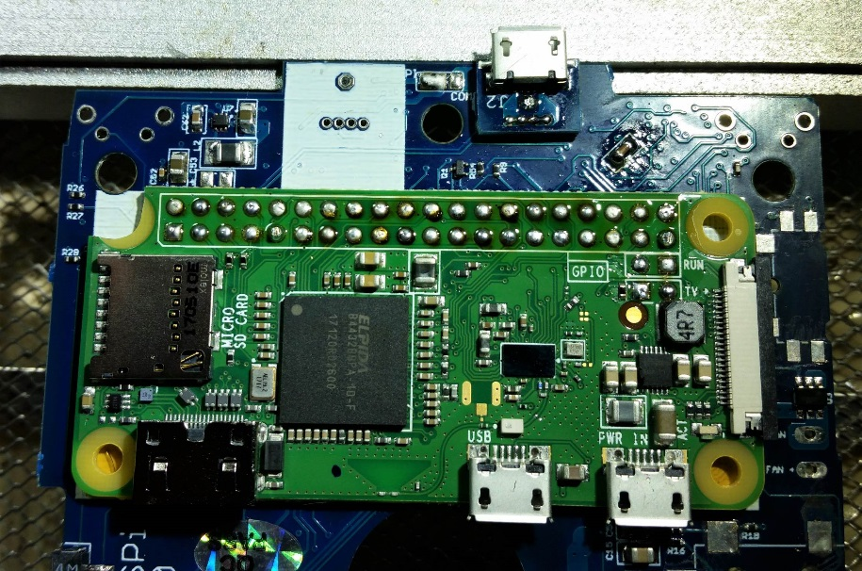

Figure 49 - Finished soldering Pi pins

Now flip the board over, and don’t forget to solder the USB pins. Use the same technique as soldering the Pi pins.

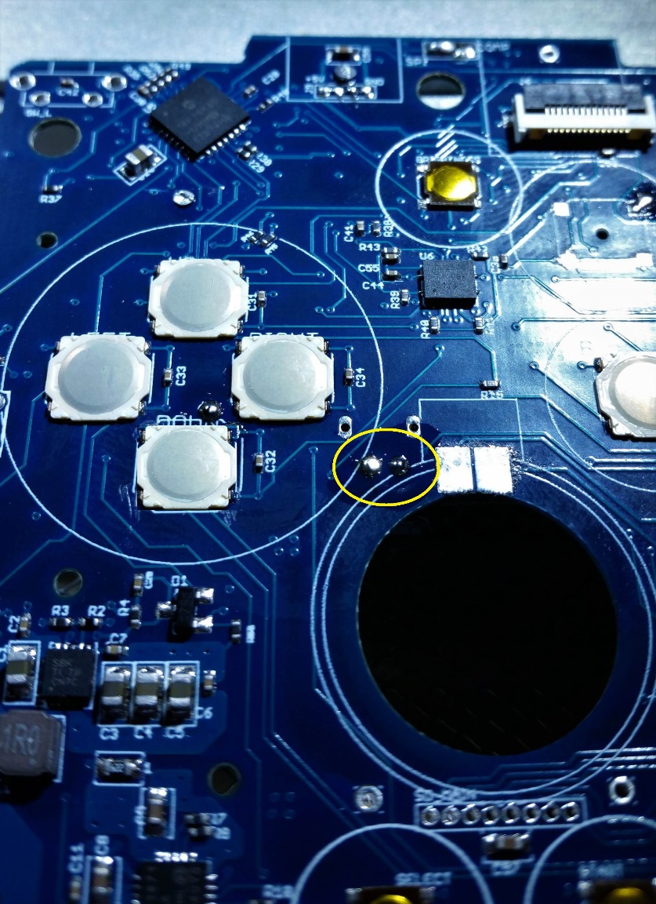

Figure 50 - Solder the USB pins

## Headphone Jack

If you want to have the headphone jack option, then install it like the picture below

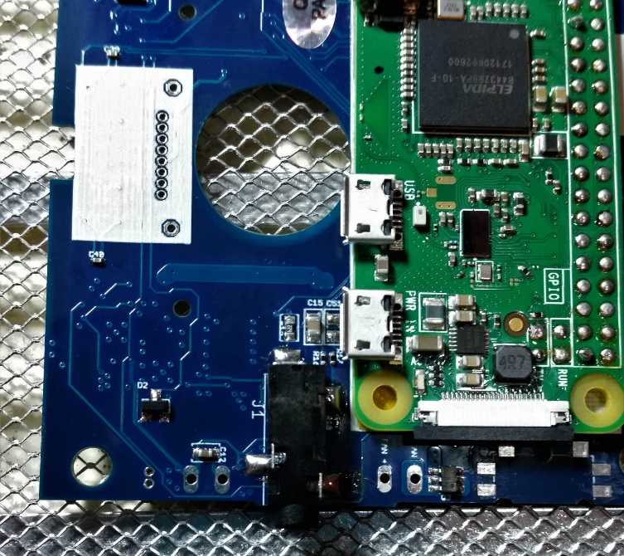

Figure 51 - Headphone jack soldered on

If you do not want the headphone jack (it requires extra case cutting), then you need to solder a jumper wire between the two points shown in the picture below.

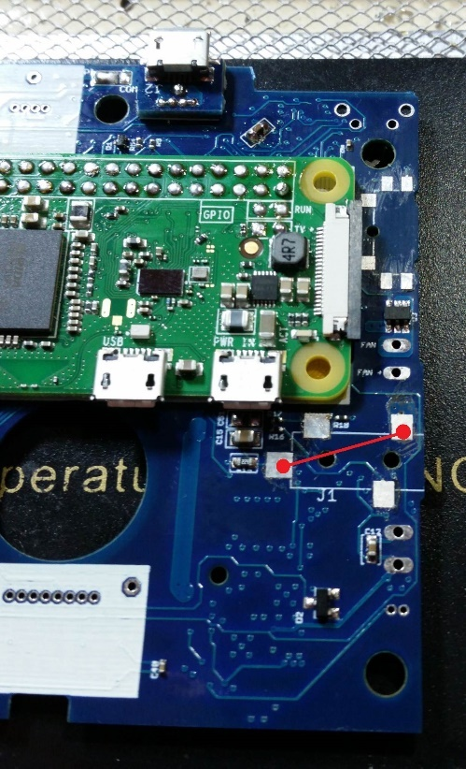

Figure 52 - Connect these two points if headphone jack is not installed

## Volume Slider

The volume slider should already be glued together.

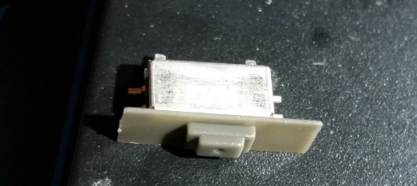

Figure 53 - Assembled volume slider

Install the volume slider, but for now only solder the two connections on the right, shown in the picture below. This will allow for you to slightly adjust the location to make sure it fits better into the case when you begin assembling.

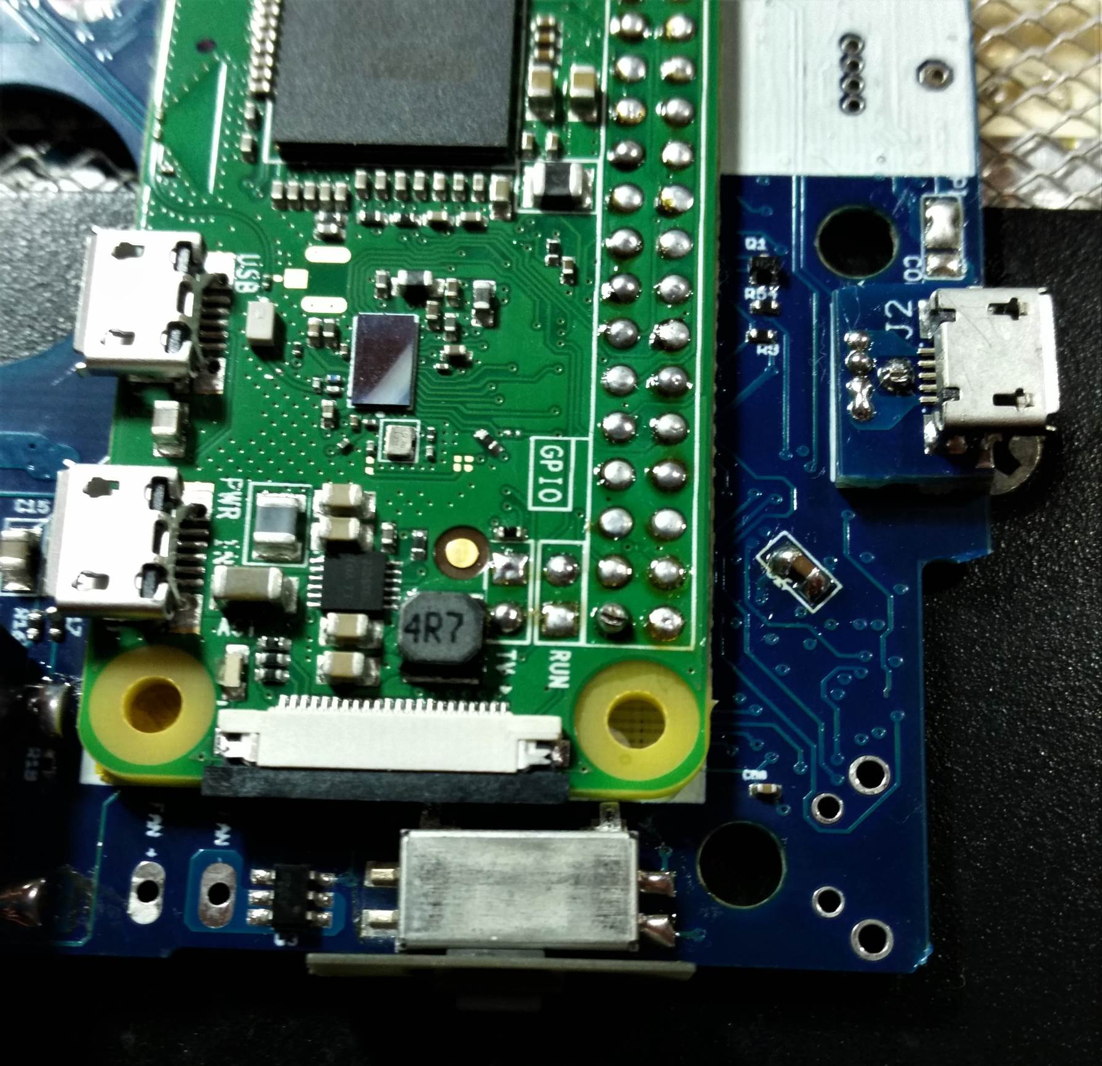

Figure 54 - Volume slider - only solder two right connections for now

## Shoulder button switches

Pretty self-explanatory. Install the L and R buttons, making sure the buttons are on the same side of the board as the Pi.

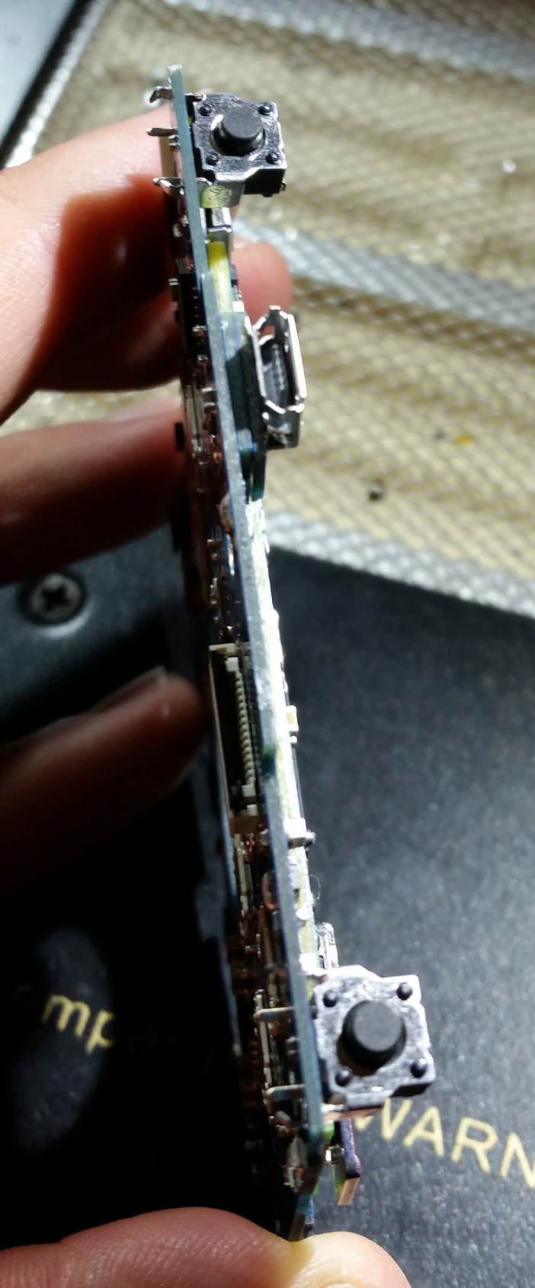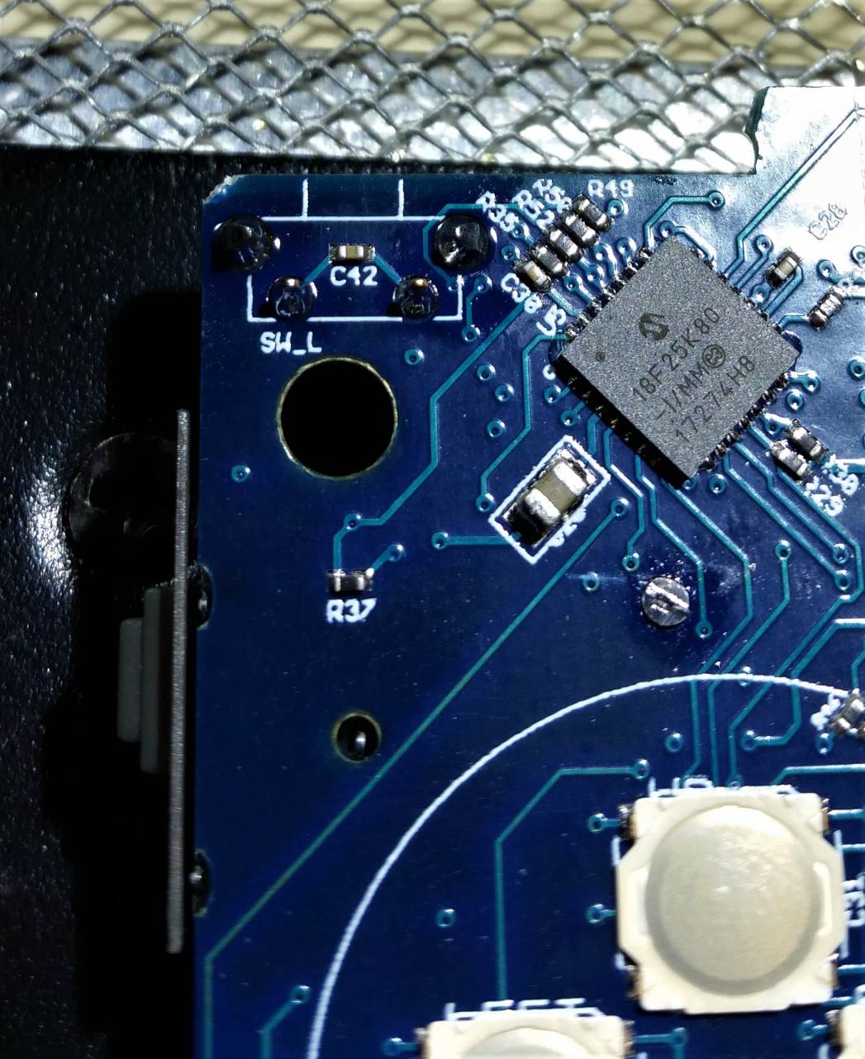

Figure 55 - Shoulder buttons installed and soldered

## USB Riser Board

Break away the USB riser board and be sure to trim the excess PCB stubs. Then place the board on the AIO board, and align it with a pin, as shown below.

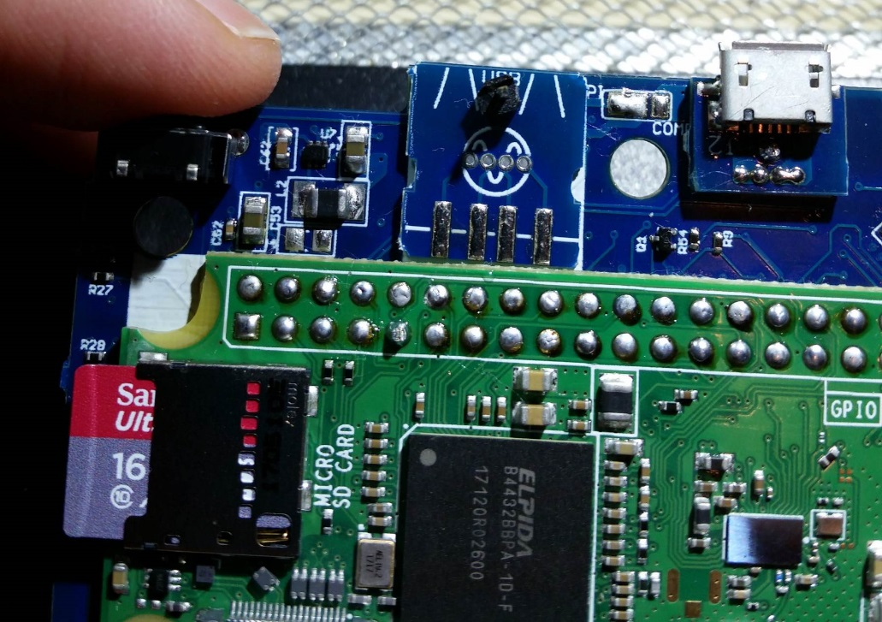

Figure 56 - Add USB riser board, align with pin

Hold the pin in place by the plastic and add a quick solder blob to the other side of the board. This will hold the USB riser board in place.

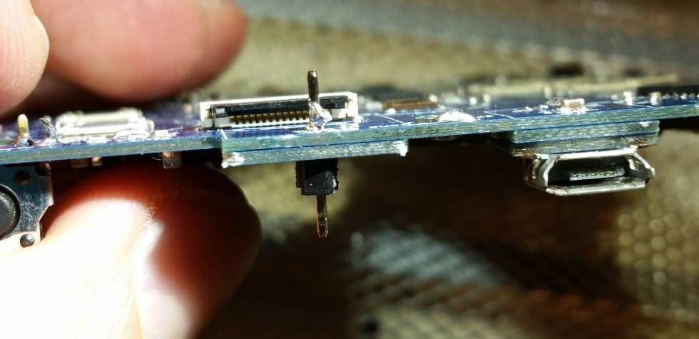

Figure 57 - Solder blob USB riser board pin

Solder through the four holes, using the same technique as the micro USB power board. Again, flux is your friend! The result should look like the picture below.

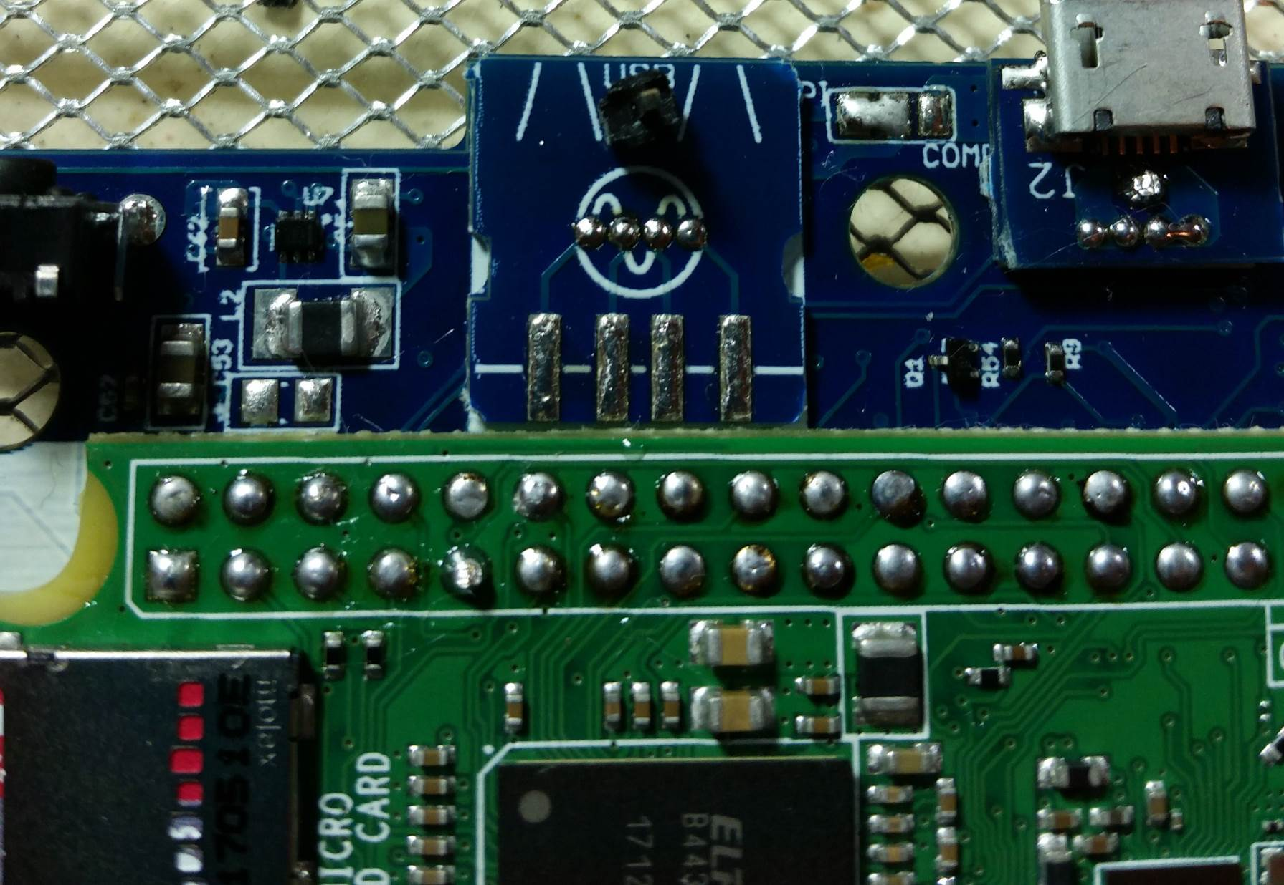

Figure 58 - USB connections soldered

Then cut the pin and finish soldering both sides. Be sure to cut the pin flush to the board, especially on the opposite side where the ribbon cable will be going.

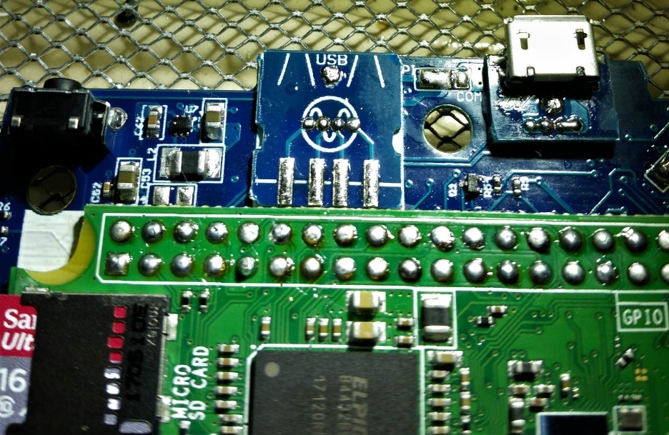

Figure 59 - Cut and solder the USB board pin

Put the USB port onto the USB board, but only solder one pin right now. This is important, since we might need to adjust this USB port slightly when we begin assembly.

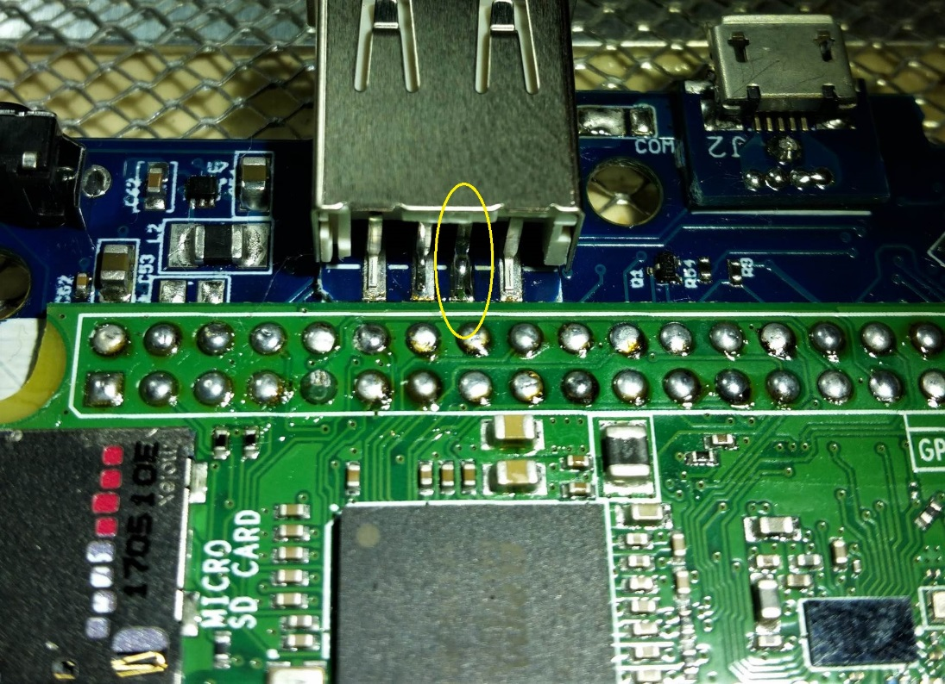

Figure 60 - Add USB port, solder only one pin

At this point you should put the AIO board into the front shell piece, and confirm the fit of the USB port. You will likely find that it needs to be trimmed very slightly for the port to fit cleanly. Get out that x-acto knife again!

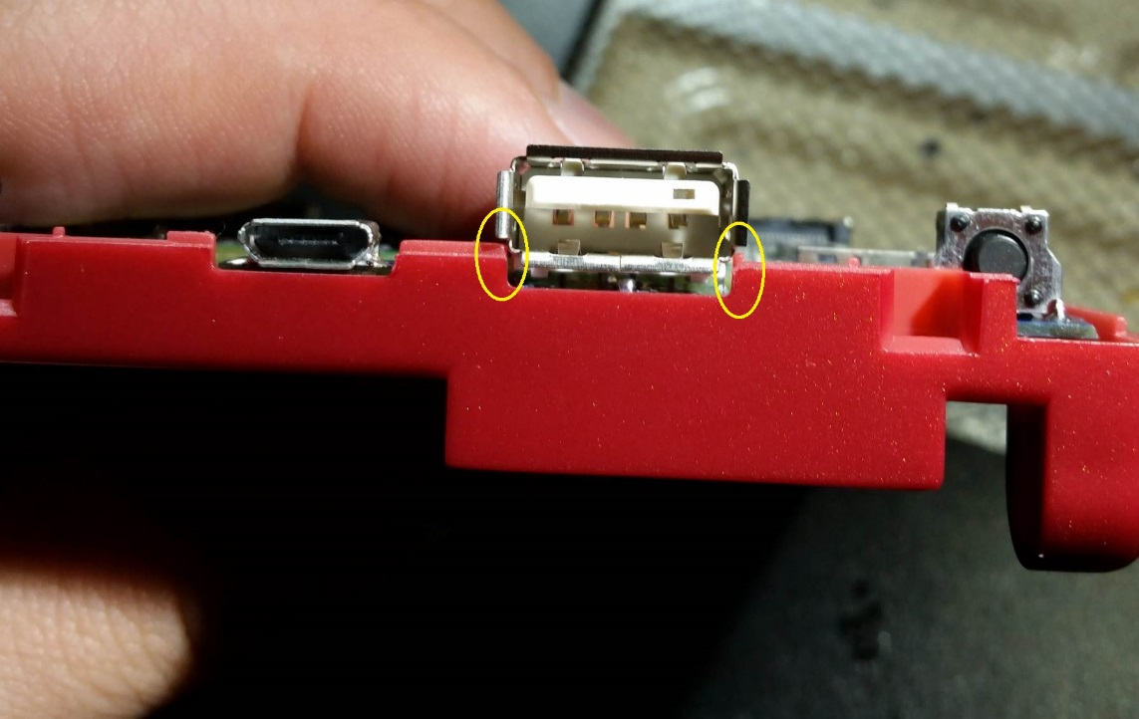

Figure 61 - Slight trimming for USB port fit

## Screen assembly

### Soldering and taping the screen

Soldering the 18-pin connector to the adapter board takes some care, but careful planning and more flux makes it not very difficult.

First tape down the screen ribbon cable using kapton tape. Then align the adapter board pins, and tape it down. Once everything is aligned taped down, it’s much easier.

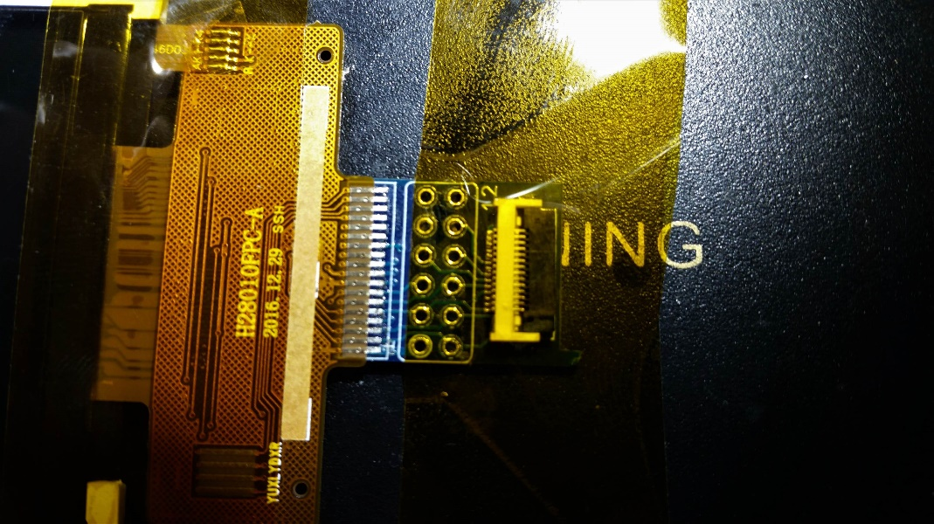

Figure 62 - Align and tape down screen ribbon and adapter

Before soldering, be sure to apply flux again! Then solder down just the end pins, and confirm that the alignment is still good, as shown below.

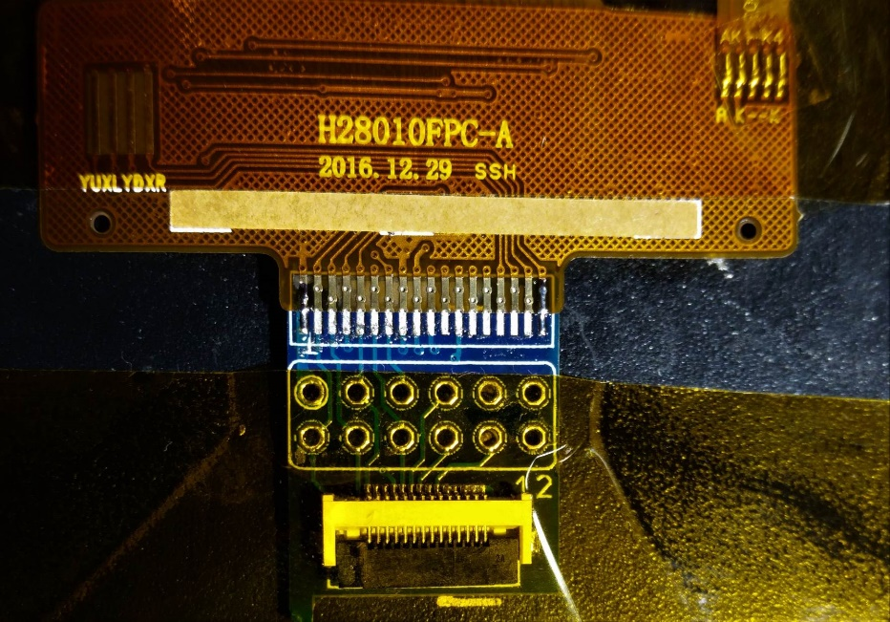

Figure 63 - Solder end screen pins, and confirm alignment

Finish soldering the rest of the pins…add more flux if it begins to dry up. You should have nice shiny solder joints on all the pins, as shown below.

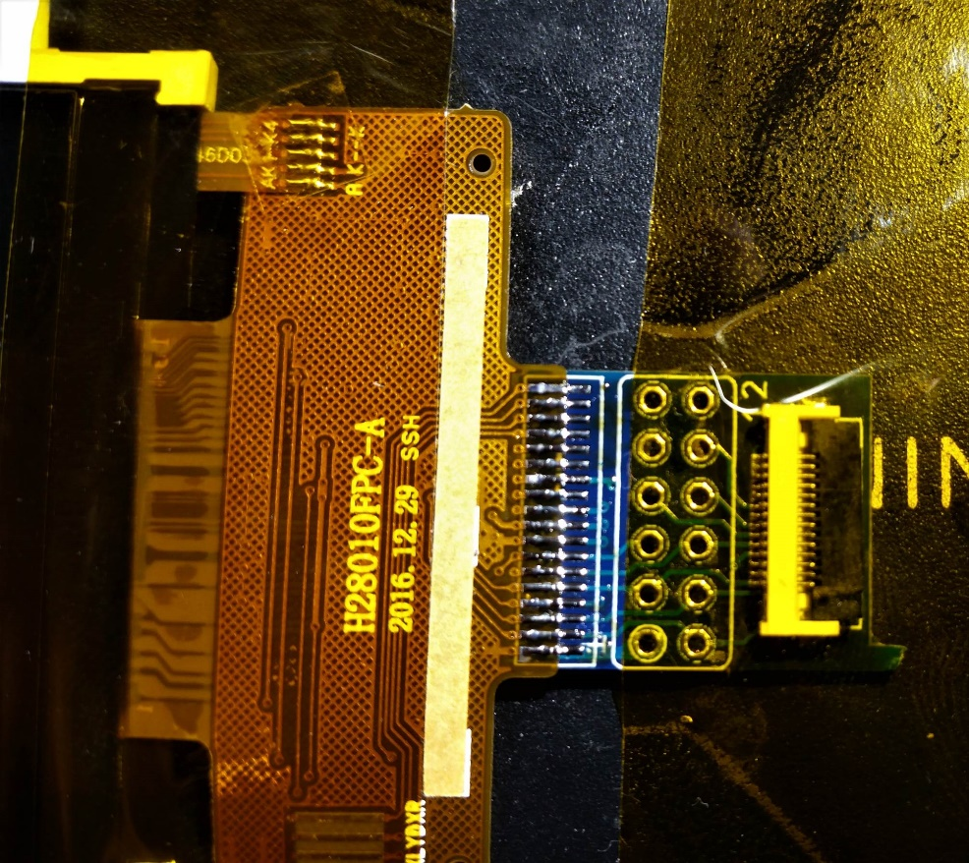

Figure 64 - Finished screen soldering

Make sure to put kapton tape on the back of the screen. This is necessary to insulate the adapter board from the metal on the back of the screen.

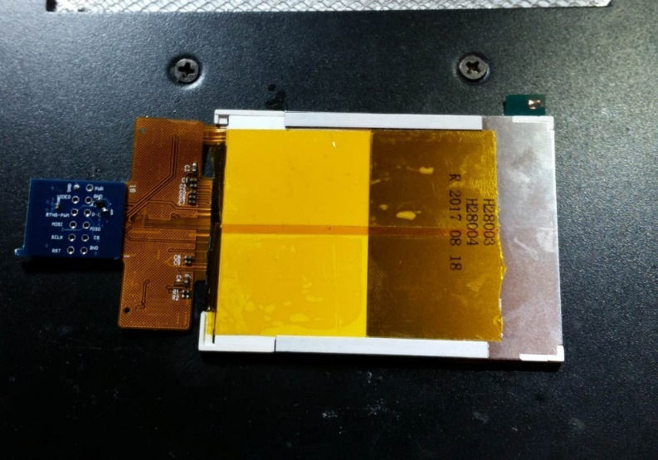

Figure 65 - Kapton tape on back of the screen

Now test it! Plug the ribbon cable into the screen adapter, and the AIO board. Plug in a power supply to the micro usb port and slide the power switch. Give it some time, since it can take a little while before the SPI screen gets initialized, but it should all power up! Press the brightness button and a battery indicator should show up. Try running a game, and pressing the speaker into the speaker cutout, so the metal tabs make the proper connection. You should also be able to adjust the volume using the slider. So close to being done!

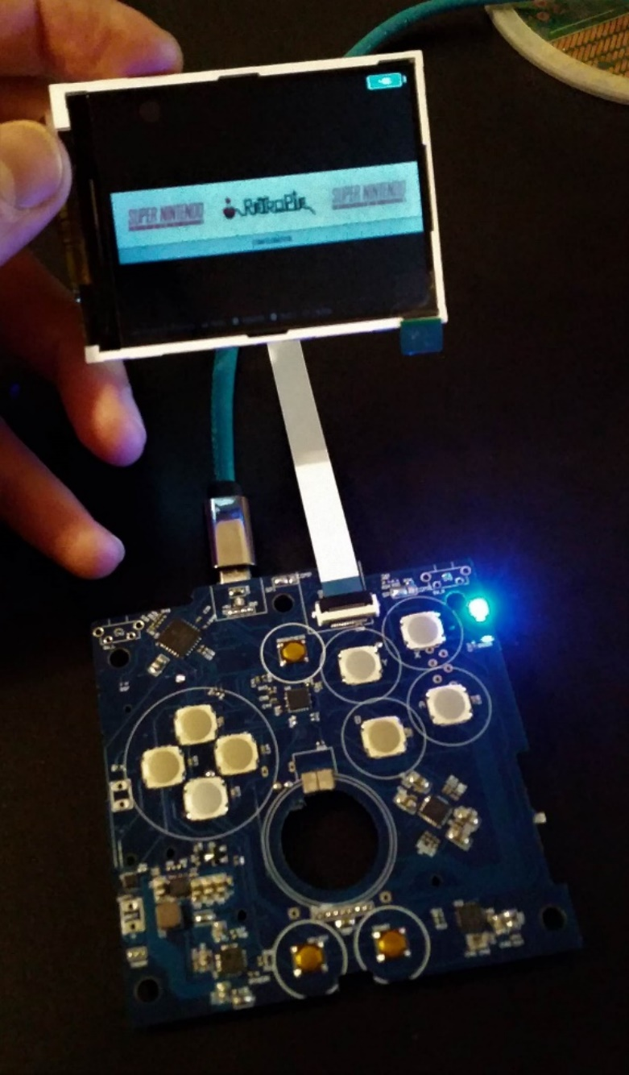

Figure 66 - Test the screen and AIO board

Fold the ribbon cable onto the back of the screen, and tape it down with more Kapton tape. I also put tape on the rest of the metal pieces of the screen, just to be safe.

Then it’s time to align the screen behind the GBA SP screen protector. Once the screen is aligned to your liking, tape it down, again, using Kapton tape (this stuff is great).

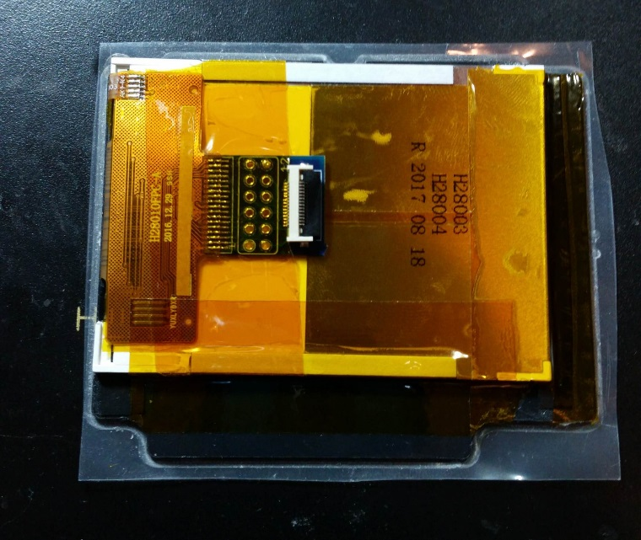

Figure 67 - Tape down ribbon cable, align behind the screen protector and tape screen down

The 2.8 inch screen does not completely fill the screen opening. So I put two thin strips of black electrical tape on the back side of the screen protector, on either side of the screen opening. Then I aligned the screen in the new available opening. If you can’t tell where the tape is in the picture below, then that means it looks good!

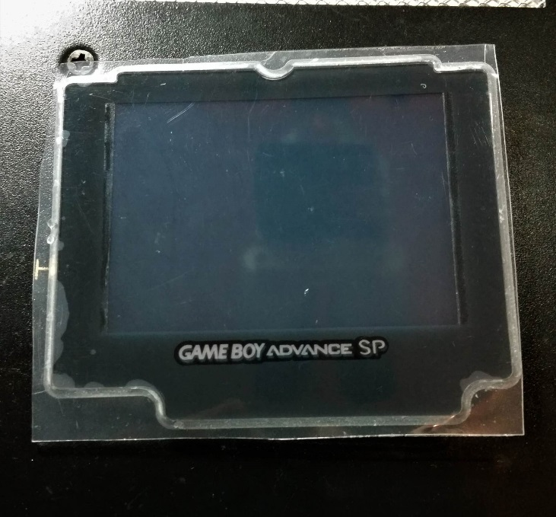

Figure 68 - Screen aligned behind protector, with electrical tape on edges

### Assembling the screen shell

Now that the screen itself is ready, it’s time to put it into the screen shell, and close it up.

First insert the ribbon cable into the connector, with the blue side of the ribbon cable facing up. Then put a fold in the cable as shown below. Try not to put a kink in the cable, just fold it gently. The trick to getting the cable safely through the rest of the hinge is to spiral the cable through. This is also shown in the picture below.

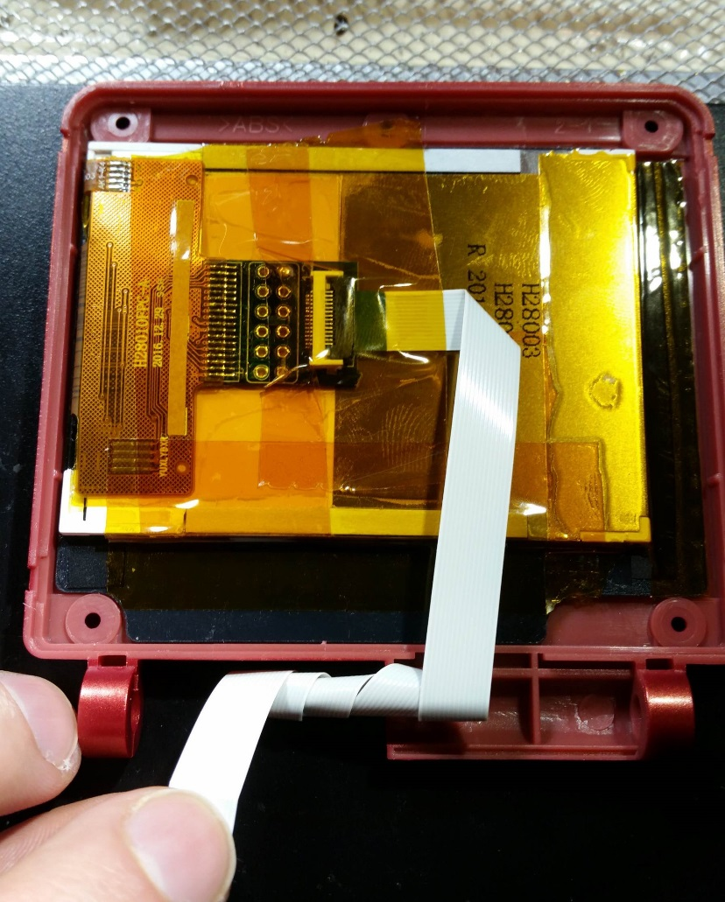

Figure 69 - Spiral the cable through the hinge

Once your cable looks like the one above, with a little over an inch of extra “tail” after the spiral, then you’re good to put on the backing of the screen shell, and screw it in.

**After you’ve put it together, I highly recommend plugging in the ribbon cable to the board, and making sure that it still works!**

## X and Y Buttons

### Disclaimer

This is at the end of the build section because it is completely optional. The X and Y buttons are placed on the AIO board, but the mechanical aspect of how to cut the button holes, make them look nice, etc., is not easy to do. I also admit I’m not the best in terms of mechanical engineering, and figuring these things out.

There are definitely better ways to do the X and Y button additions to this project, and I’m hoping the community can figure them out! The only thing that needs to be followed is the location of the buttons. After that, **the builder is free to figure out how to cut the holes, what buttons to use, how to create the button wells, how to countersink the holes if desired, etc.**

### Using the included button wells

All that being said, the AIO board includes pieces that act as the button wells for the stock GBA SP A and B buttons. This section shows how I used those to implement X and Y buttons.

First remember that we have already made the markings for where the button holes should go. First step is to drill a small pilot hole through these points in the case.

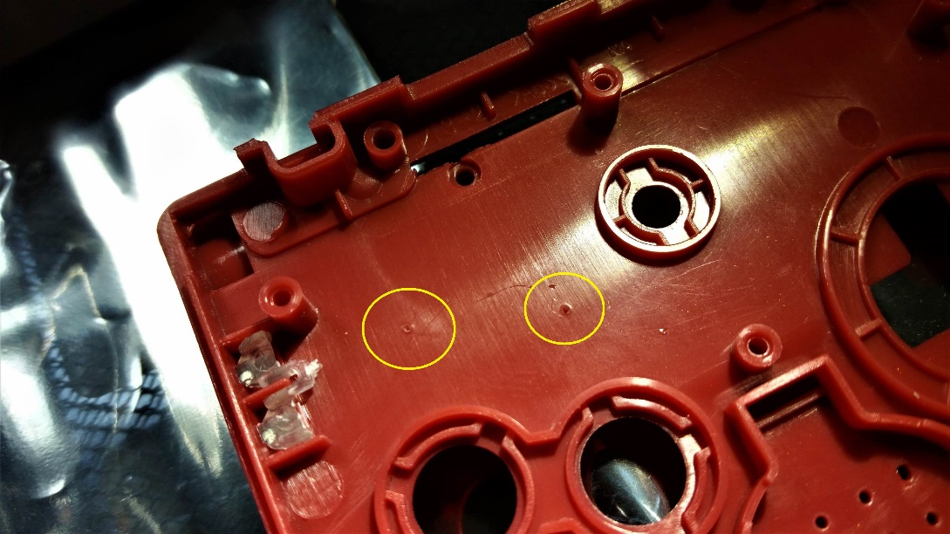

Figure 70 - X and Y button hole locations

Once the pilot hole is drilled, you can use a step drill bit to slowly open the holes so they are just wide enough for the GBA SP buttons. Turn the drill bit by hand! The plastic is soft and will cut easily, so go slow and be careful.

To finish the holes I used a large 120 degree countersink. The holes come out ok, but it certainly could be better. Just looking for input from others on how to make these buttons better!

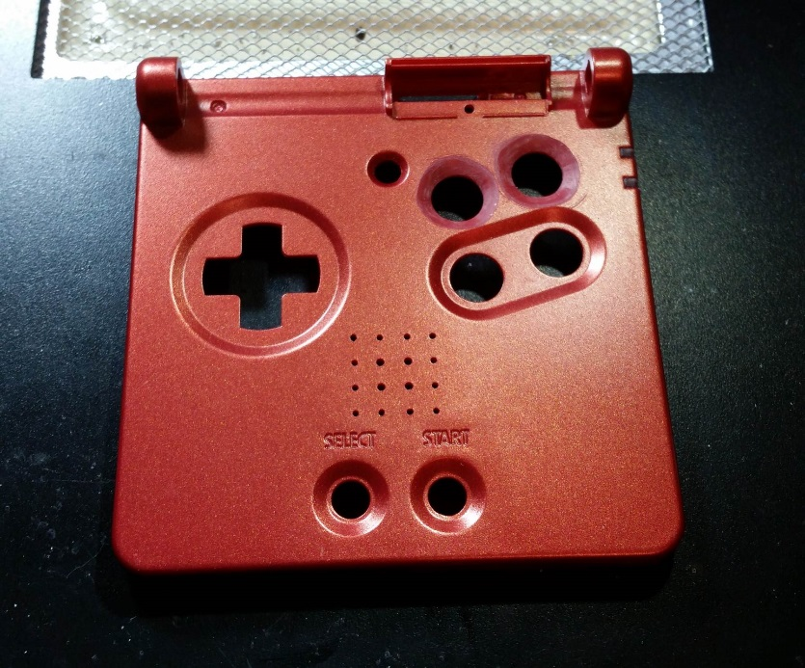

Figure 71 - Countersunk X and Y holes

Next take the x-acto knife and scratch up the plastic around the holes, and both pieces of the PCB button wells, like in the picture below. This will help the glue adhere better.

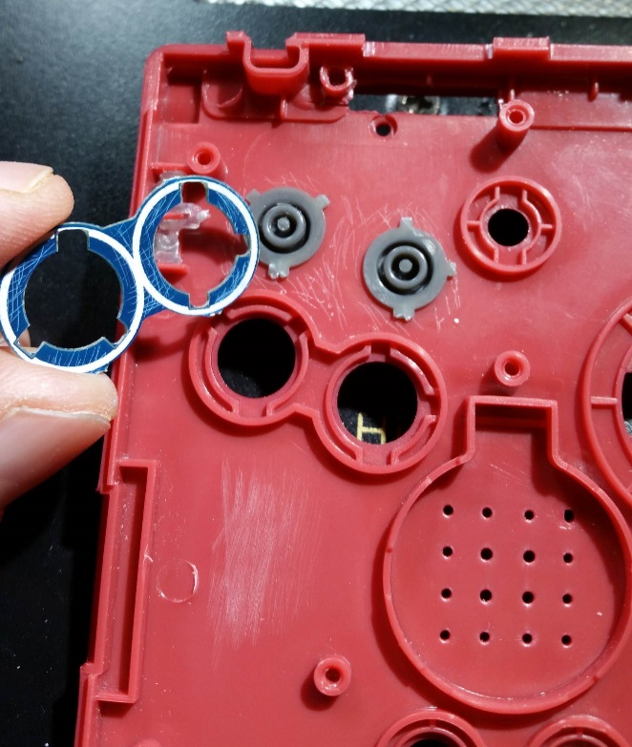

Figure 72 - Scratch button well pieces

Next use some super glue to glue the first button well layer around the buttons. Put the buttons in there to make sure the piece is aligned properly, but as soon as you have pressed down the piece, make sure to remove the buttons so they don’t accidentally get any excess glue on them, and get stuck.

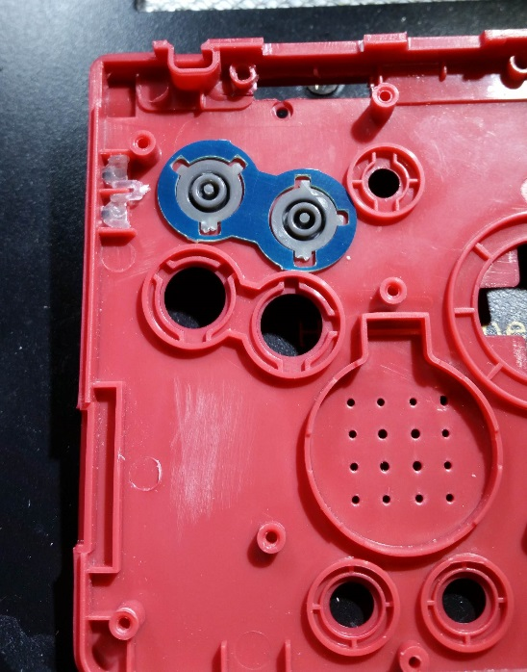

Figure 73 - Glue first button well layer

Do the same thing for the next layer. This thin layer is to provide the ring necessary for the rubber gasket to sit properly.

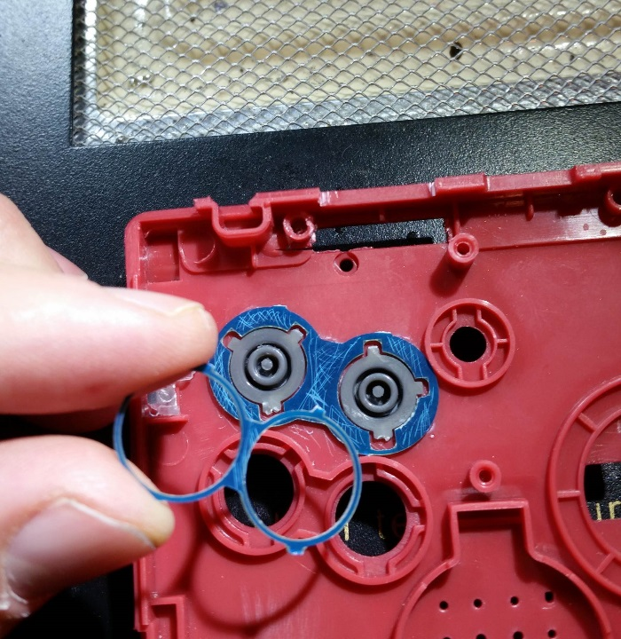

Figure 74 - Scratch up both button well layers

Once they are both adhered together and are solid, use the x-acto knife to trim off the excess nubs of PCB, so the whole thing is smooth and round.

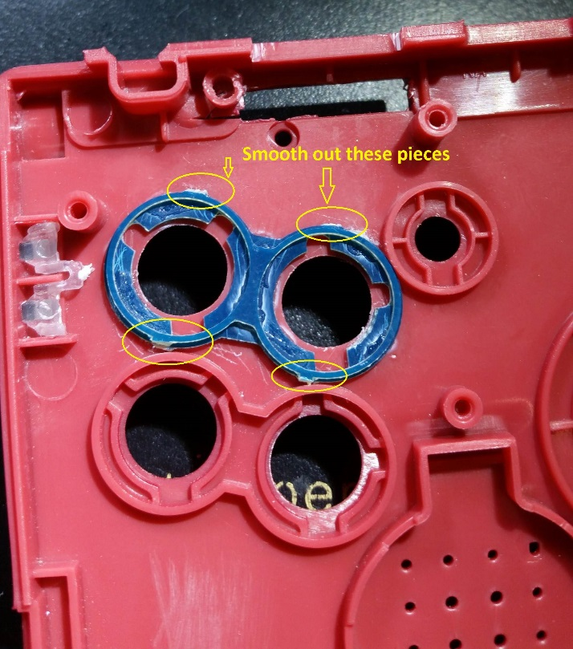

Figure 75 - Button wells assembled

# Assembly

Now everything is finally ready to put it all together!

## Screen attach

First mate your assembled screen shell to the board shell piece. And feed your nicely spiraled cable through the hole.

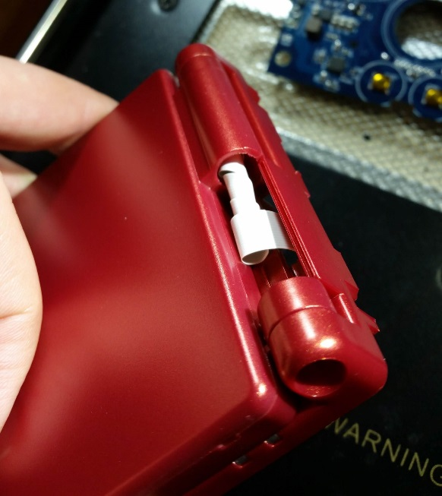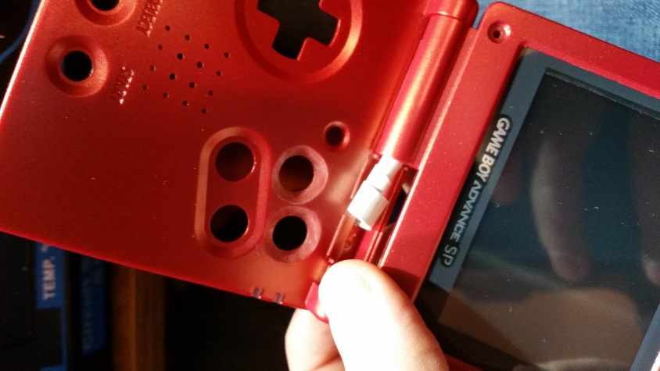

Figure 76 - Screen shell mounting to board shell

Be sure to install the cable cover piece on the top side of the shell, to cover the cable. And don’t forget to install the holding screw, shown in the picture below.

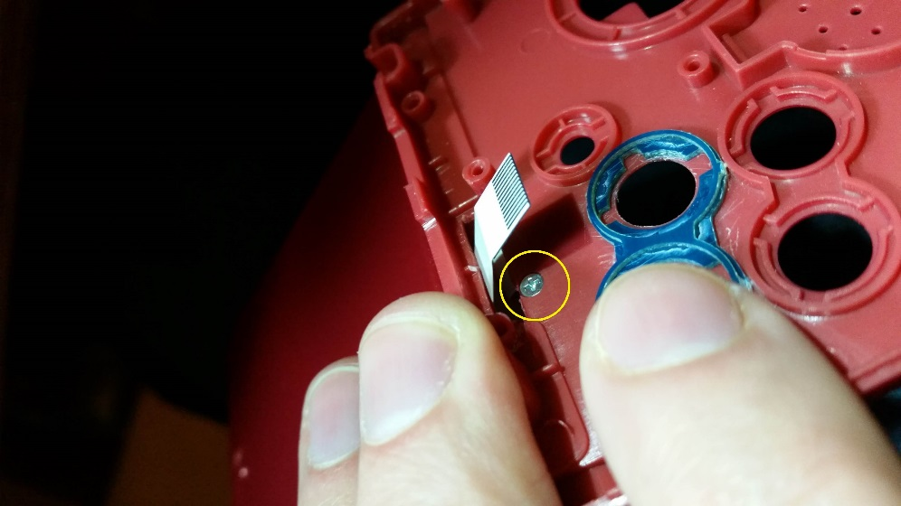

Figure 77 - Cable cover holding screw

## Assembling the buttons

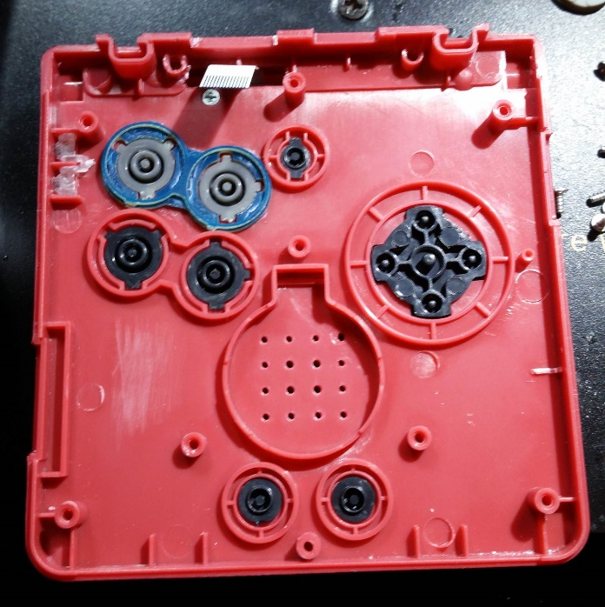

Figure 78 - Buttons installed

Install the rubber button gaskets, and the speaker. Trim the gaskets as shown in the picture, to allow them all to fit properly. If you did not install X and Y buttons, then the gaskets do not need to be modified, they should just fit.

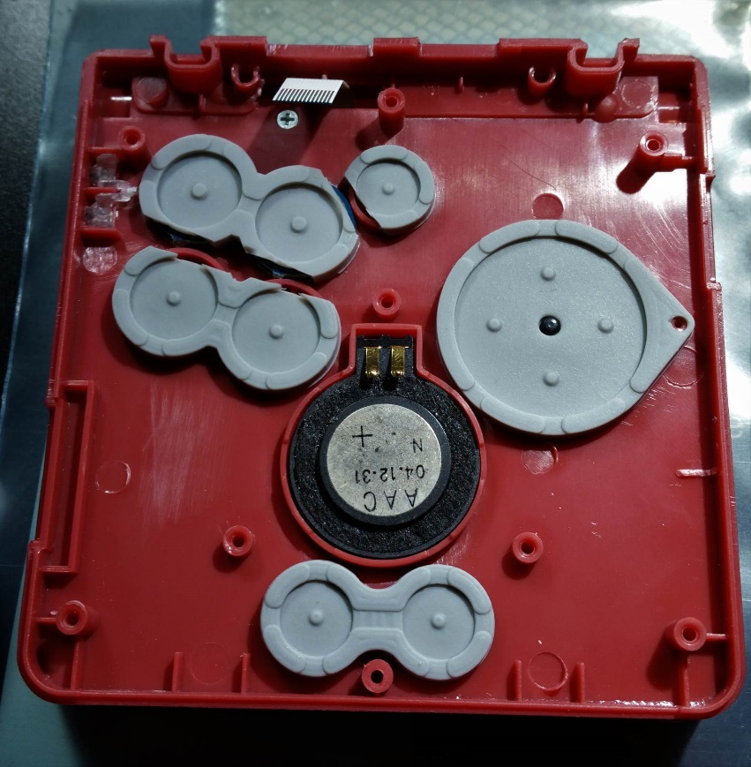

Figure 79 - Add button gaskets and speaker

## Attach the AIO board

This is the trickiest part of the assembly, and I don’t have a good explanation of how to do it. But fit the screen ribbon cable into the connector on the board, and close the connector. Also be sure to put a bit of kapton tape over the connector, to ensure it says closed and secure.

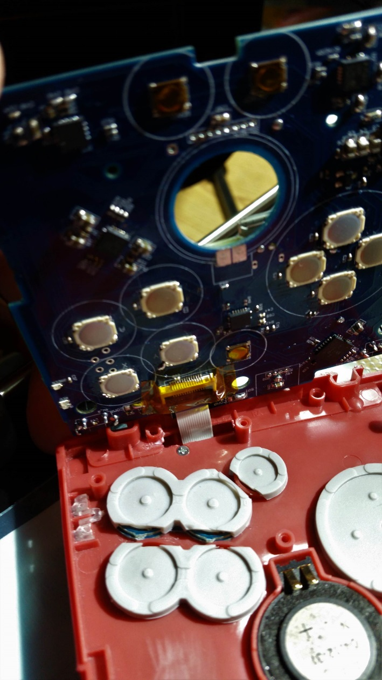

Figure 80 - Install ribbon cable and kapton tape

Getting so close! Can now seat the AIO board into the front half of the shell. Don’t forget the screws to secure the board in place.

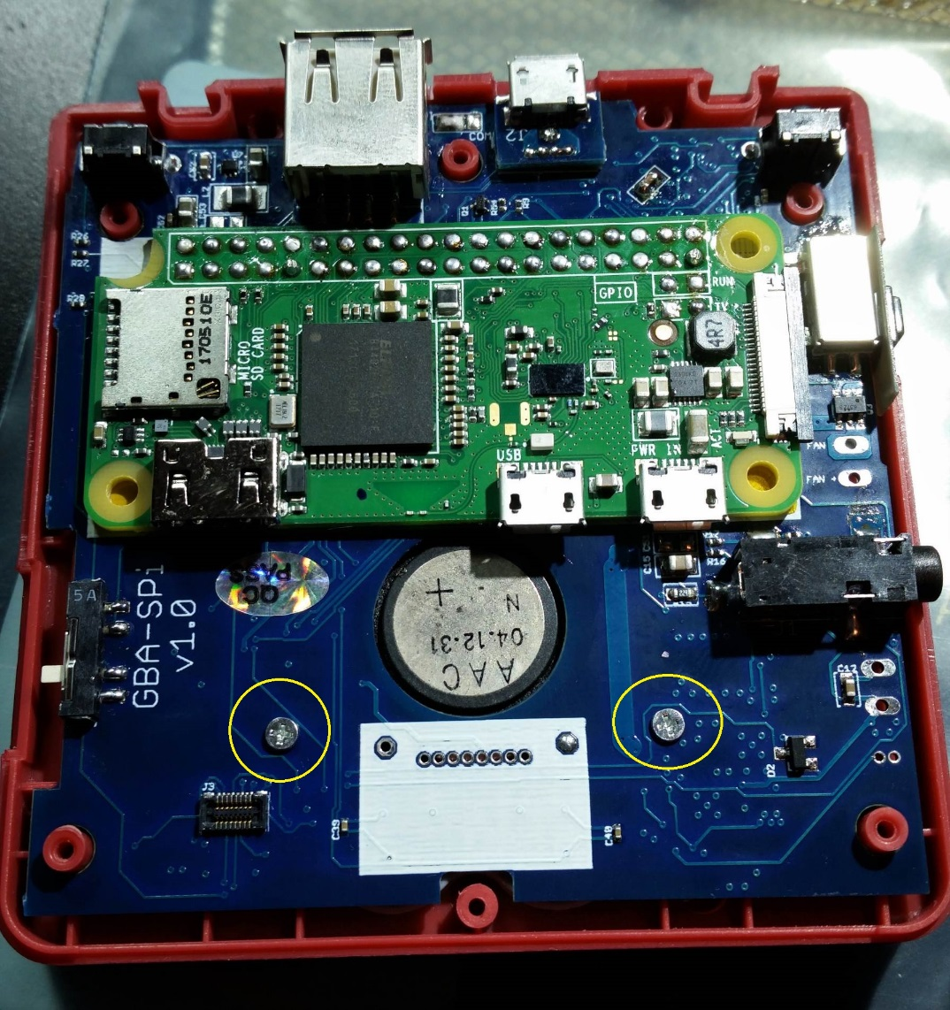

Figure 81 - Seat AIO board into shell, screw in place

**Now is a good time to plug in power and confirm that everything works again!** You should have already tested before now, so you should be confident it works. Now you are just testing that your ribbon cable connection is secure. At this point you should also be testing the functionality of the sound.

## Hinge installation

Once you’ve confirmed it’s still working, it’s a good time to install the hinges. Or you can wait until later when the back portion of the shell is installed as well. Just google how to install the hinges, you’ll find info and videos on how to do it.

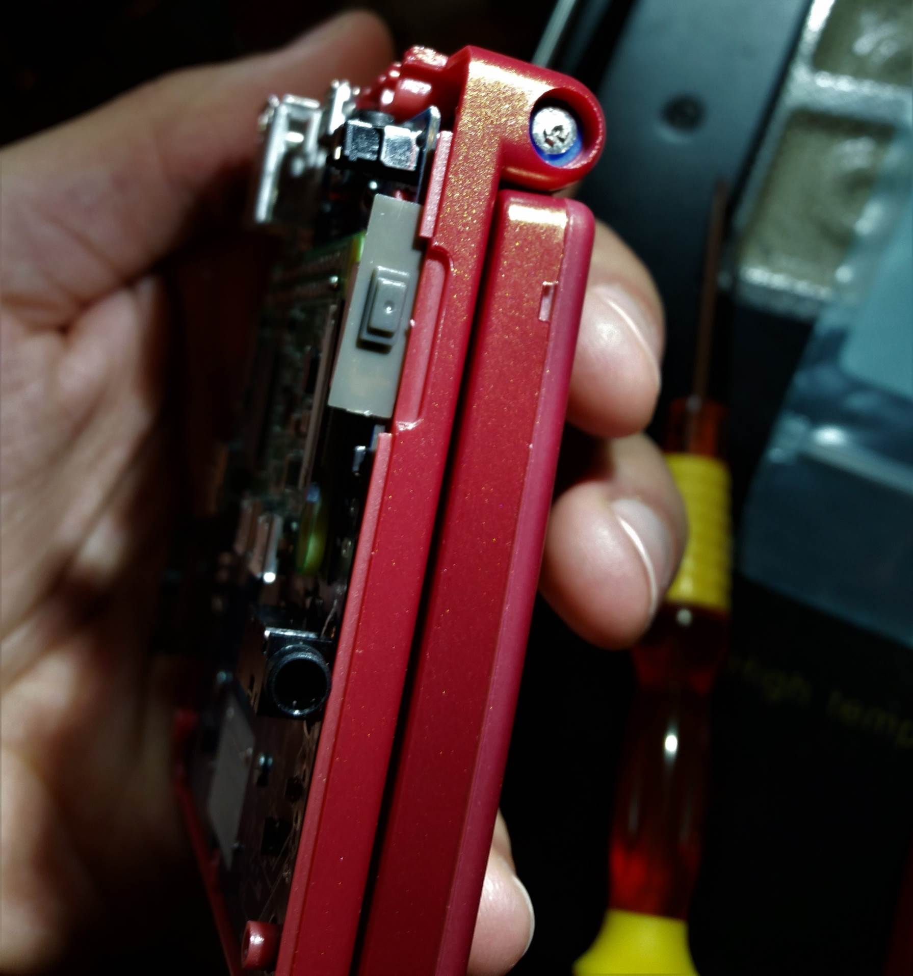

Figure 82 - Install the hinges

## Headphone jack

Put on the back portion of the shell, and mark off where the headphone jack hole needs to be cut. 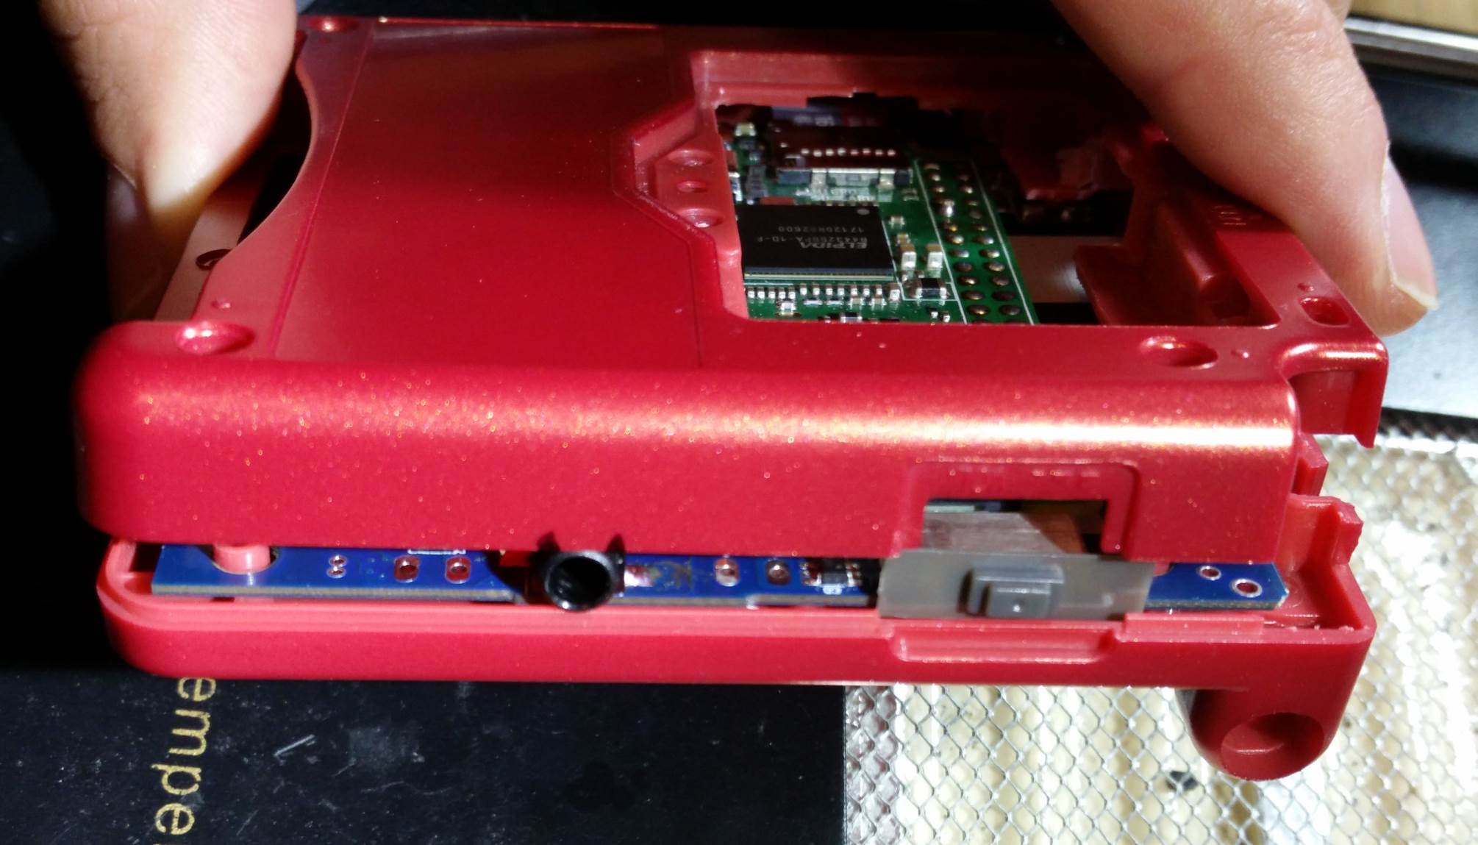

Figure 83 - Mark headphone jack location

Use the x-acto knife to slowly shave away the plastic to fit the headphone jack. Be sure to keep checking the fit, so you don’t cut too far.

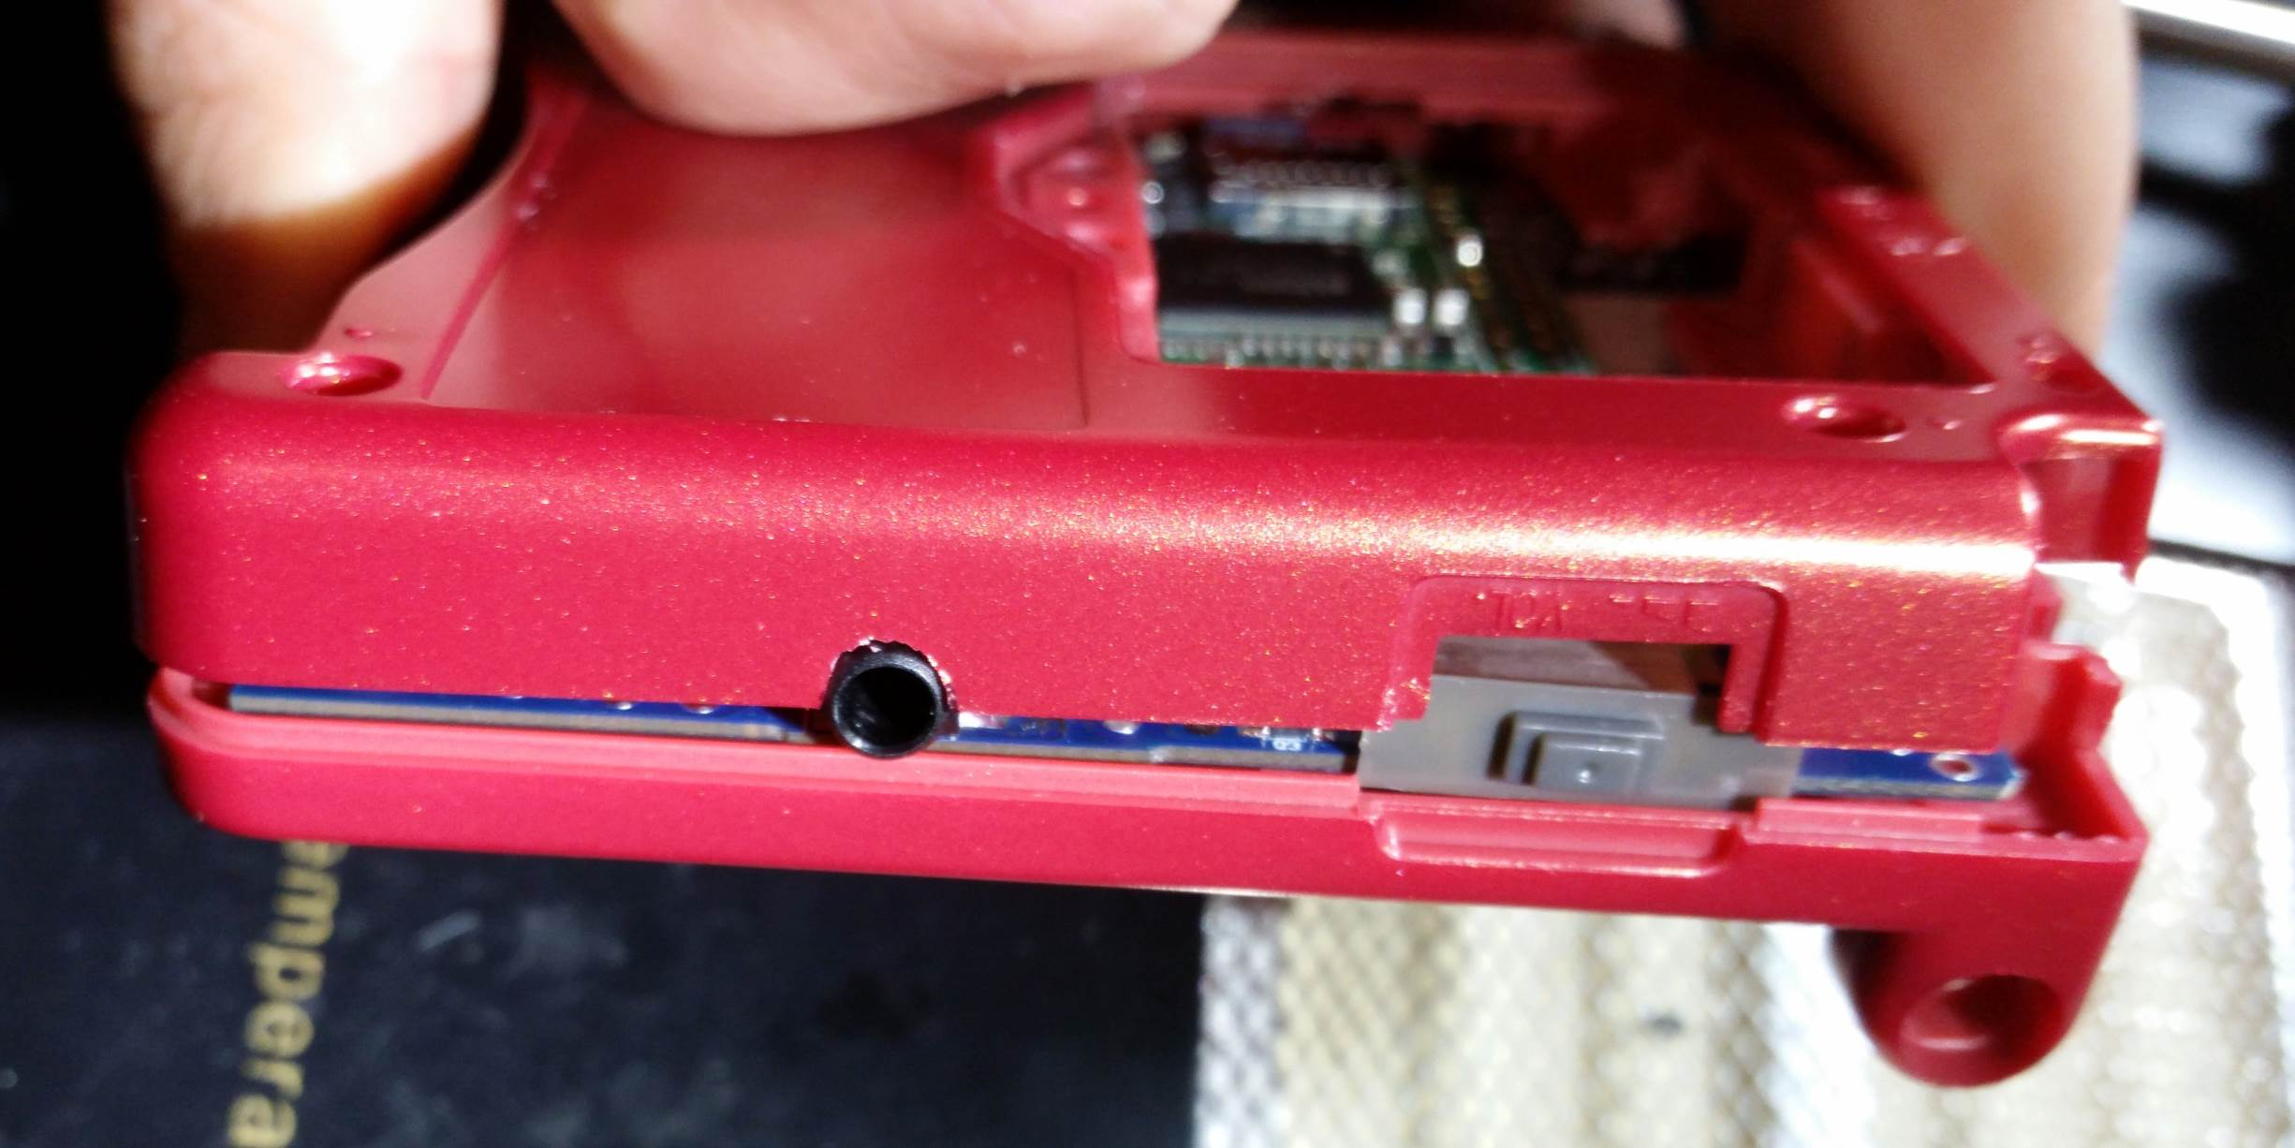

Figure 84 - Check headphone jack fit

Once you’ve cut a clean hole for the headphone jack in the back portion of the shell, also make sure to shave a little bit of the front shell, shown in yellow below. This is just to ensure it fits and does not put too much stress on the board/headphone jack when everything is closed.

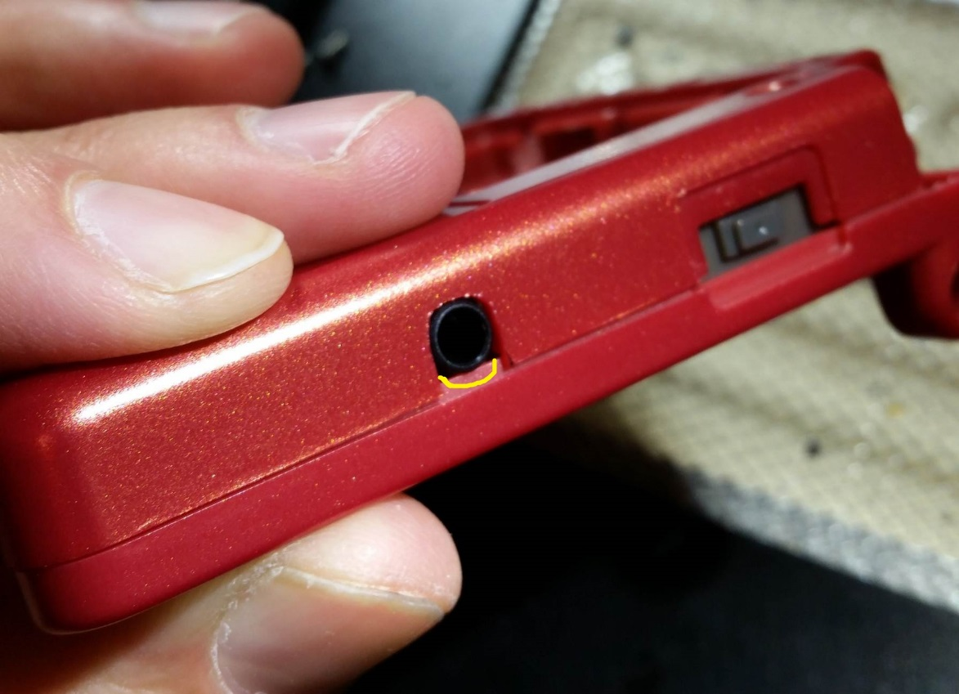

Figure 85 - Finish headphone cutout

## USB port

Install the back portion of the shell, and then look at the USB port. You can apply heat to the one pin that you soldered, and you should be able to rearrange/realign the USB port to fit nice and snug into the cutout you have made.

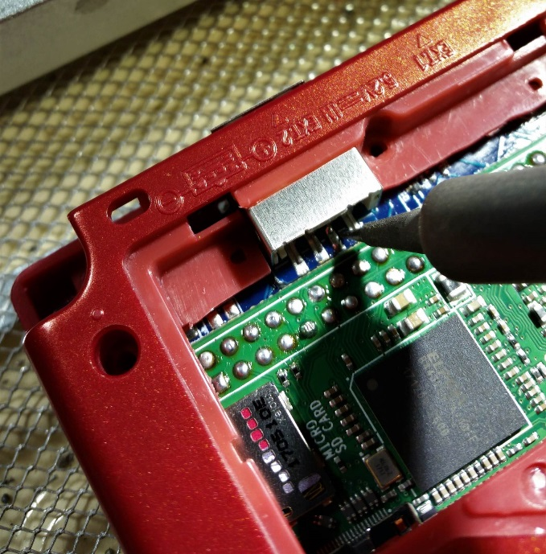

Figure 86 - Realign the USB port

Once it is aligned and fit how you like it, solder the rest of the USB port pins.

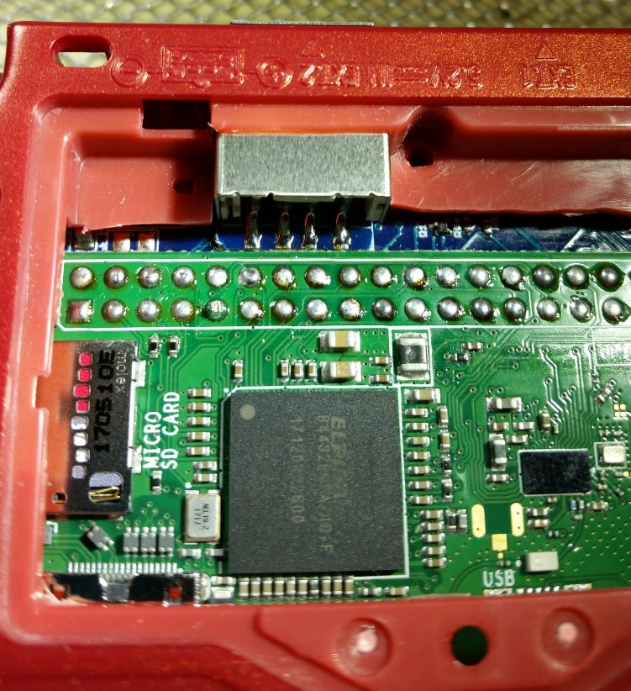

Figure 87 - USB port pins soldered

Now is when I usually put a bead of gel super glue underneath the plastic piece of the USB port. Since we cut off the mechanical pins of the USB port, this just gives a little more stability.

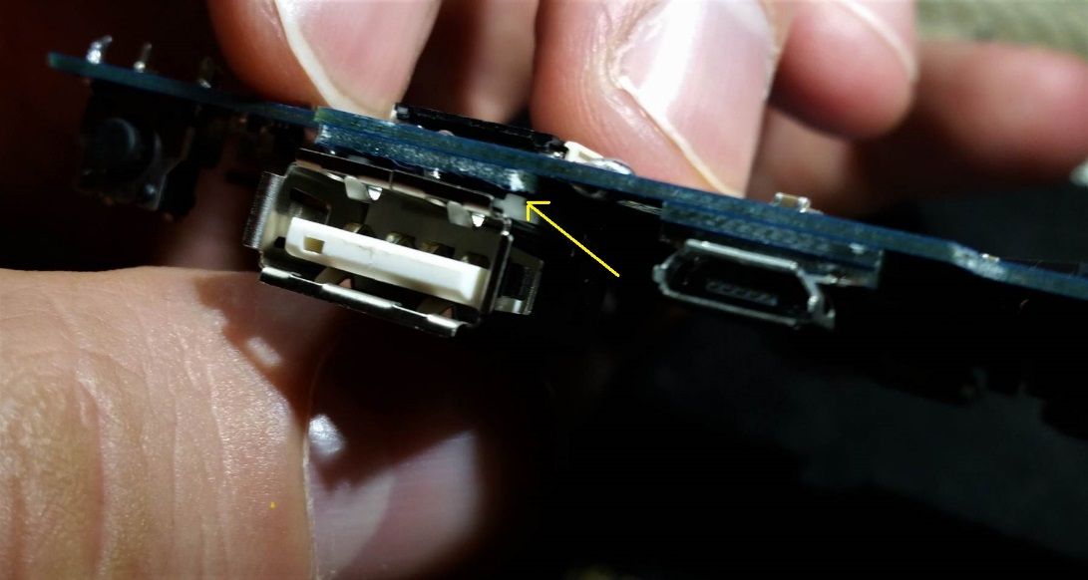

Figure 88 - Super glue under USB port

## Volume Slider

Remember back when we only soldered two pins on the volume slider?

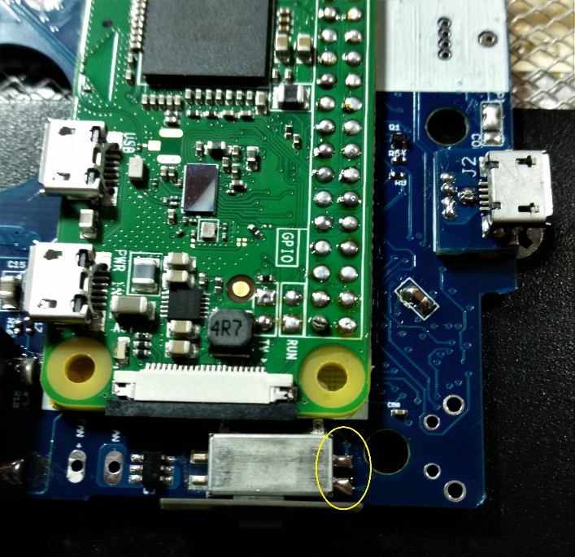

Figure 89 - Two pins on volume slider

This was so when we assembled the case we can adjust the location of the slider. So now is the time to adjust. Assemble the back piece of the case, and confirm that the slider can move freely. If it needs to be adjusted then your soldering iron should be able to melt both these pins at the same time, and you can slightly adjust the alignment of the volume slider until it fits perfectly.

Once it fits to your liking, then solder the other two volume slider pins on the opposite end, and it should be nice and secure.

## Battery

Wrap the whole battery in a layer of kapton tape! This is important to ensure it doesn’t short anything inside the case accidentally.

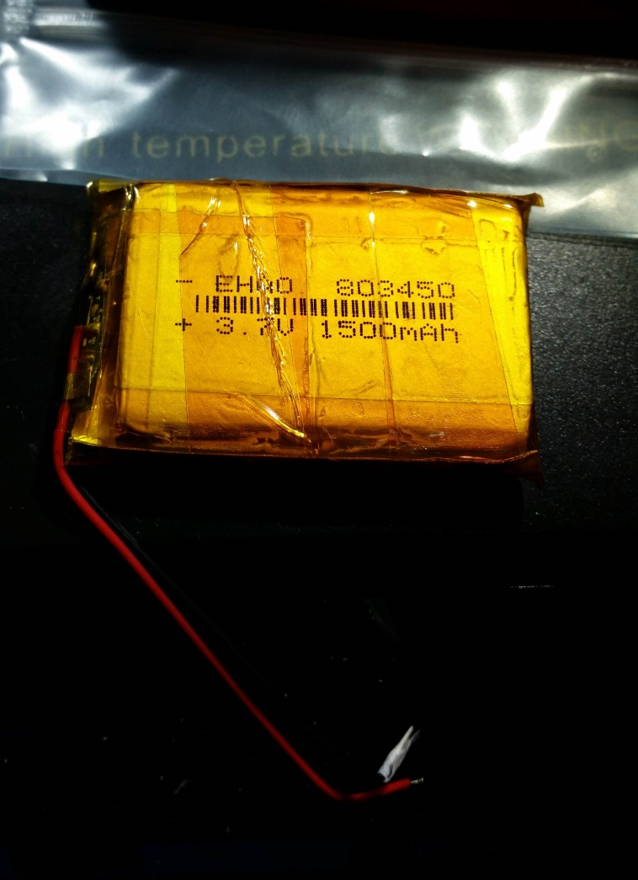

Figure 90 - Wrap battery in kapton tape

Place the battery on the AIO board, to get a sense of how short you should cut the wires.

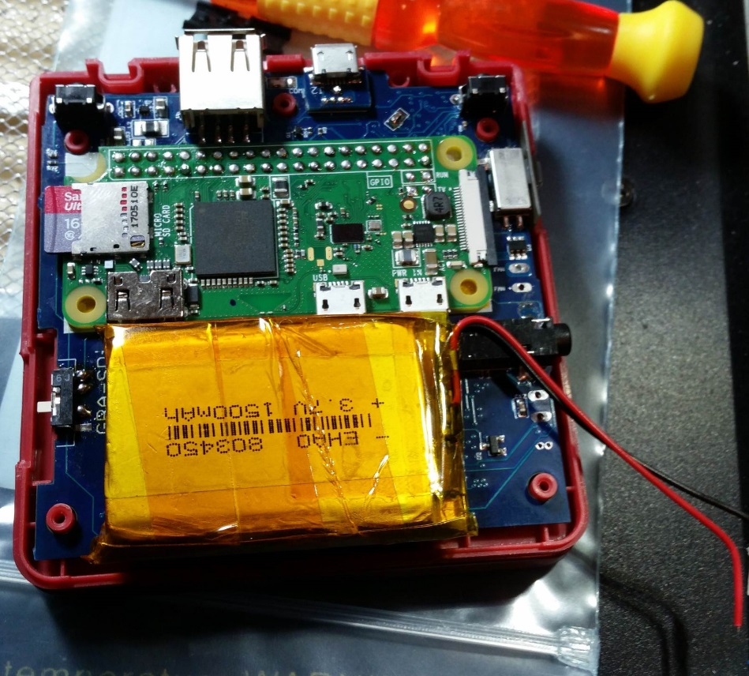

Figure 91 - Battery location on AIO board

Once you see how long to cut the battery wires, it’s time to cut them.

**BUT DO NOT CUT THEM TOGTEHER!** The metal of the cutter will create a short circuit between the positive and negative battery terminals, and there’s a strong possibility you could blow the protection circuitry in the battery, and you will need a new battery.

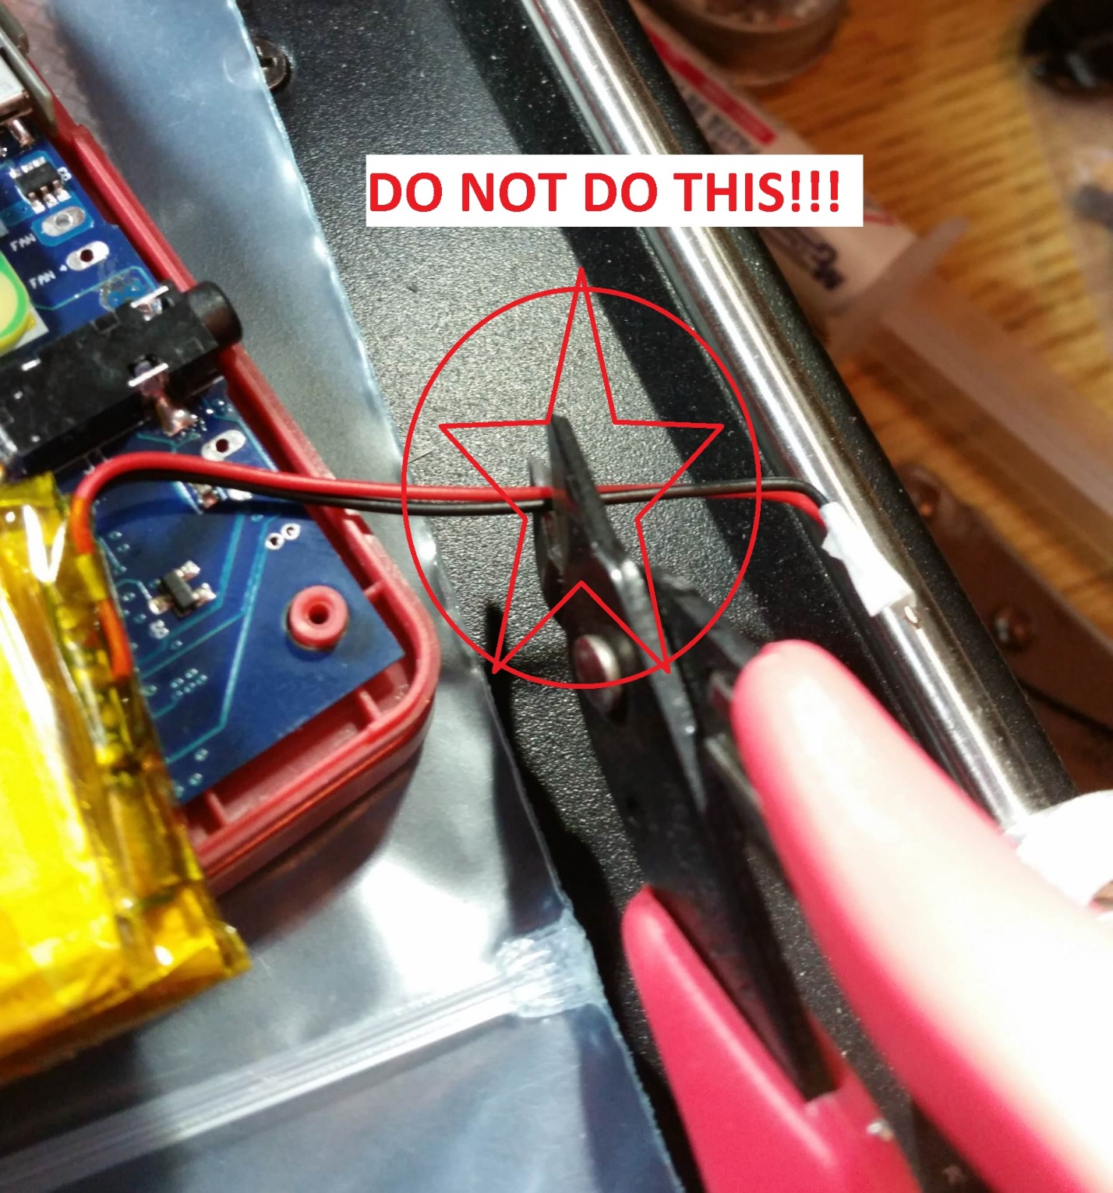

Figure 92 - DO NOT CUT BATTERY WIRES TOGETHER

Instead, cut them one at a time.

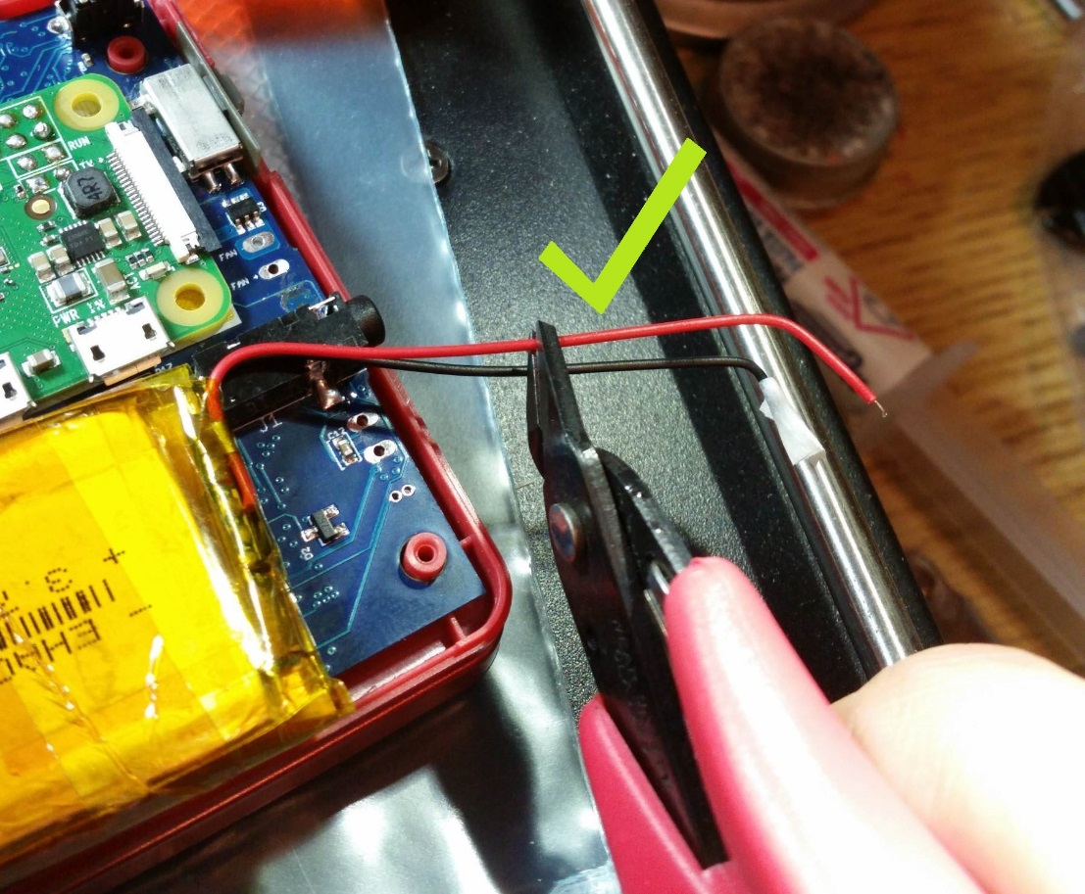

Figure 93 - Cut battery wires one at a time

Now strip the wires, and solder them as shown below. Again be careful not to short circuit anything with your iron, or with the wires themselves after you strip them. Also add some kapton tape to hold the wires down, this is just to provide some strain relief.

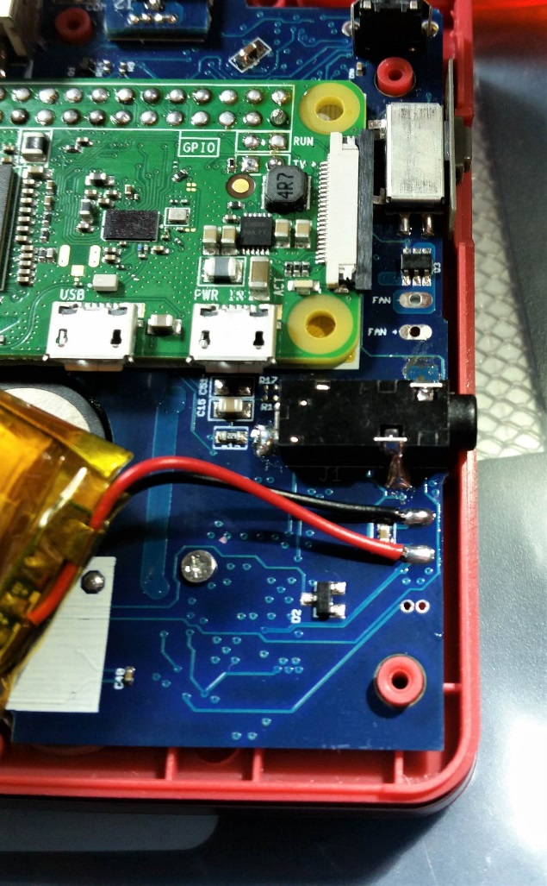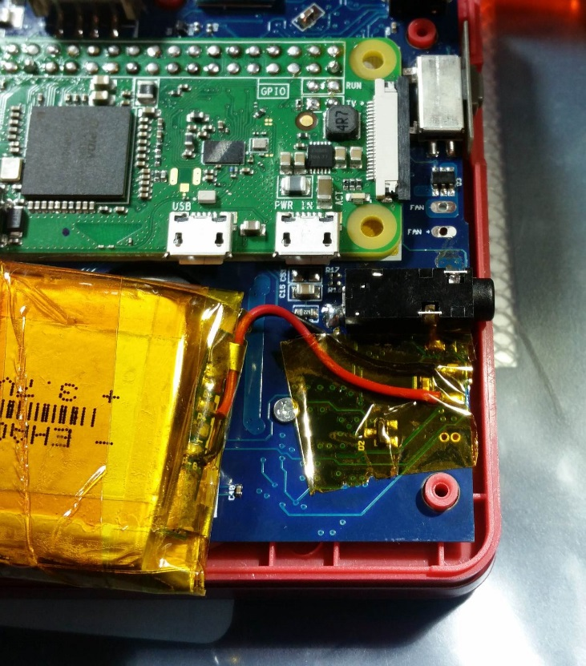

Figure 94 - Solder the battery wires, and add some kapton tape

## Final Assembly

Finally we get to put the whole thing together. Don’t forget to add the pieces circled below. The small square nut where you will screw in the back battery cover, the L and R buttons with their springs, and the slide power switch piece.

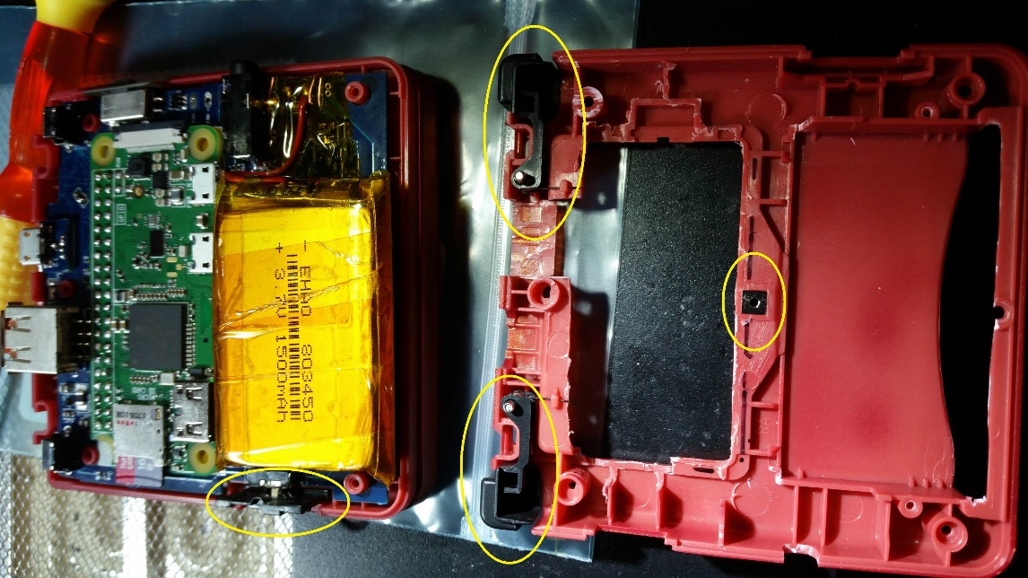

Figure 95 - Adding the final assembly pieces.

Terrible picture quality below, but when putting on the back shell piece, it will make things easier if you start by feeding the battery through the cartridge slot.

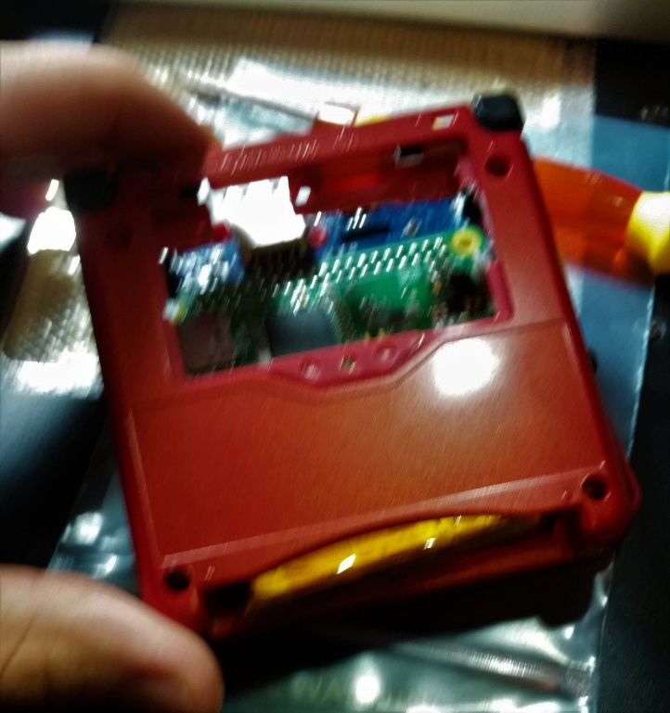

Figure 96 - Battery through cart slot first

Then screw it all together!

## Fitting the cartridge

The final piece to finish is the cartridge itself. This will cover the battery, and make everything look fully stock again!

First super glue the two cartridge halves together. There is a screw, but we will be cutting through the screw mounting plastic, so glue is the way to go.

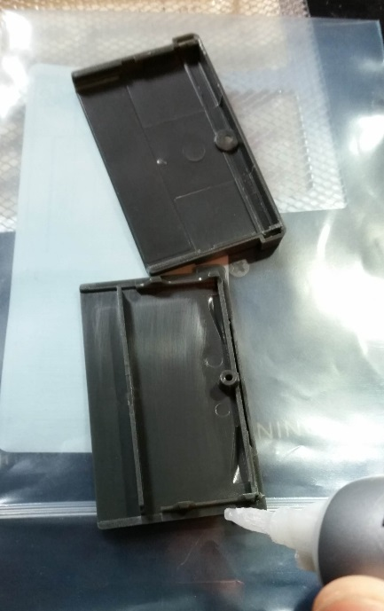

Figure 97 - Glue cartridge shell together

Put the cartridge over the GBA SP and estimate how far to cut, my mark is shown on the cart below.

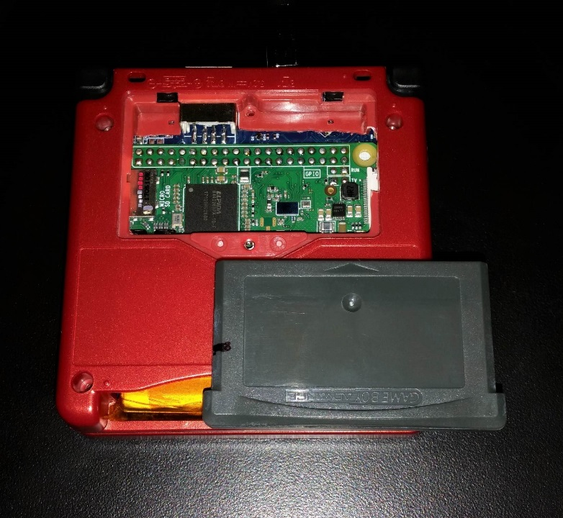

Figure 98 - How far to cut the game cartridge

Use your trusty dremel to cut and hollow out the game cartridge like in the picture below.

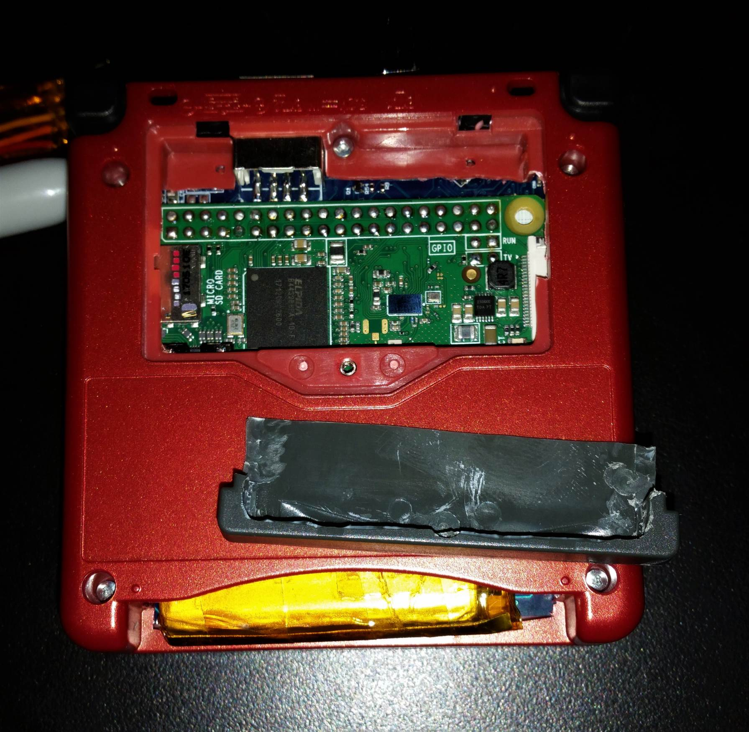

Figure 99 - Fully cut game cartridge

# All Done!

You did it, now it’s all done!

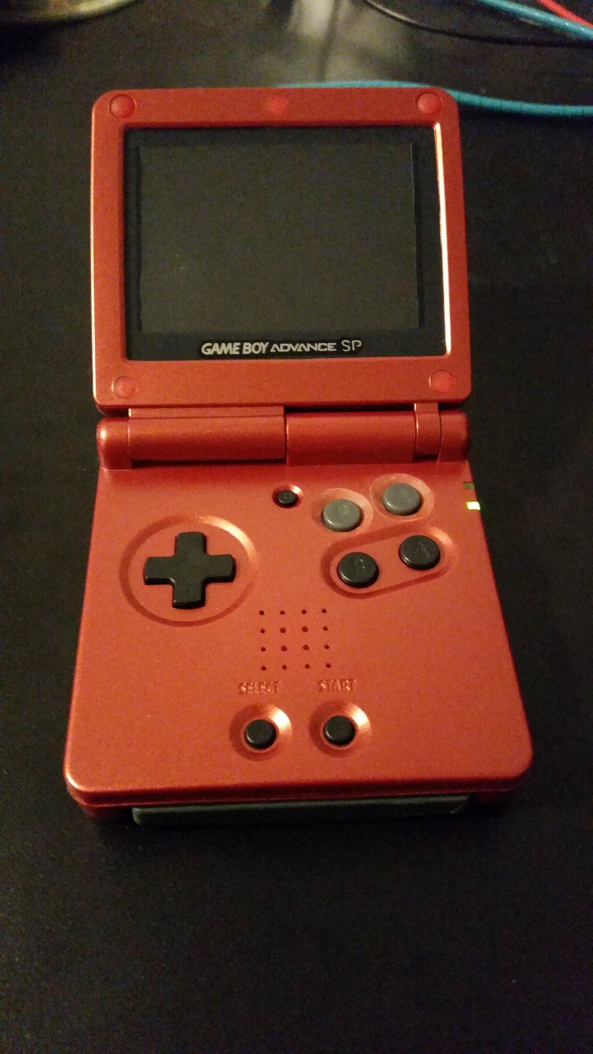

Figure 100 - FInished product

When you plug in power, the green LED should go on indicating the battery is charging. You can power it on and play as the battery is charging! Or you can unplug power and start playing on battery right away, the battery should have some charge in it for you to use.

**Enjoy!**